Position on the hill:
Make sure you can clearly see all your gates  Stay above the fall zone  Clean hill:  Limit what you have with you. No loose items on the snow. If you have skis they need to be flat on the snow | 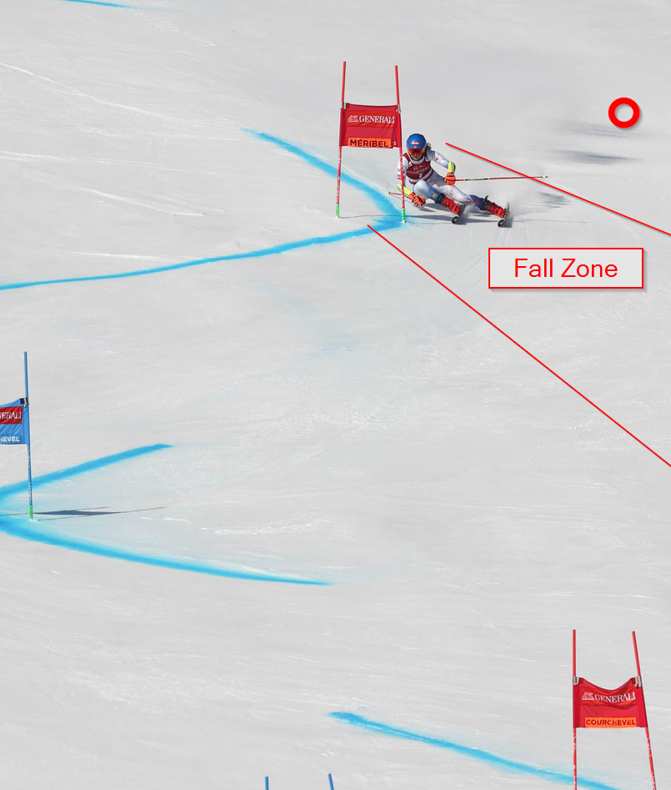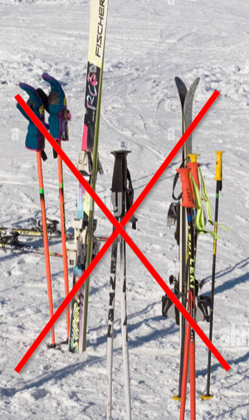
Blue Hills  - Stand on skier’s right  - Make sure you can see your gates | 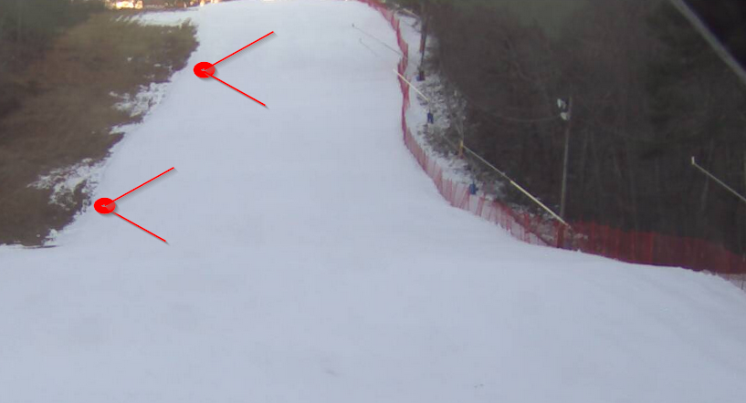
Ragged  - Stand on skier’s right  - Stand inside the rope marking the course | 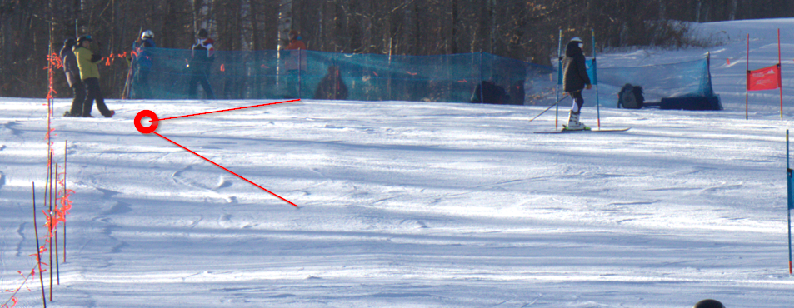

Race Duties:
Draw and number your gates.  Draw the correct path  Note that for an undergate:  - Both gates have one number  - The orange path is wrong but legal  If you are not sure, ask a race official  Put your name on the front. | 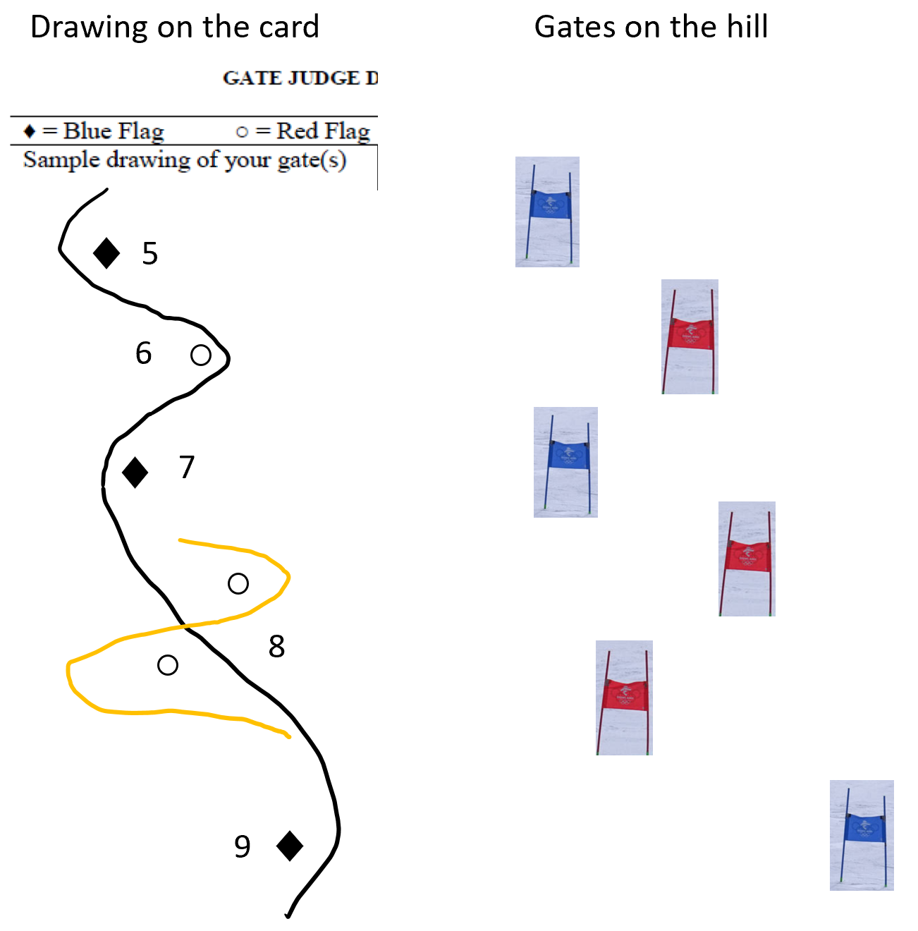
Take note when a racer does something wrong  - Write  - No hiking allowed in GS. Mark if racer fell or stopped but then continued  - Both ski tips and boots have to be outside the gate, but arm can go in the middle  - You can have several racers on one drawing for the same fault  - Add notes if needed (for example: didn’t see the bib number but next racer was 87)  Be consistent and objective  No need to call faults on radio | 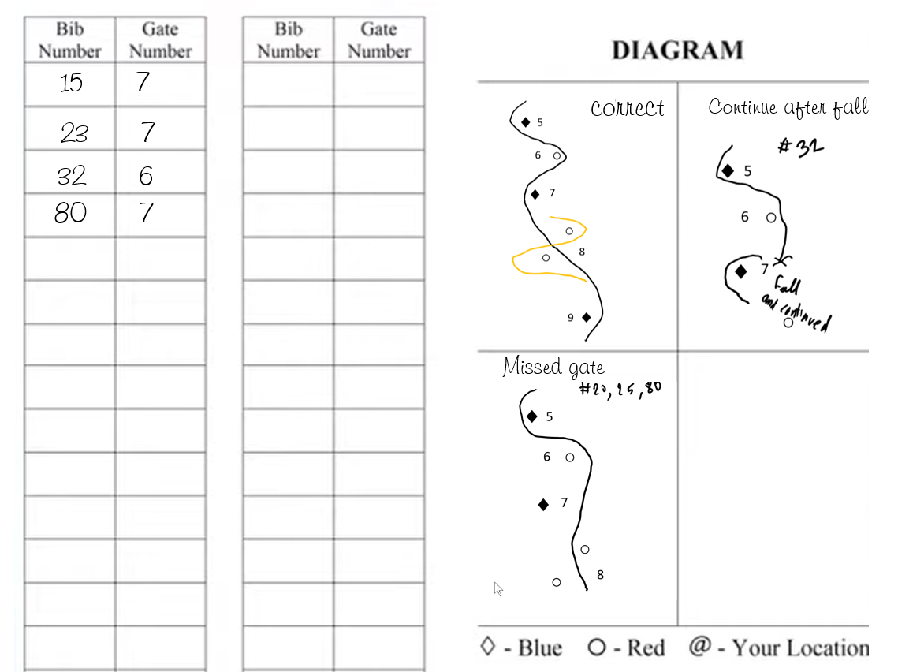
Racer skis out = Did Not Finish (DNF):
Call on the radio “Racer 25 DNF”
Racer Falls in course  - Help clear the course if you can, but be aware of next racer on the hill  - Wave off next racer if there is risk due to obstacle (only if there is a risk)  - If racer is blocking the course call on radio “Racer 22 down and blocking course” | 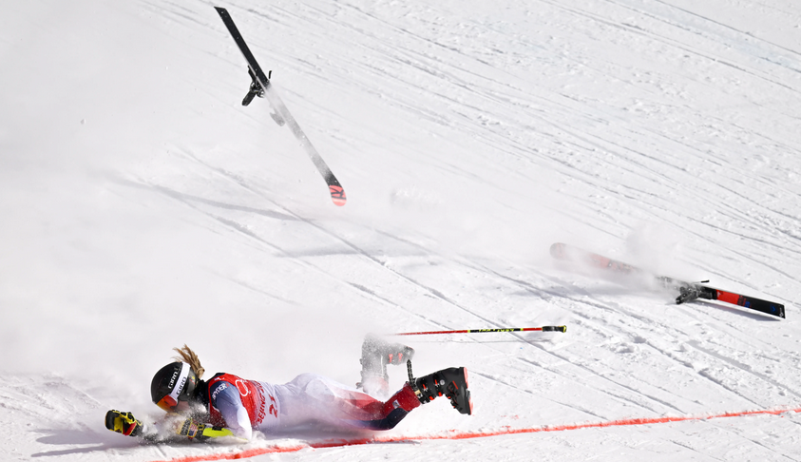
If you see a racer coming towards course workers:
Yell “course”
If a racer stops and claims interference  Call on radio “Racer 41 requesting rerun”  Send the racer to the finish judge  Mark the card. Add notes if you saw the interference | 