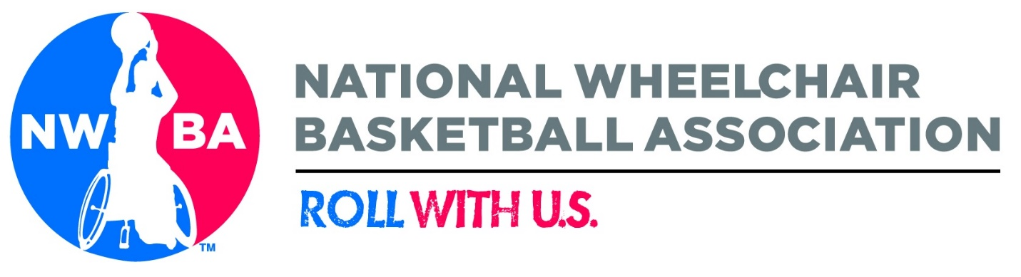

NWBA HIGH PERFORMANCE
COACHING POOL APPLICATION
2019 U.S. Women’s U25 World Championships Team

2019 IWBF Women’s U25 World Championships
May 22-30, 2019
Suphanburi, Thailand

Please Return to NWBA By November 30, 2018
Send via email to: brandonmcbeain@nwba.org

Coaching Pool
The NWBA High Performance Coaching Pool is an active database of qualified coaches that are interested in serving the NWBA on a coaching staff for one of its High Performance teams that include:
MEN
Senior National Team
Junior U23 National Team
Special Event Teams

WOMEN
Senior National Team
Junior U25 National Team
Special Event Teams
Inclusion in the pool will provide access to NWBA training and education programs, early notification of position openings, opportunities to serve on team selection committees at NWBA sponsored camps and priority consideration for staff openings.

Contact Information
For more information related to the NWBA High Performance Coaching Pool please contact Brandon McBeain, at brandonmcbeain@nwba.org or call (719) 266-4082 ext. 108.

Application Form
Please complete the following application form in its entirety. Include as much information as possible in order for the NWBA to determine your level of expertise and capacity to serve on a USA National Team Staff. Please be honest and forthright. It is the goal of NWBA High Performance to include, not exclude coaches from the pool.
One of the ways this application will be used is to develop training and education programs to fill the gaps that exist in current coaching training and education programs in an effort to provide as many opportunities as possible for our coaches to become the best they can be.
Please email your completed application to Brandon McBeain at brandonmcbeain@nwba.org.

Contact Information
First Name Middle Initial Last Name
Date of Birth (MM/DD/YYYY) Age Male Female
Shirt Size Small Medium Large X-Large XX-Large
Street Address City State Zip
Home Phone Cell Phone
Email Address
Emergency Contact
Relationship Contact Number

Coaching History and Achievements
Levels Coached
Prep # Years Team(s)

Junior # Years Team(s)

DIII # Years Team(s)

Women # Years Team(s)

Championship # Years Team(s)

Collegiate # Years Team(s)

National Team # Years Team(s)

Other (Stand Up Basketball) # Years Team(s)

Championships Won

Coaching Awards

Camp Staff Positions and Years

Playing History and Achievements
Levels Played:
NA
Prep Years
Junior Years
DIII Years
Women’s Years
Championship Years
Collegiate Years
National Team Years

Championships Won

Playing Awards

PLEASE ANSWER THE BELOW QUESTIONS FOR THE COMMITTEE TO BETTER UNDERSTAND YOUR CREDENTIALS.

Coaching Philosophy
What is your coaching philosophy?

Why NWBA High Performance/TEAM USA?
Why do you want to be part of NWBA High Performance/TEAM USA?

Why does NWBA High Performance/TEAM USA need you?
Explain what assets you bring to NWBA HP/Team USA?

Technology Acumen
Please describe your level expertise with the following: 1 is no experience, 3 is average and 5 is expert:
Microsoft Office
Microsoft Word 1 2 3 4 5
Microsoft Excel 1 2 3 4 5
Microsoft Outlook 1 2 3 4 5
CyberSport 1 2 3 4 5
Dartfish 1 2 3 4 5

Explain areas where you marked less than a 3 and areas where you marked a 5.

Explain other areas of technology where you have expertise that would assist NWBA HP/TEAM USA in achieving its goals.

Sport Psychology
Explain your philosophy of how mental skills training should be a part of a high performance program.

Strength and Conditioning
Explain your philosophy of the role strength and conditioning should have in a high performance program.

Nutrition
Explain your philosophy of the role nutrition should have in a high performance program.

Sports Medicine
Explain your philosophy of the role sports medicine should have in a high performance program.

Training and Education
What do you feel the NWBA needs to provide in order to develop a deep pool of qualified coaches that can serve within our high performance program?

Decentralized Training
The NWBA currently operates a decentralized training program for its national teams. This means that athletes are brought together for team training approximately one time per month in preparation for competition. Athletes are given strength and conditioning, shooting, and mental skills training programs complete on their own on a weekly basis. Discuss advantages and/or challenges to this model.

Additional Information
Please add any additional information that you feel would be beneficial to the NWBA in evaluating your application.

