The 2025 Porter Parent Football Association (PPFA) Newsletter – Playoff3
The LTHS Porter Parent Football Association (PPFA) is a volunteer group dedicated to enhancing the football experience for players. Our goal is to foster a positive, memorable environment for each player, achieved through support for both the players and coaches. The PPFA funds its efforts through various fundraising initiatives, including spirit wear, player sponsorships, and volunteering.
- Twitter @LockportFootba1 - Facebook @ LTHSFootballBoosters  - Lockportfootball.com
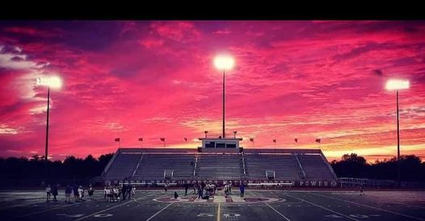Every Week
Varsity Players Pasta Dinner – Every Thursday @ Cooms Corner, but breakfast will be served this week (see below).
Playoff-3 Breakfast (Cooms Corner): Sat 11/15 @ 9:30am **Parent Volunteer and/or Drink Donation**
** Ask-a-Porter ** - 10Q with AJ Garcia
Game Schedule/Results
Varsity: Porters vs Barrington: Sat 11/15 @ 6:00pm Game Preview Concession Volunteer
Porters over Homewood-Flossmoor on 11/8 (21-20) Game Recap
Game Photos (TKMEDIA09) Game Photos (ZL VISUALS) Game Photos (RJ.Prodz) Game Photos (Flicz.By.J)
News and Notes
PPFA Board Meeting: 11/18 (Tuesday) @ 7:00pm – LTHS (Room 107A)
Save-the-Date: 11/15 – State Playoffs (Quarterfinals)
11/22 – State Playoffs (Semifinals)
12/8 – Varsity Banquet @ Crystal Grand Banquets (details to follow)
**Lost and Found** Missing a PPFA 2025 Newsletter? Click HERE

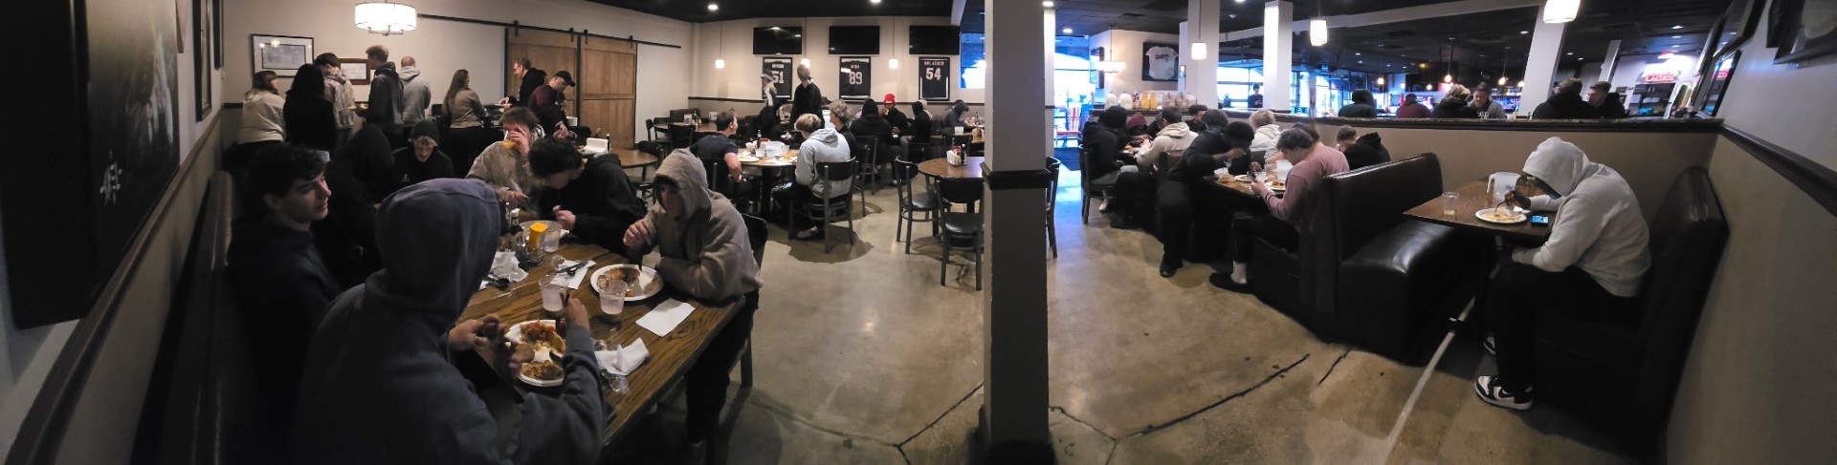
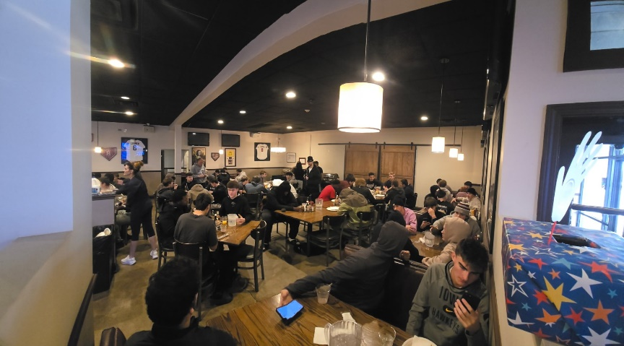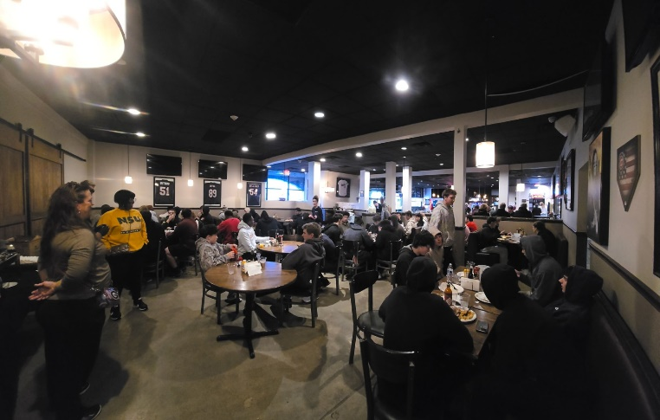
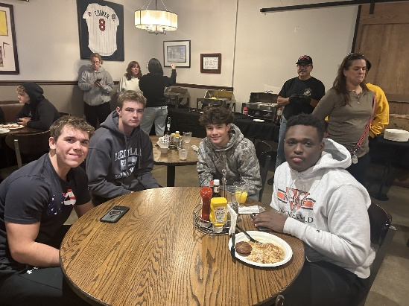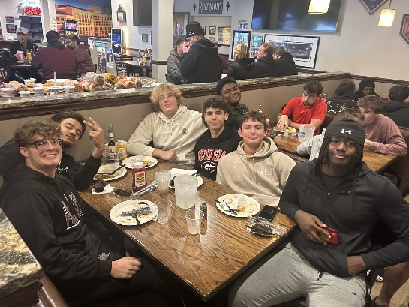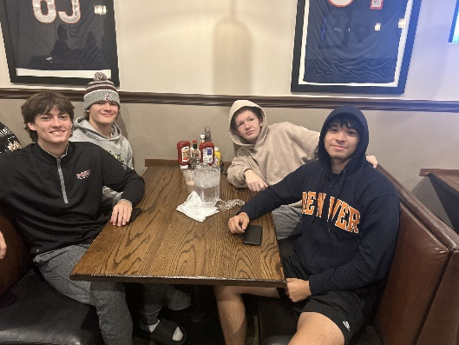
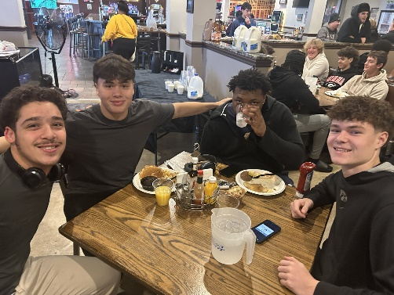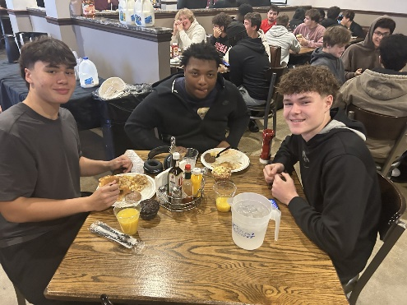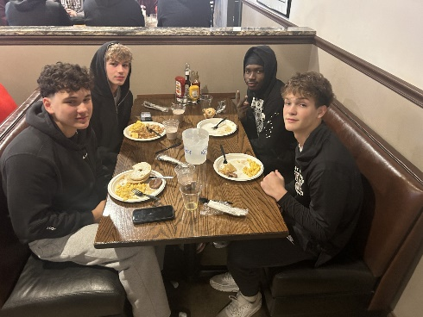
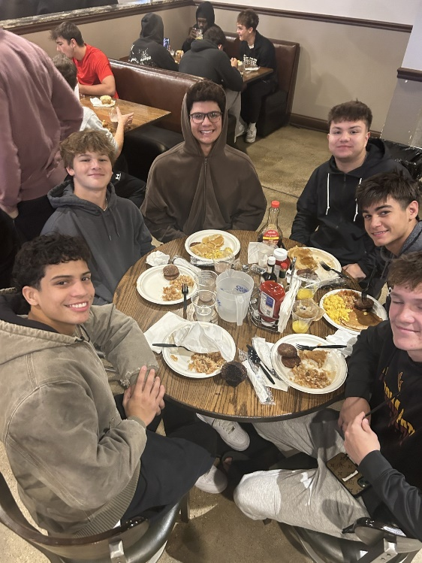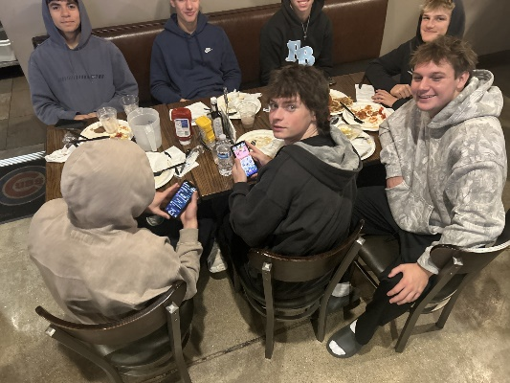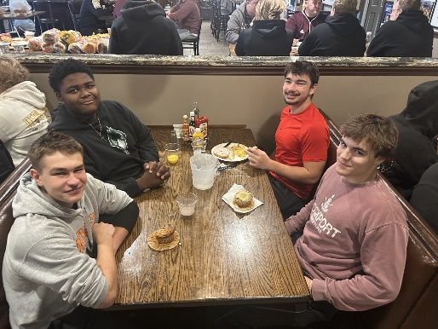
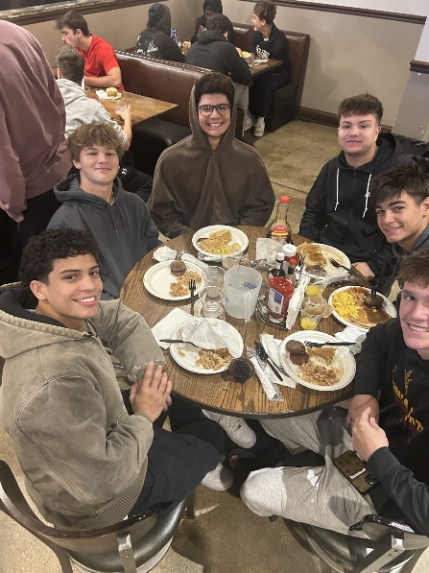

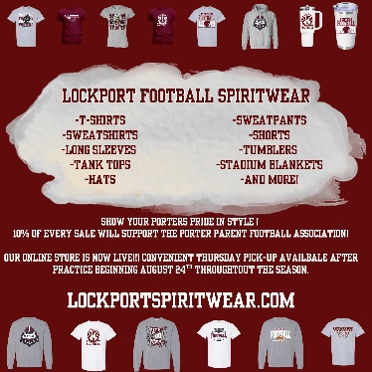
Order your 2025 Lockport Football Spirit wear HERE
Helpful Links
Spirit Wear Game Digital Tickets IHSA Football Info 8to18

