Scoring in the APP
- Download the Sports Engine App
- Open Sports Engine APP – Your team should be listed
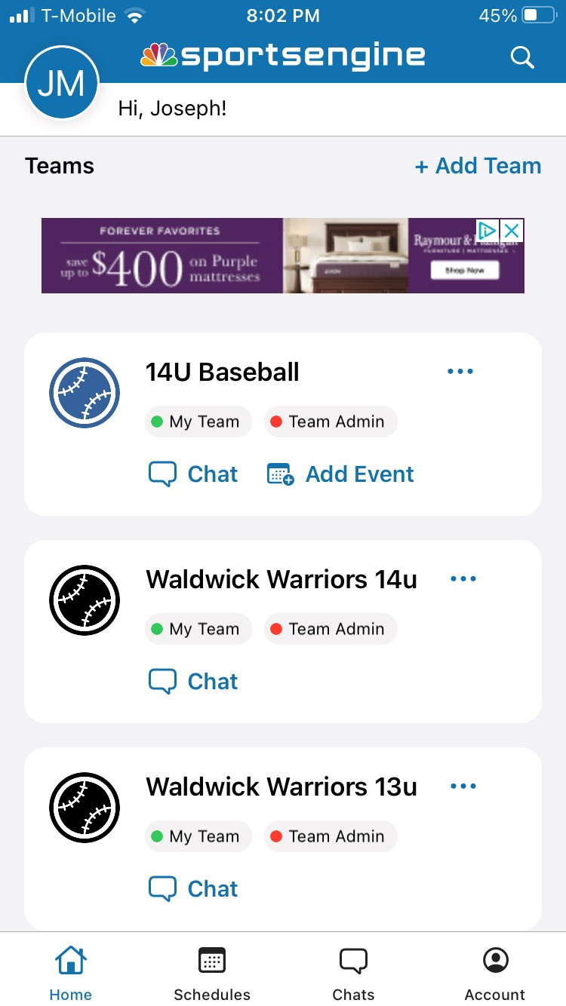

- Once your team is open click on the Schedule Icon
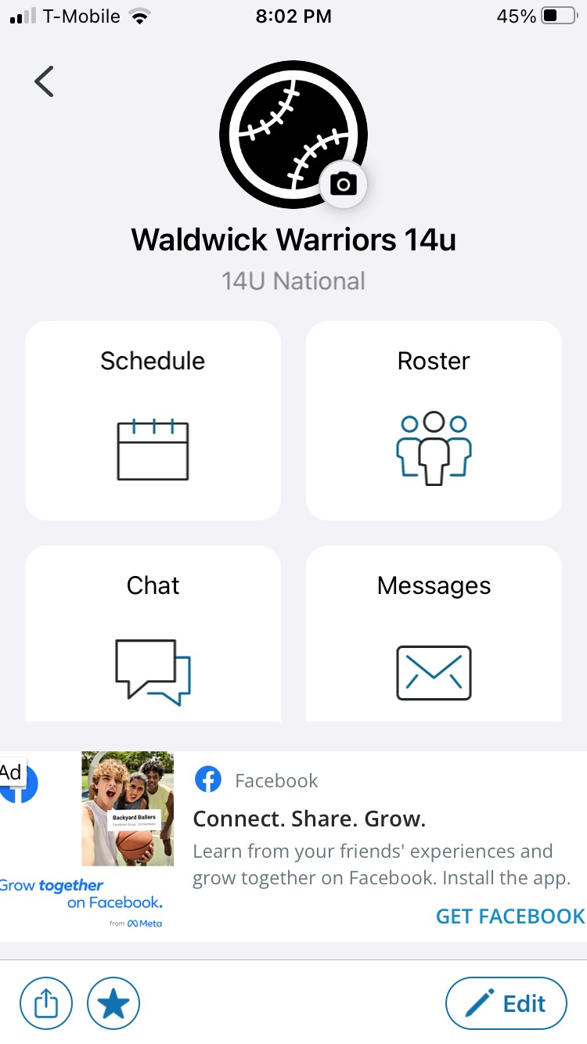

- Your schedule will be displayed. Click on the game to score.
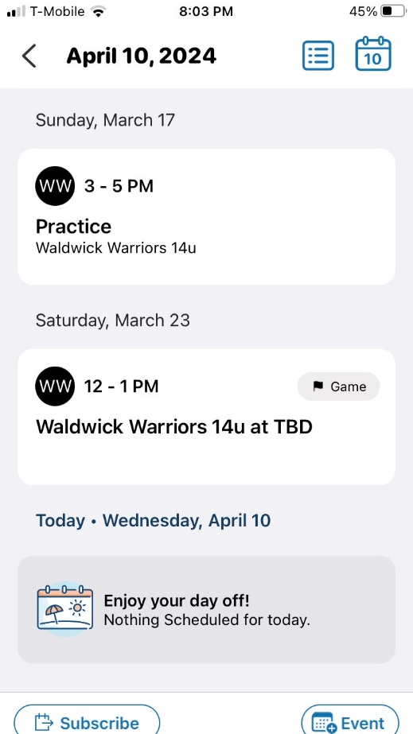

- Game Details will be displayed. Click on the Score Icon at the lower right
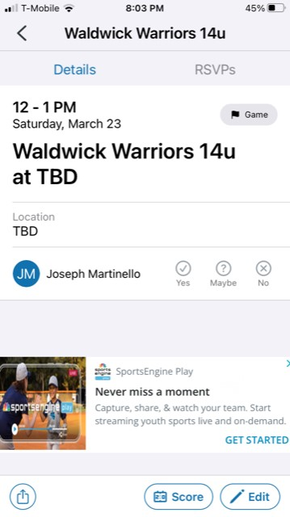

- Update Score. Make sure to change to status Final! Then Save.
