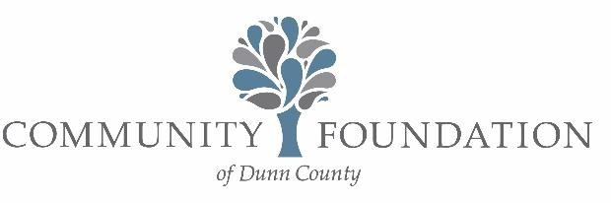

JOHN R. DALE YOUTH HOCKEY MEMORIAL SCHOLARSHIP APPLICATION FORM

Menomonie native John R. Dale was a loving son, brother, husband and father with a true passion for hockey. At eight years old, John signed up as an initial member of the newly-formed Dunn County Youth Hockey Association, playing
hockey as a “Cougar” for eight years and went on to play for Menomonie High School’s first hockey team in 1980. John’s love of hockey continued in adulthood, as he coached his son Jake’s hockey team in Hastings, MN. John, along with his wife Julie and daughter, Jenna, never missed a game. It is in his loving memory that this scholarship has been established by his family and many friends to provide one or more youth members from the greater Menomonie area with the opportunity to participate in the Menomonie Youth Hockey Association’s “Squirts” or “U10” program by covering the full registration cost.

Youth Skater Name Date
Mailing Address Parent/Guardian Name Phone
1. Has the applicant completed the Menomonie Youth Hockey “mite” program? | YES | NO
2. Is the applicant planning to enroll in the MYHA “Squirt” or “U10” program? | SQUIRT | U10
3. Does the applicant have one or more siblings enrolling in a MYHA program? | YES | NO
4. Does your family currently qualify for any low-income assistance programs,
such as FoodShare, Free/Reduced School Lunch, Home Energy Assistance, etc.?  5. In 50 words or less, please have the youth applicant complete the statement: | YES | NO

Youth Hockey is important to me because…

*Optional: An additional statement of 50 words or less may be attached by the parent/guardian.

The Scholarship Application Deadline is September 1.
Please submit completed forms to: MYHA Attn: Heidi Neverdahl P.O. Box 492 Menomonie, WI 54751 or
Hneverdahl@yahoo.com

