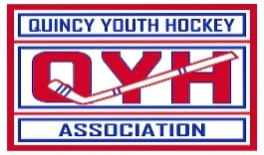
QUINCY YOUTH HOCKEY
2024 Scholarship Application
“Book Award”

Awards are available to family members of past/present members of Quincy Youth Hockey Association. To be considered, someone in your immediate family (sibling/parent) must have played hockey in QYH. Additional factors include length of time in QYH and service activity in the community.

NAME: __
ADDRESS: __
CELL PHONE: _________
EMAIL: _________
Dates of membership/involvement with QYH: _______________________________
Teams and/or Coaches: ___
Community Service History: ____________________________________________________
Continuing in the field of (list current school, employment, deployment in service or other): _____________________________
Please read and sign the following statement:
I certify that I am not under a full scholarship with the school/program that I am enrolled. I would like to be considered for a QYHA Scholarship.

Signature of Applicant:
All applicants must be members in good standing. Please return applications to:
QYHA @ 60 Murphy Memorial Drive OR via EMAIL to treasurer@qyha.net
Applications must be submitted by November 15th, 2024

