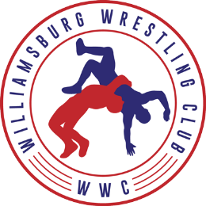1st Annual WWC Round Robin Invitational
(MADISON SYSTEM BRACKETING)

Date: January 31^{h}, 2021 (Tournament is limited to the first 300 wrestlers)

Location: Hampton Roads Coastal Sports Plex 12650 Patrick Henry Dr, Newport News VA 23602

Weight classes: This is a Madison system round robin separated by grade level and not to exceed 10% of the lowest bracketed weight as well as not to exceeded 6 wrestlers per bracket.. Brackets will be built based on the following age groups: K-1st graders
2nd-3rd graders
4th-5th graders
6th – 8th graders

Wrestling Starts: K-1st graders- 9:00 AM
2nd-3rd graders- 9:00 AM
4th-5th graders 12:00pm
6th – 8th graders 12:00pm
*All wrestling will be completed by 3:30

*All bouts will be 1-1-1 (1 minute periods)

Awards: Awards will be presented to ALL participants K-1st Graders and The top 3 in each other weight will medal

Entry Fees: This is a club invite and we will charge $300 per team to enter as many wrestlers registered to your club VIA USA WRESTLING. Checks made out to “Williamsburg Wrestling Club”

CARD REQUIREMENTS: THIS IS FOR USA WRESTLING CARD HOLDERS ONLY

Registration and confirmation of attendance to this event is Due NLT Sunday Jan 24th 2021 9pm.

Weigh ins: Weigh ins will be held VIA Satellite weigh in through your Club rooms and roster and weights will be due by Thursday JAN 28th 2021 9pm

Confirmations, Roster to include Name Weight and grade are to be emailed to Ron Kavanaugh @ aauwrestling@hotmail.com and CC’d to Timp757@vt.edu

SPECTATORS: $5 Adult – LIMIT ONE SPECTATOR PER WRESTLER, COACHES FREE WITH
USA COACHES CARD

Contact: Ron Kavanaugh 757-812-8426 Email: aauwrestling@hotmail.com

