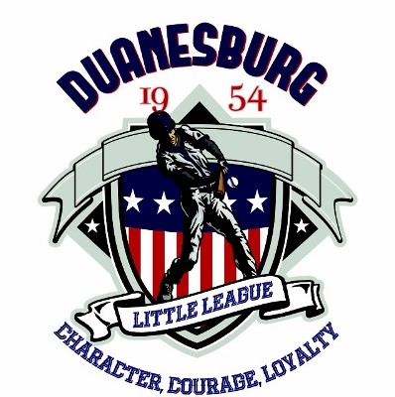
DUANESBURG LITTLE LEAGUE

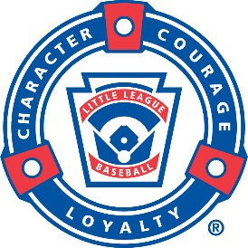

Safety Manual
2024 Season

Board Members 2024
BOARD MEMBER | POSITION(S) | PHONE | EMAIL
Chris Parslow | President | 518-470-4661 | cpars8@yahoo.com
Camille Simon | Treasurer & Concession | 518-320-4593 | Canoco21@gmail.com
 | Safety Officer
Dean Bartholomew | Field Maintenance | 518-669-9831 | Gabart07@yahoo.com
Nicholas Molik | Equipment Manager | 518-836-4471 | nicholasmolik@gmail.com
Shawn Palluti | Player Agent/Umpire Liaison | 727-692-2434 | spalluti@gmail.com
Brian Reese | Vice President - Baseball | 518-469-8366 | brianja11@hotmail.com
Jim Sanders | Vice President - Softball | 518-857-8835 | Jsand22@twc.com
James Simon | Field Maintenance, League Coaching Coordinator | 518-837-7080 | jmsimon2918@gmail.com
Ryan Smith | Information Officer | 518-860-2495 | ryansmith5882@yahoo.com
Brendan Walsh | Marketing | 518-573-7499 | brendanwalsh33@gmail.com

Duanesburg Little League
P.O. Box 184
Duanesburg New York 12056-0184
Email: duanesburgll@gmail.com

Eastern Regional Headquarters  P.O Box 2926  Bristol, CT 06011  (860) 585-4730 | Little League Baseball & Softball  539 Route 15 Highway  P.O Box 3485  Williamsport, PA 17701-0485

Emergency Phone List for
Duanesburg Little League

Emergency: 911
Schenectady County Sheriff: 518-393-8300
Duanesburg Ambulance Service: 518-895-2200
American Association of Poison Control Center: 1-800-222-1222

Esperance LP Gas: 518-875-9116
National Grid: 1-800-867-5222
Schenectady County Public Health: (518) 386-2810

PHYSICAL ADDRESS:
10179 Western Turnpike, Delanson, NY 12053

Little League Support Numbers
Eastern Regional Headquarters
P.O. Box 2926
Bristol, CT 06011
(860) 585-4730

Little League International Office
Phone – (570) 326-1921
Fax – (570) 322-2376

PO Box 3485 or 539 Route 15 Hwy.
Williamsport, PA 17701 Williamsport, PA 17702

Mission
To promote and provide a safe environment for our children, their families and the spectators. To teach our children the fundamentals of baseball and softball in the proper way. To embed a system of moral value, good sportsmanship and respect for one another and for persons in a position of authority. To institute a code of safety to be followed by all those involved in Little League Baseball and Softball.

DLL Board and Coaches Responsibilities

- Responsibility for safety procedures should be that of a board member of the local league.
- Managers/coaches will have player medical forms at all practices and games (see attached Medical Release form)
- Managers/coaches will have access to a phone and a first aid kit at all practices and games.
- Managers/coaches will be trained in CPR and basic first aid.
- Managers/coaches will be trained in fundamentals of the game.
- No games or practices should be held when weather or field conditions are not safe—particularly when lightning is present or when is dark outside.
- Fields will be inspected before every practice or game (see attached Pregame Safety Checklist.)

Field Guidelines

- Only players, managers, coaches, and umpires are permitted on the playing field during games and practices.
- Bats and loose equipment should be kept off the playing field at all times to prevent tripping hazards.
- All defensive players should be alert and watching the batter on each pitch.
- When playing catch, players should be spaced properly, alert, and watching their partner.
- Inspect equipment before each practice or game and make sure it fits properly. If equipment is unsafe, contact one of our board members for replacement.
- Pitching machines must be inspected before each use to assure they are in good working order. Machines can only be operated by trained operators.
- Batters must wear protective helmets during practices and games.
- Catchers must wear catcher’s helmet, face mask, throat guard, chest protector, shin guards and protective cup during practices and games.
- Headfirst sliding is prohibited, except when a base runner is returning to a base.
- Procedure for Medical Emergency Injuries will be followed by Managers and Coaches (see attached procedure)
- “Horse play” is not permitted on the playing field or in the dugout at any time.
- Players must not wear watches, rings, pins, or jewelry of any kind. Note: (Medical alert jewelry is permitted)
- Procedure for avoiding a “wild pitch” will be taught to the players (see attached procedure.)
- Warm up swings are only permitted in the batter’s box. No on deck circle allowed.
- Fingers thru chain link fencing are not permitted.
- Throwing the bat after a hit is not permitted.
- Shorts are not permitted during baseball practices or games.
- Procedure for avoiding fielder collisions will be taught to the players (see “Procedure to Avoid Fielder Collisions.”)
- Climbing or jumping over fences is not permitted.
- Pitchers must wear a protective helmet when warming up on the mound.

Remember – Play it Safe!

An annual Facility Survey will be completed each year.

Prevention is the key to reducing accidents to a minimum.

Report all safety hazards to a board member immediately.

Do not play on a field that is not safe or with unsafe playing equipment.

Be sure your players are always fully equipped.

FIRST AID KIT
Recommended First Aid kit supplies are as follows:
☐ Bandages - sheer and flexible
☐ Non-stick pads - assorted sizes
☐ Soft-Gauze bandages.
☐ Oval eye pads
☐ Triangular bandage
☐ Hypo-allergenic first aid tape in dispenser
☐ 2-inch elastic bandage
☐ Antiseptic wipes
☐ First aid cream
☐ Instant cold pack
☐ Tylenol® extra-strength caplets
☐ Scissors
☐ Tweezers
☐ First aid guide
☐ Contents card
☐ Disposable gloves


Pregame Safety Checklist

The Manager’s checklist is to be completed by each team and turned in to the Drop Box at the Clubhouse at the end of the game.

- Medical release forms on hand
- Water or sports drinks available
- Perform pregame field inspections (holes, stones, etc.)
- Are players adequately warmed up?
- Accident forms on hand
- Players wearing proper uniforms and safety equipment
- Jewelry has been removed
- First aid kit on hand & stocked
- Equipment check completed

Manager/Coach:_____________________________
Home

Manager/Coach:_____________________________ Away

Umpires:___________________________________

___________________________________________

Please contact Safety Officer or President with any safety concerns.

Procedure for Medical Emergencies/Injuries

- Be sure to have your medical release forms with your team always.
- In case of medical emergency:
- Give first aid and have someone call 911 immediately if an ambulance is necessary (ie, severe injury, neck or head injury, not breathing.)
- Notify parents immediately if they are not on the scene.
- Notify Safety Officer after the field accident report (see attached) has been completed.
- Please drop completed form in the mail slot at the Clubhouse. If the Safety Officer is unavailable, contact a board member.
- Talk to your team about the accident. Review how it could have been prevented.


ACCIDENT REPORTING: Accident claim forms for the 2022 Season may accessed here or by clicking on the icon to the left.
Fill out the accident report and submit to insurance company and let the safety officer know or submit to the safety officer to forward to insurance company.

Procedure for Avoiding a “Wild Pitch”

- Batters should always turn away from the wild pitch, bringing the shoulder closest to the pitcher back toward the catcher to shield their chests.
- The batter should also drop to the ground if they have time. The back has better muscles and bones to protect vulnerable areas.
- Younger players who have slower reaction times and less developed skills would benefit most from a face mask.
- Tennis balls can be used to practice this procedure.

Procedure to Avoid Fielder Collisions

- Collisions result in more injuries than is the case with most other types of accidents.
- They are usually caused by errors in judgment or lack of teamwork between fielders.
- It is important to establish zones of defense to avoid collisions between players.
- Once the zones are established, play situation drills should be held until these zones and patterns become familiar to the players.
- The responsible player should call out the intentions in a loud voice to warn the others away.
- If no call is made, other teammates not involved should yell out the warning.

Concession Stand Safety Rules and Procedures

Preparation
- Concession volunteers must wash hands before start of shift, after using the restroom, before and after handling money, and whenever soiled.
- Only concession stand volunteers, announcers, official scorekeepers, and umpires are allowed behind the counter in the concession stand.
- Spills should be wiped or mopped up immediately and the wet floor sign should be placed out when appropriate. Care must be exercised to remove oily spills and a caution sign should also be placed out to prevent slips and falls.
- Concession volunteers will be instructed to wear appropriate footwear. Flip Flops and any other open-toed shoes will not be allowed behind the counter.
- Fire extinguisher procedures will be taught to the concession stand leaders and the procedure will be posted for all volunteers to see.
- Concession stand leaders will also be trained by the in the Heimlich maneuver and the procedure will be posted.

Food Safety
- Clean- Wash Hands and Surfaces Often!
- Wash hands with hot soapy water before handling food.
- Wash cutting boards, dishes, utensils and counters with hot soapy water after preparing each food item.
- All wiping cloths must be stored in a sanitizing solution made up of bleach and water at approximately 1 capful bleach per 1 gallon of water.
- A supply of disposable towels and hand soap must be available.

Separate- Don’t Contaminate
- Use a clean plate for cooked foods. Never place cooked food on a plate that previously held raw food.
- All food items should be covered whenever possible.
- Store food at least six inches (6”) off the floor to minimize the contamination of the food and allow proper floor cleaning.

Cook- Food to Proper Temperatures
- When cooking in a microwave oven, cover food, stir and rotate for even cooking.
- Keep hot foods hot and cold foods cold! Hot foods must be kept at 140F or above, and cold foods must be kept at 41F or below.
- Use clean metal stemmed thermometer to measure the internal temperature of cooked food to make sure it is thoroughly done.

Chill- Refrigerate Promptly
- Refrigerate foods quickly. Cold temperatures keep harmful bacteria from growing and multiplying.
- Refrigerate temperature must be set at 40F or lower, and freezer and 0F or lower. Check these temperatures often.
- Thaw food in the refrigerator.
- Divide large amounts of food into small, shallow containers for quick cooling.
- Do not over-pack the refrigerator or freezer.
- Keep freezer and refrigerator closed when not in use. This keeps the cold air inside.

Communicable Disease Procedures
While risk of one athlete infecting another with HIV/AIDS during competition is close to non-existent, there is a remote risk other blood borne infectious disease can be transmitted. For example, Hepatitis B can be present in blood as well as in other body fluids. Procedures for reducing the potential for transmission of infectious agents should include, but not be limited to the following:
- The use of gloves and other precautions to prevent skin and mucous membrane exposure when in contact with blood or other body fluids.
- Bleeding must be stopped, the open wound covered, and if there is any excessive amount of blood on the uniform, it must be changed before the athlete may participate.
- Immediately wash hands and other skin surfaces if contaminated (in contact) with blood or other body fluids. Wash hands immediately after removing gloves.
- Clean all blood contaminated surfaces with a solution made from a proper dilution of household bleach (CDC recommends 1-100 ratio) or other disinfectant before competition resumes.
- Practice proper disposal procedures to prevent injuries caused by needles, scalpels, and other sharp instruments or devices.
- Although saliva has not been implicated in HIV transmission, to minimize the need for emergency mouth to mouth resuscitation, mouthpieces should be available for use.
- Athletic trainer/coaches with bleeding or oozing skin should refrain from all direct athletic care until condition resolves.
- Contaminated towels should be disposed of or disinfected properly.
- Follow acceptable guidelines in the immediate control of bleeding and when handling bloody dressings, mouth guards, and other articles containing body fluids.

Concessions Stand Inspection:
☐ Cooking Appliances and Equipment: Most concession stands house a variety of appliances and equipment for cooking. Make sure that whatever cooking appliances your concessions stand features are in good working order.
☐ Electrical Outlets and Sinks: Take the time to go around to every electrical outlet in the concession stand and test them to make sure they’re working properly. This also is a good time to check your sinks and faucets to ensure that you’ll have the clean water you’ll need.
☐ Countertops, Tables, and Floors: Food and debris left over from the previous game can be the source of serious health concerns if it’s attracted insects and rodents. Scan these areas carefully to make sure this hasn’t happened. Speaking of pest control, keep an eye out to make sure any pesticides are stored away from any food.
☐ Train Your Staff: One of the best ways to avoid injuries and safety issues in the concessions stand is by properly training the workers who will staff it. This includes giving clear guidelines on operating equipment and creating a safe working environment.

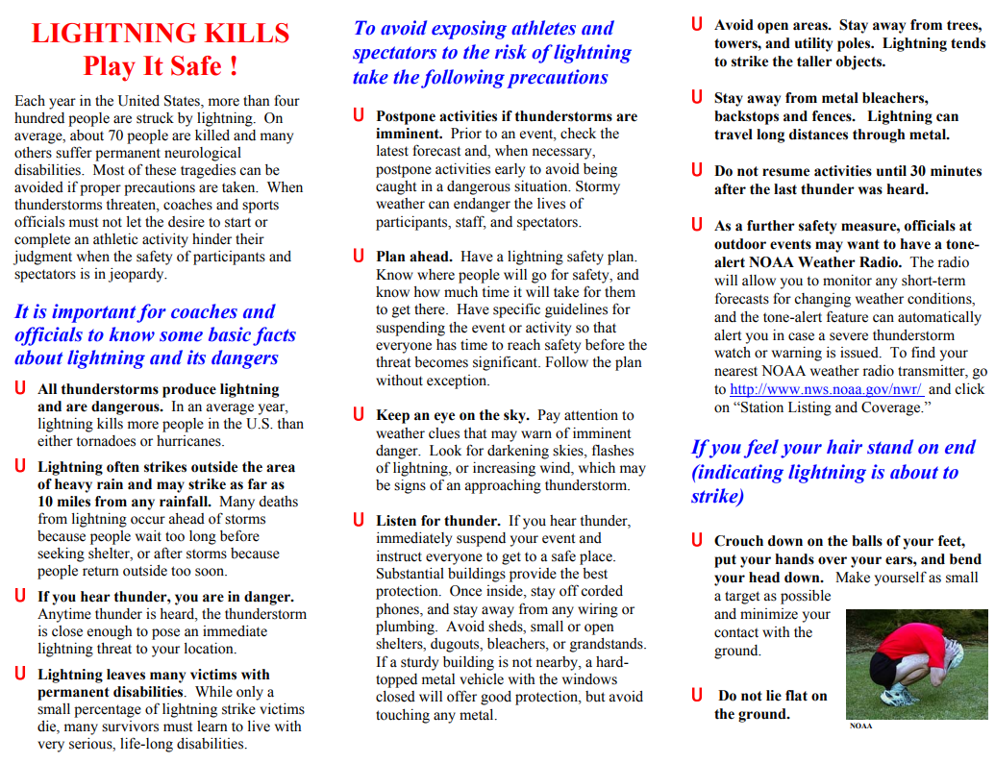
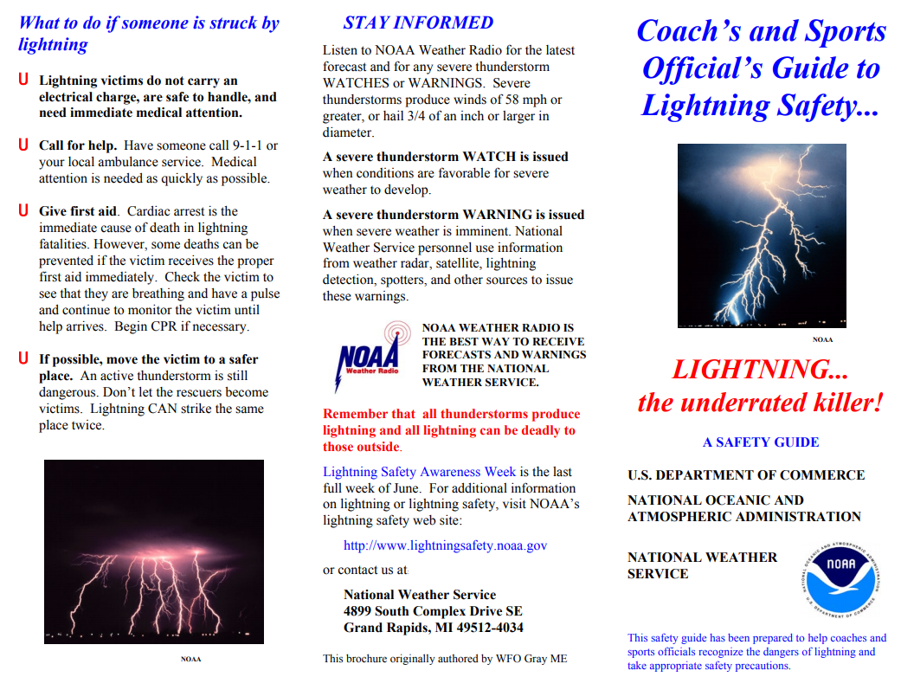

Ground Rules
The following ground rules apply to all leagues and games except where noted.
- All garbage should be disposed of properly in the provided containers around the property.
- All weekday games will start promptly at 6:00 pm. All pregame activities will be accomplished according to the following schedule:
  - Visiting team warm up
  - Home team warm up
  - Field preparation
  - Roster & line up to umpire; weather decision
- The first game on Saturday will start at 10:00 am. Length of Saturday games will be consistent with agreed upon duration rules for all divisions. All pregame activities will be accomplished according to the following schedule:
  - Visiting team warm up
  - Home team warm up
  - Field preparation
  - Roster & line up to umpire; weather decision
- Once a game has started only one person, manager or coach will be allowed to the foul line in the case of a dispute or visit the field.
- Managers and coaches in the Majors and Minor Leagues are only allowed to cross the foul line to visit the mound or attend to an injured player once the game has started.
- Both teams are responsible for the field before a game and grooming the field after each game.
- Both teams are responsible for cleaning up the grounds and emptying the trash cans after each game.
- Consistent with Division rules, NO inning shall be started after 8 p.m. The umpire must call the game.
- The home team shall be responsible for providing the official score keeper, putting away game and other miscellaneous equipment after all games. Home team will also be responsible for taking down the flag after a night game.
- Weather decision will be made by 5:00 for evening games and 9:00 for Saturday morning games. Managers and players for both teams must show up at the field.
- Managers must give a complete line up to the umpire or league official by 5:50 (9:50 for Saturday games). All players on the lineup must be present. Teams unable to field a full team by game time or other time agreed upon by both managers may be required to forfeit the game.
- All postponed games are to be rescheduled by the league with consideration given to both managers.
- If a player is absent from school due to illness or injury, that player is not eligible to play a game that day.

CODE OF CONDUCT
Speed Limit 5 mph in roadways and parking lots while attending any Duanesburg Little League function. Watch for small children around parked cars.

No Alcohol allowed in any parking lot, field, or common areas within the Duanesburg Little League complex.

No SMOKING or Tobacco products of any kind (including spit tobacco) allowed in any common areas within the Duanesburg Little League complex.

No Playing in parking lots at any time.

No Playing on and around lawn/maintenance equipment.

No Profanity allowed in any parking lot, field, or common areas within the Duanesburg Little League complex.

No Swinging Bats or throwing baseballs at any time within the walkways and common areas of the Little League complex.

No throwing balls against dugouts or against backstop.

No throwing rocks and no climbing fences.
Only a player on the field and at bat, may swing a bat (Ages 5 - 12).

Observe all posted signs. Players and spectators should be alert at all times for Foul Balls and Errant Throws.

During game, players must remain in the dugout area in an orderly fashion at all times.

After each game, each team must clean up trash in dugout and around stands.

All gates to the field must remain closed at all times. After players have entered or left the playing field, gates should be closed and secured.

No children under age of 16 are to be permitted in the Snack Bars.

Failure to comply with the above may result in expulsion from the Duanesburg Little League field or complex.


Hey Coach! Have you…
- Walked the field for debris/foreign objects?
- Inspected helmets, bats, catcher gear...?
- Made sure a First Aid kit is available?
- Checked conditions of fences, backstops, bases, and warning track?
- Made sure a working telephone is available?
- Held a warmup drill?
- Completed the Pre-Game Check List?



Home Team Rules
- The home team will be responsible for providing official score keeper and game announcer.
- The home team will be responsible for lining the playing field.
- The home team will be responsible for putting up and taking down the flag, as well as putting away game and other miscellaneous equipment.
- The home team must rake the field after the game.
- Both home and visiting teams are responsible for cleaning and sweeping out the dugouts after each game.
- Both home and visiting teams are responsible for garbage removal from the trash cans near their spectator’s seating.
- Manager or coach of home team must stay with concession workers until closing is complete.
- As a courtesy to the umpires, if the game will undoubtedly be called due to weather, please notify umpires at least one hour (or more) prior to the game.
- An ideal situation would be created, if the visiting team would participate in the above noted home team responsibilities, the numerous requirements of the home team would then be shared.

EQUIPMENT CHECKLIST
KEEP YOUR PLAYERS SAFER

Do you know what equipment is required for player safety on the field? Do you know which optional items can help keep players safer? Check out the following list for ideas and reminders.

REQUIRED PLAYER EQUIPMENT
Defense
❑ Athletic supporter – all male players
❑ Metal, fiber, or plastic type cup – all male catchers
❑ Catcher’s helmet and mask, with “dangling” throat guard; NO skull caps – all catchers; must be worn during pitcher warm-up, infield practice, while batter is in box
❑ Catcher’s mitt – all baseball catchers
❑ Chest protector and leg protectors – all catchers; must be worn while batter is in box; long model chest protector required for Little League (Majors) and younger catchers

Offense
❑ Helmet meeting NOCSAE standards – all batters, base runners, and players in coaches’ boxes
❑ Helmet chinstrap – all helmets made to have chinstrap (with snap buttons, etc.)
❑ Regulation-sized ball for the game and division being played; marked RS for regular season or RS-T for regular season and tournament in baseball
❑ Regulation-sized bat – all batters; Little League (Majors) and younger baseball divisions must have bat marked with BPF 1.15 beginning in 2009
❑ Non-wood bats must have a grip of cork, tape, or composite material, and must extend a minimum of 10 inches from the small end. Slippery tape is prohibited.

REQUIRED FIELD EQUIPMENT
❑ 1st, 2nd and 3rd bases that disengage from their anchors
❑ Pitcher’s plate and home plate
❑ Players’ benches behind protective fences
❑ Protective backstop and sideline fences

OPTIONAL PLAYER EQUIPMENT
Defense
❑ Metal, fiber, or plastic type cup – any player, esp. infielders
❑ Pelvic protector – any female, esp. catchers
❑ Heart Guard/XO Heart Shield/Female Rib Guard – any defensive player, esp. pitchers, infielders
❑ Game-Face Safety Mask – any player, esp. infielders
❑ Goggles/shatterproof glasses – any player, esp. infielders or those with vision limitations

Offense
❑ Helmet – adults in coaches boxes
❑ Helmet with Face Guards or C-Flap meeting NOCSAE standards – all batters, esp. in younger divisions ❑ Mouth guard – batters, defensive players
❑ Goggles/Shatterproof glasses – any player, esp. those with vision limitations
❑ Batters’ vest/Heart Guard/Heart Shield/Female Rib Guard – any batter
❑ Regulation-sized reduced impact ball

OPTIONAL FIELD EQUIPMENT
❑ Double 1st base that disengages from its anchor
❑ Baseball mound for pitcher’s plate
❑ Portable pitchers baseball mound with pitcher’s plate
❑ Protective/padded cover for fence tops
❑ Foul ball return in backstop fencing

VOLUNTEERS

BACKGROUND CHECKS
Procedure for Background checks is as follows:
- At the Annual team managers meeting the initial forms and driver licenses are turned in for any managers and known coaches.
- Coaches and new volunteers are entered into the JDP Background check system first to prioritize new unknown individuals.
- Manager background checks are run before the start of the first practice.
- Assistant coaches who are recruited by coaches are collected asap and turned to the safety officer to background check in order to utilize new volunteers for the start of practices.
- A list of eligible volunteers is shared with the Duanesburg Little League President as they become available.
- Any indications of risk in background check are immediately reported from the Safety Officer to the President of the Duanesburg Little League.
- The President and/or Safety Officer will notify the coach of any team of any person who is not able to pass clean through the background check.

REQUIRED ABUSE AWARENESS TRAINING FOR ADULTS
- In 2018, the “Protecting Young Victims from Sexual Abuse and SafeSport Authorization Act of 2017” became Federal law. As part of SafeSport, abuse awareness training has been highly encouraged for participants and volunteers in the Little League program.
- Beginning in 2024, this training will now be a required part of the annual Little League Volunteer Application, along with the annual background check. The training must be completed before any individual can assume any duties for the current season, including District Administrators and Assistant District Administrators.
- It is important that all volunteers in a league complete the training on an annual basis. Even though it may be a training an individual has completed in the past, it is important to keep the information that is taught through Abuse Awareness Training fresh in everyone’s mind. The more individuals involved in a league that have the information that Abuse Awareness Training provides, the better.
- Each league must determine which Abuse Awareness Training its volunteers must complete. USA Baseball’s BASE Abuse Awareness Training is a FREE online training that is SafeSport-compliant. This course can be completed in approximately 30 minutes online, producing a certificate of completion that you will share with the individual at your league who is responsible for overseeing your league’s background checks to verify you have completed the training. Regardless of which training program is used, each individual is responsible for providing their league with documentation to show that they’ve completed Abuse Awareness Training, annually.
- Visit LittleLeague.org/SafeSport for information on how to access the USA Baseball’s BASE Abuse Awareness Training and for more information on this Federal law.

OTHER EDUCATIONAL RESOURCES FOR PARENTS
- As a Little League parent or volunteer, you can play a crucial role in helping to keep all children safe. The free resources listed below are tools to educate and raise awareness of the potential dangers children may face. You are urged to review these resources and arm yourself with additional knowledge on how to protect children.
  - Helping Parents Prevent Abuse | U.S. Center for SafeSport
  - Parent Toolkit | U.S. Center for SafeSport
  - Safe to Compete
  - Bullying 101: Understanding and Responding | Resources | USAB Develops
  - Emotional & Physical Abuse & Misconduct Toolkit | Resources | USAB Develops
  - Nothing Heals Like Sport | Center for Healing and Justice Through Sport
  - Resource Guide on Preventing Child Sexual Abuse in Youth Sports | LA84 Foundation
The safety and well-being of all participants in the Little League program is paramount, and we hope that this latest evolution of our Child Protection Program will continue to provide tools and resources to help keep our Little League communities a safe, welcoming environment for all children and families.

BAT CHARTS
Minors & Majors | USA Baseball marking  2 5/8” barrel maximum  *Approved Tee Ball bats may be used in coach pitch/machine pitch divisions only with the use of approved tee balls.
Intermediate (50/70) & Junior | USA Baseball marking or BBCOR marking  2 5/8” barrel maximum
Senior | ALL bats must be BBCOR

Tee Ball Bats
Starting on January 1, 2018, all Tee Ball bats in the Little League Baseball® Tee Ball program must feature the USA Baseball mark and accompanying text. Tee Ball bats for Little League Softball® Tee Ball programs must follow the Little League Softball Official Regulations, Playing Rules, and Policies.

