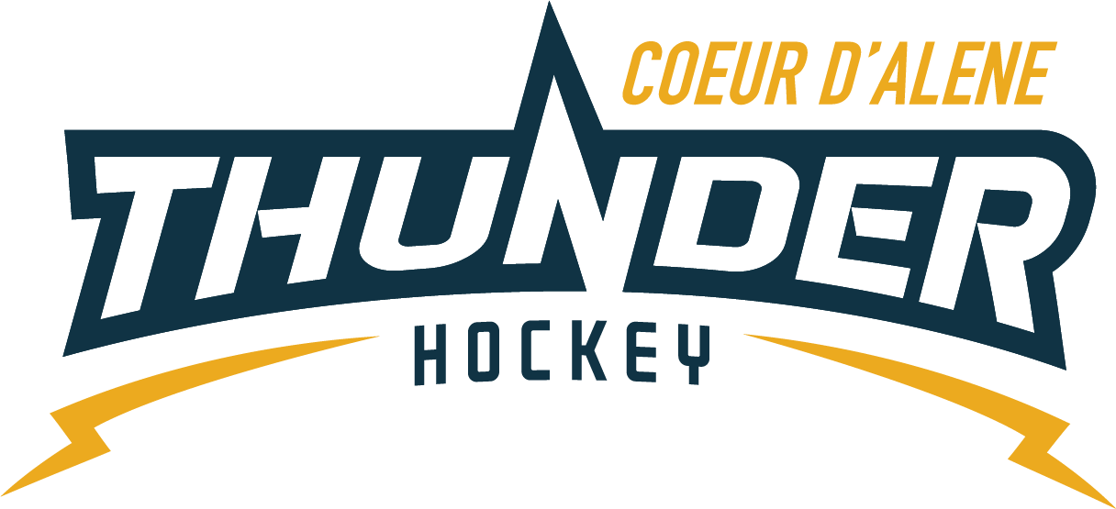

CDAHA

Meeting minutes
Location: Frontier Date: October 27 2021
Attendees: Bob Nelson, Katie Lovitt, Will Higgins, Megan Smith, Elliot Taub, Matt Creighton, Matt Fisher

Absent -, Jarred Hansen, Josh Leppert
Guest – Joe White, Kami Winfrey, Torsten Langley
- Call to order
Matt Creighton , Vice President called meeting to order 10/27/21 6:33PM
- Roll call
As stated above -
- Approval of minutes from last meeting
Minutes approved motioned by Megan Smith– Second by Bob Nelson passes unanimous
- New Items
- Treasurers Update
  - Missing Ice invoice since August
  - See attachments
  - CPA completed taxes of 500.00 – Motion to pay 2020 taxes by Elliot – second by Fisher
  - Katie will provide a copy of Tax Return for review
  - Raffle drawing completed -280 dollars towards CDAHA – lost 1000.00
  - Still working on correcting registrations
C) Coaching Committee Update
      - HIS accounts have been sent out – keep tabs on coaches so we can see if they used it – do an exit interview with coaches and see if they like it.
      - Recgroup to all coaches Joe is evaluating and sharing
  - Gear Committee Update
- No update
  - Discipline committee update
- No update
  - Safesport update
- Torsten relocating to Florida
- Handed out signs for doors

- Scheduler Update
  - 180 games scheduled
  - Jenifer is entering all the games and everything seems good
  - Referees should be good – can use internal support to verify –
  - Check frontier site if something is wrong call Kami

- General Updates
  - Jarrod Hansen BOD member has decided to resign and submitted his resignation via email to Matt Creighton. Majority voted to remove Jarrod and not
  - State registrar resigned – no change in process still goes to April
  - Team decision on travel based on restrictions we are not asking about personal decisions we will be constant with our external communication about not mandating or requiring vaccinations.
  - Be careful on where we are traveling too – look at restrictions especially Seattle
  - Moving to every 4 weeks meeting next meeting is
  - Will put a sign up on window of room to run the skate sharpener – will train and show how to do it will blast out 5.00 cash or 50 punch card – might need some wheels for sharpening – Megan will make sign
  - Girls thank you – for having 12U games and opportunities
  - Golf follow up – Josh will follow up with the organizer and see how it went
  - XMAS – Skate coordinator – Jackie Peterson – Deanna will help and Matt to get Ice coordinate raffle etc…
  - No to chief vouchers or other fundraising right now
  - Record and show how to do score sheets and clock – record and train common problems
  - Bob motions to purchase 200 score sheets Josh seconds – Katie will order them
  - Look to get all teams into new style jerseys and work over the summer for a complete lease program
Motion to Adjourn Bob Nelson second by Megan Smith
Minutes submitted by: Elliot Taub
Minutes approved by: BOD
- Next Meeting
  - Wed Nov 17 2021 6:30PM
  - Megan motions to adjourn – Bob seconded

