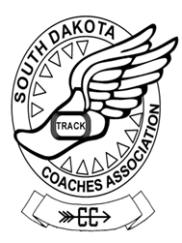

2022 SDCCTFCA AREA CROSS COUNTRY
COACHES OF THE YEAR

Area I COTY
- Class A – Eric Townsend – Milbank
- Class B – Jessica Larson – Potter County
- Area 1 - Assistant COTY – Derek Boeckelheide – Northwestern

Area 2 / East COTY
- AA East Girls – Tony Thoreson – Brandon Valley
- AA East Boys – Luke Jelen – Sioux Falls Lincoln
- Class A – Luke Vander Leest – Sioux Falls Christian
- Class B – Julie Eppard – Chester Area
- Area 2 - Assistant COTY – Mike Putnam – Brandon Valley

Area 3 – COTY
- Class A – Stephanie McCord – Kimball/White Lake
- Class B – Larry Buffington – Gayville/Volin
- Area 3 - Assistant COTY – Valerie Nelson – Chamberlain

Area 4 / West COTY
- AA West Boys – Jesse Coy – Rapid City Stevens
- AA West Girls – Blake Proefrock – Sturgis
- Class A – Russell Cournoyer – Red Cloud
- Class B – Ralph Kroetch – Philip
- Area 4 - Assistant COTY – Matt Osbourne – Aberdeen Central

