Roll Call:
Executive President- Kirby Brownfield Treasurer- Beth Davis
Coaching Coordinator- Pete Just Secretary- Ginnette Romkey
Guests Webmaster- Lori Cook
Fusion Representatives: Alyssa Mehltretter, George Kiernan, Barabara Clark
Greenville Warriors Representatives: Jessica Bagley
Charleston Representatives: Stacey MacDonald, Lori Cook, Star Jordan
Ft. Mill: Karen Barber
- Call to Order
- Approval of previous minutes Lori, Beth and Jessica 2nd motion
- Treasurer Report
- Balance 3397.75 as of 8/12/23
- Has not yet received refund yet from SE, approx. 600.00
- Received info from teams and sent to accountant for tax return, should have ready in September and will file by November 15th. State registration for charitable designation and raffles are due also due in fall.
- Updating new team managers for banking access, will provide information to Beth to set up.
- Registrar’s Report
- Registrations will go live soon for Nationals, they have been created in SE and just need to be reviewed. Palmetto will soon be created, takes 5 days to be completed.
- Terri Mills- informed that Highschool eligibility in their championship book at start of season.
- Greenville Hockey Volunteered to support Fusion’s roster for first tournament; if unable to get all school forms due to schools not being open yet. Will disband after first tournament.
- Portal is now open to create rosters.
- Secretary’s Report Unfinished Business
- As a reminder, the changes we had been discussing throughout the 2022~23 season were:
  - Rule changes NOT made from the end-of-season meeting last year regarding:
    - Pool players be assigned by September 1 each season.
    - Having the schedule published by September 1 each season.
    - Using electronic scoresheets rather than paper forms.
- Vice President’s Report/Discipline
- Vacant position
- Disciplinary review and any carry over from penalties from last year.

- CAHA Disciplinary Rules-
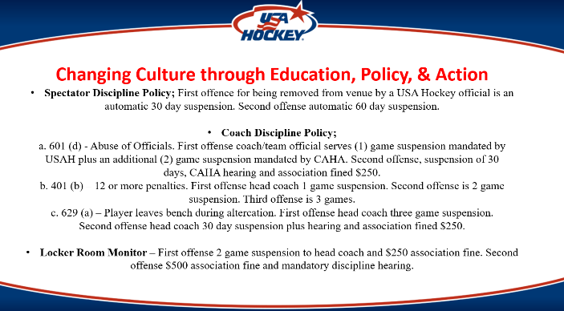 | 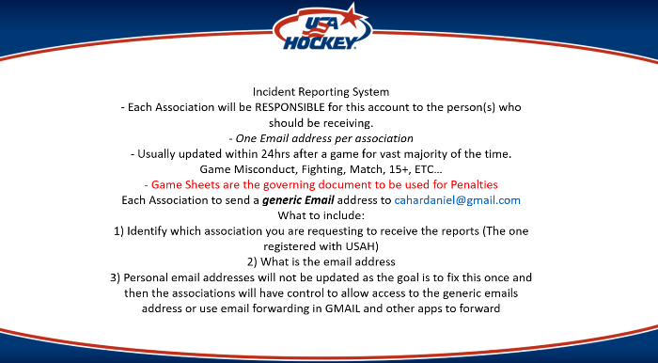
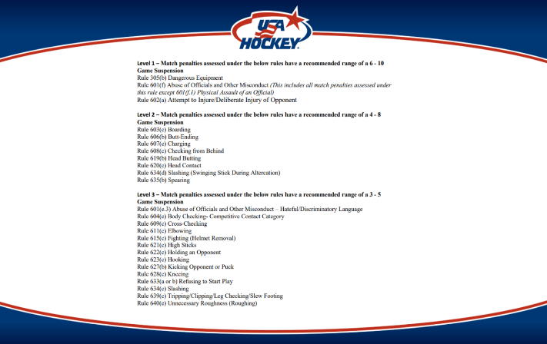 | 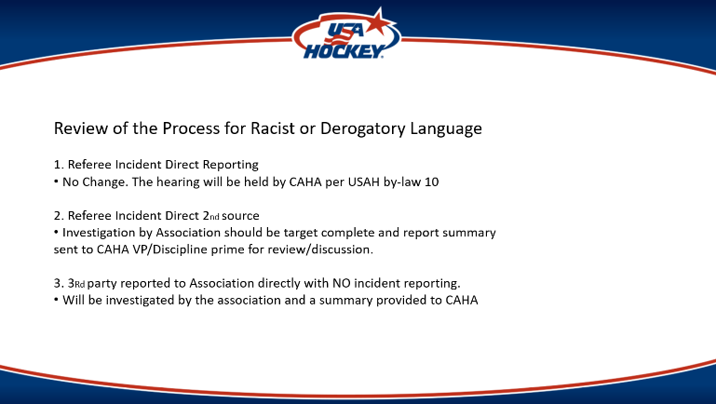
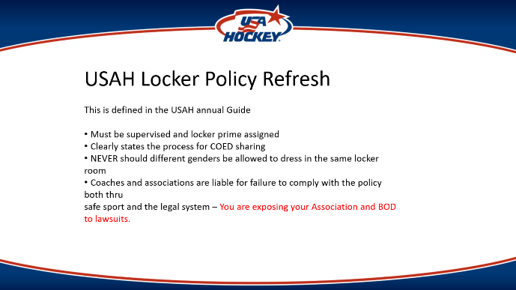 | 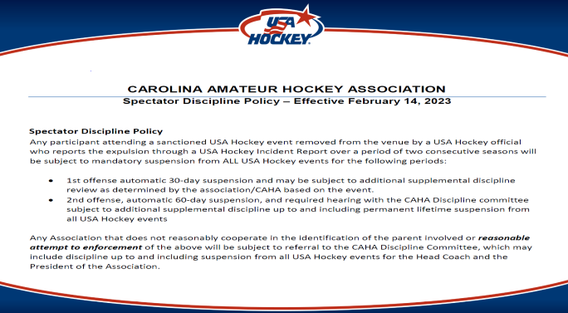
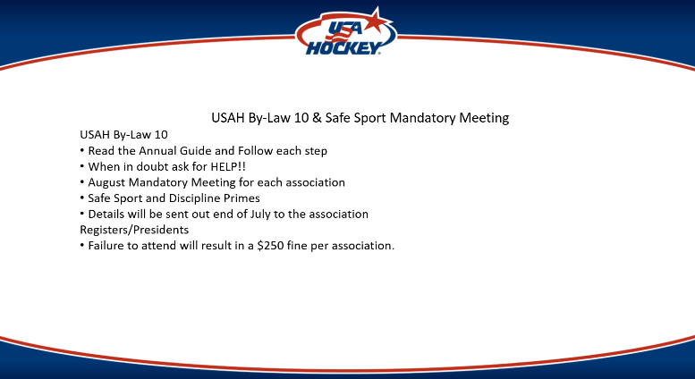

- Fines are initiated this season for abuse of officials- we need to vote on who pays these fees
- Discussion regarding Parents being ejected- TM will need to monitor and report to SCSHA
- All ejections and suspensions carry over to the next season.
- Need to create volunteer registration for LRM
- Creating culture of non-violence in Highschool League Hockey
- Locker Room Policy
- Safesport Locker Room Monitors – must have minimum of 1 adult in the locker room at all times. They need Safesport and background checks. Female locker rooms need to be covered.
- USA Hockey is being audited by USOPC for background screening and safesport
- 65% of Safesport issues arise from the locker room
- Team Census
National:
Charleston Mariners- 23 and 2
Head Coach- Chris Matson
Holy City Rebels- 18 and 2
Head Coach- Jordan McLean
(Side note -Need fluidities of line for Charleston, is cooper river, but should have fluidity been 85 or Ashley
Should be declared by start of season. Goalies need to be fluid )
Columbia Fusion- 16 and 2
Head Coach- George Kiernan
Greenville Warriors- 19 and 3
Head Coach- Eric Kenney
Fort Mill Ice Jackets- 15 and 2
Head Coach- Ted Reilly
Palmetto:
Charleston Ice Raiders- 18 and 2
Head Coach- not yet finalized
Columbia Fusion- 10-2
Head Coach-Chris Mehltretter
Greenville Warriors- 10-1
Head Coach- Josh Singley
- Pete will need full coaching staff list.
- Discussion on commitment date for Fort Mill.
- Kirby- Motion to allow Fort Mills Home Games to be at 10:15
2nd Jessica
Passed with Majority
- Kirby- Motion- to allow Columbia Fusion to retain Nate Clark to return to Fusion for the 2023-2024 season as long as he is released from Fort Mills Ice Jackets
2nd Beth
Passed with Majority
Fusion and Ice Jackets sustained from voting.
Ice fees-
Columbia 375 per hour plus 50 ice cut with back to back games
Greenville 367 per hour
Charleston 365 per hour
Fort Mill 450 per hour
- New Business
Resignation of VP Andrew Foster- next steps
Andrew resigned 8/12/23.
Bylaws- can appoint, make lateral movement and then at end of season we can elicit bio and vote.
Ginnette to laterally move to VP
Season Schedule/Date of Completion
TM- have request ice spots
Need someone to initiate schedule
Ginnette to initiate scheduling, black outs and ice schedule by 8/13
Will start with first ice time. September 29th
Would like completed by 9/1/2023
EOS Tournament Dates and Tournament Set up
March 1-3
Lori- motion to have EOS tournament March 1-3 weekend
2nd- Stacey and Jess
Vote- passed with majority
Kirby to request CHL have 16u A and AA in Charleston
Kirby- motion to amend appendix K in rules to add Hobey Baker
2nd- Beth and Lori
Vote- passed with majority
Tournament Bracket Selection (Single Elimination? Round Robin?)
Kirby and Beth to reach out to CAHA to request update on options for EOS format
Location- Charleston for 2024
Must vote on by 14 days prior to start of season
GroupChat /Communication Via Sports Engine
Everyone to sign up
Website Maintenance and use per team
GVL is only NON profit, all other teams should have access to use website as home base. We need to create pages per team.
We need to honor all of the league accomplishments
Team managers- access to pages
Updated access- removed
We Honor the Game Awards (CAHA)
We need to do better at show casing our players
Limited Goalie Discussion (8th Grade)
Having 8th graders practice with Highschool
Terri Mills per USAH says 8 graders cannot participate in any team events- off or on ice. Can impact eligibility for Nationals.
Additional games Palmetto Level
Is it possible for us to increase game counts?
Look to schedule 10 games, not including state weekend
Crossing the border to NCSHA friendlies
AAA players
The officials were not prepared
Fusion had players injured
Make sure you have 4 skilled refs
Do they need these games to qualify for Nationals?
National team can do up to 2 tournaments to support counts to game counts outside of league play.
Season: September through March
CAHA Grant Submission
Kirby spoke to Robert and Greg with CAHA and requested if we could put in a grant to support the 4th.
Ginnette to complete grant application
Scholarships
Application needs to be updated, Kirby to create policy. Executive board reviews application. Funds come out of General League funds.
- Voting Items
- New Association Logo
Kirby- Motion to adopt new logo
2nd Lori and Beth
Vote- passed with majority
- All Star Jersey
$32 all in for jersey, league fees
Kirby- Motion to adopt new player jersey for All Star Jersey
2nd Barabara and Lori
Discussion- can league cover cost of jersey, t-shirt will be replaced by jersey
Vote- passed with majority
- Game sheet
Kirby- Motion to adopt Gamesheets as our scoring program for the 2023-2024 season
2nd- Barbara
Vote- passed with majority
Discussion- Paying for gamesheet will come out of the team registration fee of $650 for National and $550 for Palmetto. Fees with stay the same.
- Tournament Format
Tabled, Kirby to gain update from CAHA
- Playoff Discussions
Tie Games
Current rule is 10 minute 5 on 5, 2-minute rest and then continue with 5-5 until winner is declared.
Lori- proposed change to rule to 4v4 for 5 minute stopped clock, 2 minute rest, 3 v3 for 5 minute, then shoot out of 5 players and after that refer to rules.
2nd- Stacey
Vote- motion passed with majority
- Officials
Lori- Motion amend officials to 4 man system for National level
2nd- Stacey
Vote- passed with majority
- Playoff Committee
Jess- Motion to update verbiage for Playoff committee to include SCSHA
2nd- Pete
Vote- passed with Majority.
- Playoff Brackets
Motion to amend playoff brackets to include recommendations from CAHA
2nd- Beth
Vote- passed with majority
- Ice Payments
Kirby- Motion to have ice responsibilities is 100% on team managers, if rinks have issues Beth will be back up for rinks to access payment. TM to provide Beth’s contact info at start of season to rinks. Money is due at game time.
2nd- Jess
Vote- passed with majority

- Pool Players

Kirby to update forms and distribute to group for discussion

- Scholarships

Ginnette to update forms and distribute.

- Open Discussion

Beth- during all games you need to have a Team Announcement page for home and away games.

- Dismissal

Next Meeting date: September 12th at 7pm

Compiled by- Ginnette Romkey SCSHA Secretary

