
MINUTES TO BE APPROVED AT THE NEXT BOARD MEETING. THESE MINUTES ARE NOT CURRENTLY POSTED AND SHOULD NOT BE DISTRIBUTED UNTIL APPROVED BY USASSCS BOARD.
Board Meeting Minutes December 11, 2023
Location: Santee City Hall
Attendees Shown with Marked Box
President | Jay Strandberg | x | Field Prep | Kevin Hopkins | x
1st VP/ Field Prep | Erik Ruiz |  | Field Prep | Trevor Henton | x
2nd VP | Kelli Timanus |  | Field Prep | James Timanus
Treasurer | Tiffany Lynch | x | Field Prep | Nate Anderson
Secretary/Safety Coordinator/Head Scorekeeper | Bryan Scholar | x | Field Prep | Brad Allen | x
Tax Advisor | Lori Britt |  | Field Prep/Equipment | Shane Frary | x
Player Agent | Lance Craw | x
UIC/Parliamentarian | Felicia Leca | x | Head Team Parent Coordinator | Dana Hisaw | x
Field Scheduler/Fall Ball Coordinator | Chris Klima | x | Uniform Coordinator | Jamie DeChant | x
Webmaster/Social Media/All-Star Coordinator | Alexis Ruiz | x | Picnic Coordinator/Pictures | Kat Vecchione
BOTH Tournament Coordinator | Kayleigh Ponciano-Ahue | x | Snackbar #1 | Amy Ramirez
Sponsorships | Kylee Scholar |  | Snackbar #2
Awards | Janis Aiello | x | Social Media Coordinator | Sophia Vigil | x

Guests: N/A
Meeting called to order: 7:03PM
Meeting rule – One Topic at a Time
Financial Update (Tiffany L)
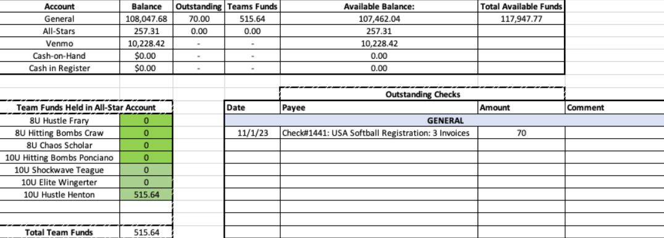

Snack Bar
- Deciding what to do with the soda machine – continue to use Coca-Cola or switch to Pepsi
Other Items
- Rule Change proposed – lowering pitching inning per week allowed in 10U division from 8 innings per week to 7 innings per week (Will be looked at again during January board meeting)
Spring Select:
- Select Managers and rosters to be approved at next board meeting on January 9th
  - Once rosters are set, players cannot leave a team to join another team unless approved by the board
Spring Rec Schedule:
Manager Interviews – Completed by 1/8
Evals- 1/13 & 1/14
Manager Meeting- 1/17
Draft – 1/18
Practices Begin – 1/22
Team Parent Meeting 1/30
Scorekeeping Meeting 2/6

Fields/Equipment – New batting cage fenced area completed to store equipment that will be more secure

Meeting Adjourned: 8:36 pm
Next Meeting: January 9

