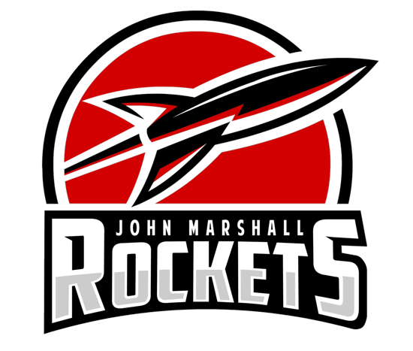

Girl’s Swim and Dive
PAC Meeting Info
- Contact Information
- Photography
- Practices and Meets
- Bagel/Snack Info
- Jimmy Johns
- Team Suit/Team Store
- Homecoming Float
- Social Media Info
- Senior Night/Parent Night

Contact Information

Coaches:
Coach Lauren - swimming: laurenrkalwasinski@gmail.com
Coach Julia - diving: mecordes2@gmail.com
Captains: jmcaptains16@gmail.com
Shannon Penney: (507)993-1424
Olivia Ruzek: (507)513-1655
Brianna Farmer: (507)421-3516

Photography

- If you or your daughter is not comfortable being photographed, email us at jmcaptains16@gmail.com
- The links the photo albums will be posted in the groupme and on our captains website
- Photos will be posted on instagram, but if anyone is uncomfortable, they will be deleted
- Yearly swim/dive photos by Ann Eldredge
  - September 16th during practice - The order form will be sent in emails closer to the date

Practices and Meets

- Build each other up!
- Positive environment!
  - Otherwise, girls or parents contact captains
- Bring basics: water bottle, suit, towel, change of clothes, goggles, cap, etc
  - Snorkel and fins
  - For diving, only need suit and towel, shammy is optional
- Home Meets
  - Warm ups take place about an hour before
  - Plan to be there at 4:45
- Away Meets
  - Bus usually leaves at 4
  - Plan to arrive at the JM athletic entrance 15-30 minutes before the bus leaves to get bagels!
  - Captains will communicate via Remind when they are 20 mins away from JM on the way back

Bagel/Snack Info

Sign Up: using the printed sheet tonight or the link to the document sent in the weekly emails
Before away meets
- Bagels and Gatorade
- Bring the bagels into the John Marshall Athletic Entrance by 3:30-3:45
After home meets
- Snacks for the opposing team and JM
- Range from bananas to granola bars
- Parents pass them out after so that the snacks are taken

Jimmy Johns

- Dinner for bus ride home
- You are not required to order Jimmy Johns
  - If you don't, you should send something for your daughter to eat after the meet
- We will send out an email a couple of days before the meet reminding you to order your food
- When ordering from Jimmy Johns you should order a day or two ahead of time to allow the order to process. The instructions to do this will be sent out every time we email to remind you of the upcoming meet and link below.
https://docs.google.com/document/d/1nOEUal43QpVAdM4zHpgmAWWcaI7o7FJ6IdrnGtnhtfQ/edit?usp=sharing

Team Suits/Team Store

- Team suit: https://www.swimoutlet.com/products/tyr-womens-hexa-trinityfit-one-piece-swimsuit-8187888?color=blackred&from=w
- Swim Outlet
  - We have a team store that allows part of the proceeds to go to our program!
  - Go to swimoutlet.com
  - Select teams, search Rochester, MN and click on Rochester John Marshall (the one with the picture)

Homecoming Float

Theme: There will be a survey posted in the groupme for girls to give their ideas
More information will be sent out later as we approach the date!
Homecoming Parade: Sept 20th
If we need a driver, your daughter or the captains will reach out to you

Social Media Information

Remind:
Parents: Text 81010 to @jmltexts
*You must include the @ in your message!
**Remind will be used to notify parents of approximate return time from meets and other small reminders

Instagram: @jmlgirlsswimanddive
GroupMe: captains will add swimmers/divers to the group
*If your swimmer/diver is not added to the GroupMe yet, please notify a captain. Also make sure they download the app--it’s free and easy to use!

Website: https://jmcaptains16.wixsite.com/mysite

Athletic website:
https://www.johnmarshallrockets.org/page/show/5803320-girls-swim-regular-season-

Senior Night/Parent Night

- October 10th
- Celebrate Senior(s) w/ slideshow of future plans and favorite memories
- Parent night: Each girl will be called up to hand a gift to each parent to show their appreciation for you all :)

