 Eagan Baseball Boosters
Booster Meeting: March 4, 2026
Booster Club Members: Steve Butler - Head Coach
Matt Boyd & Jennifer Williams - Co-Presidents
Seth Wigley - Finance Director
Erin Ayers - Communications Director & EBA Liaison
Parent Social:
Mark your calendars & join us for a fun night for our Cats parents & fans at Union 32 Craft House! Let's get together and get excited for the upcoming season!
Event Details:
• Saturday, 3/7/26 from 6-9
• $30 (Includes 2 drink tickets and automatic entry into a raffle drawing). $5 for each additional ticket. • Grand Prize: 4 Twins Tickets, chips party, Milwaukee Heated Vest, and Milwaukee Tool. Other prizes include sunglasses, Twins hat, Twins socks.
Other Upcoming Events:
- Last Captain’s Practice 3/8/26 with Team Store orders to be handed out
  - Arm Care Week- Week of March 09-14, 2026
- Spring Salt Sales 3/14-4/10
- Pick-up dates/times: Saturday 4/25/2026 (Freshman & Sophomores) & Sunday 4/26/2026 (JV & Varsity)

Treasurer Report:
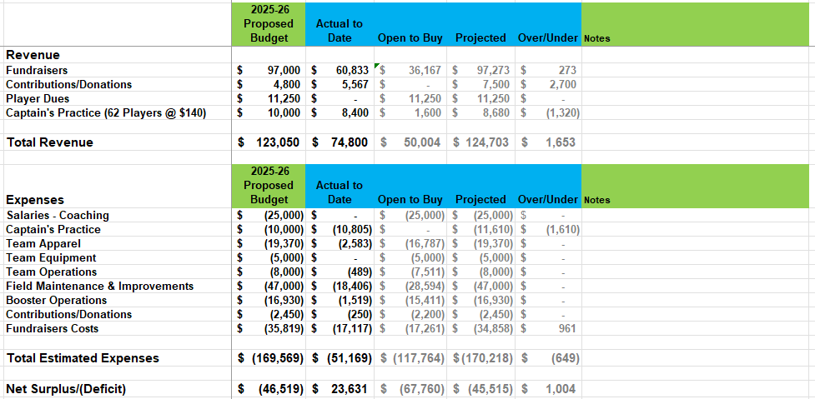
Diamond Raffle #’s:
- Total # of tickets sold: 1,579 from 66 sellers
- Total Raise: $31,580
- Players who sold over 25: Ethan Benedict 55, Ari Edgeton 41, Darwin Prado 39, Kellan Crews 38, Trevor Judo 37, Parker Pangier 35, Ben Williams 32, Ashton Sonnee 29

