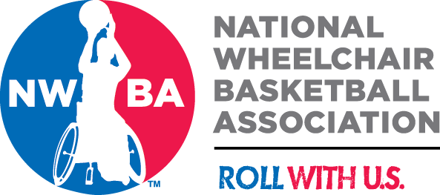

Wayne Kunishige Memorial Scholarship

Call for Applications 2022

The National Wheelchair Basketball Association is pleased to announce the 2022 Wayne Kunishige Memorial Scholarship. The scholarship will be presented to a NWBA player who is a high school senior and planning to attend college or other educational endeavors.

The Wayne Scholarship honors Wayne Kunishige, a long time NWBA member, who died in December of 2000. When Wayne was 15, he sustained transverse myelitis while playing in a church league basketball game. He fell on the court and never walked again, living his life with a spinal cord disability. He never lost his love for the game and while in high school and college in Fresno, CA he played for an adult team, the Valley Freewheelers as there were no Junior programs at that time. He later started the Fresno Red Rollers, and achieved a lifelong dream when his team won the national championship at the 47th NWBT in 1995. Wayne graduated from California State University, Fresno and worked in the health care field his entire career. He spent nearly 20 years working for Sunrise Medical Quickie Wheelchairs, where he was Vice President of Advanced Development and one of the innovators of the Quickie line of sports wheelchairs.

Wayne’s family and friends endowed this scholarship in his memory, in hopes that it would help another young wheelchair basketball player get a start in life.

The Scholarship:
• $1,000 cash scholarship

Application Criteria:
• High School Senior
• Rostered member of an NWBA team
• Minimum 3.0 cumulative grade point average
• Involved in extracurricular activities
(schools, church, volunteer, community, sports)
• Write a 500-word essay on the topic “How Wheelchair Basketball Has Impacted My Life”
• Submit a Wayne Scholarship Application and Essay by February 25, 2022

All award recipients will be announced at the 2022 NWBA Toyota National Varsity Wheelchair Basketball National Championships in Wichita, KS

2022 Wayne Kunishige Memorial Scholarship Application

Name:

Mailing Address:

E-Mail Address:

Telephone Number:

Date of Birth:

Parents’ names:

High School name and address:

NWBA Team (name and years played):

Name of College/University or Training program you will attend in Fall 2019:

Have you been accepted for entry? Yes No
(verification of enrollment will be required prior to issuance of scholarship check)

Have you received any other scholarships or financial assistance?

Describe the extracurricular activities that you have been involved in over the past five (5) years (attach separate page if needed):

What are your career plans?

All applicants for the Wayne Scholarship must submit the following documents by application deadline on February 25, 2022:

- NWBA 2022 Wayne Scholarship application form

- Official copy of your official high school transcript

- Letter of support from your NWBA team Coach

- An essay (up to 500 words)“How Wheelchair Basketball Has Impacted My Life” (this essay must be your original work, it must NOT be edited or reviewed by anyone before submission).

Submit application packet to:
ttigger9750@gmail.com
or
Toni Tyner
Wayne Kunishige Scholarship Committee Chair
9750 N. Hayston Avenue,
Fresno, CA 93720

NOTE: All documents, except the official high school transcript, should be submitted in one PDF file. Please compile all documents into a single PDF and attach to an email. Confirmation of receipt will be provided. Sealed official high school transcripts may be sent by US mail or emailed directly from the school.

All applications must be received

by February 25, 2022

For questions or additional information, contact Toni Tyner:
ttigger9750@gmail.com
(559) 284-7004

