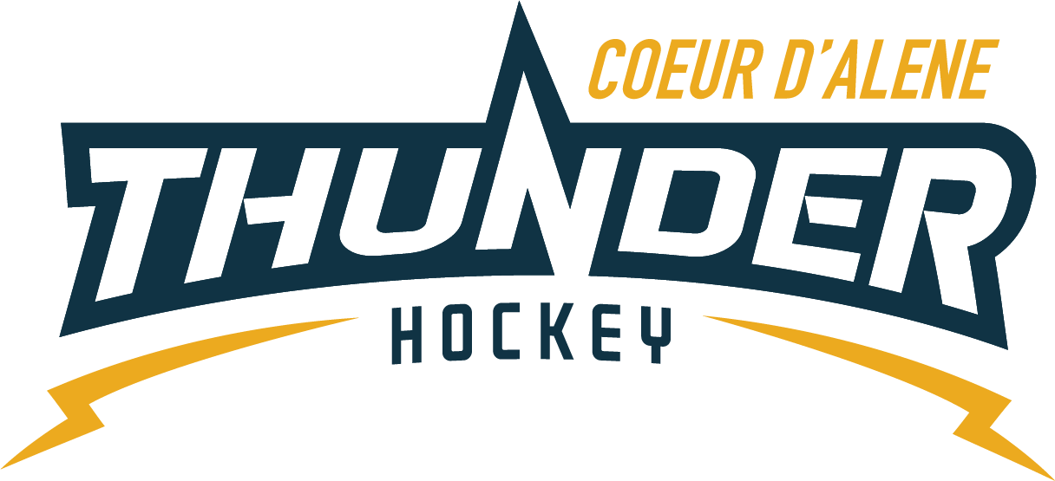

CDAHA

Meeting minutes
Location: Frontier Date: September 29 2021
Attendees: Bob Nelson, Katie Lovitt, Will Higgins, , Megan Smith, Elliot Taub, Matt Creighton, Matt Fisher
Absent -,Jarrod Hansen, Josh Leppert
Guest - Jennifer Frame, Kami Winfrey
- Call to order
Matt Creighton , Vice President called meeting to order 9/29/21 6:33PM
- Roll call
As stated above -
- Approval of minutes from last meeting
Minutes approved motioned by Bob Nelson– Second by Megan Smith passes unanimous
- New Items
- Treasurers Update
  - See attached documents
  - No other updates – from
C) Coaching Committee Update
      - No update
  - Gear Committee Update
    - 22 sets leased out sold 3 helmets money to go to Katie general fund –
    - Follow up with Josh on sharpener – get list posted on door
    - Check out puck bag vs going in and out o room – Matt will confirm who and what access
  - Discipline committee update
- No update
  - Safesport update
- Matt will call torsten and we are really behind the ball on planning for season – must have volunteers , badges, signs etc…policy and email blast must happen
- restrict parents from locker rooms – Joe discussed this with coaches – some exceptions for skate support at squirt
- Acknowledge and protect coed players at all ages
- Coaches ultimately responsible for actions and prevention
- All teams – no cell phones – policy – Megan will make posters for wall of door
  - Scheduler Update
- Monday at 5pm Oct
- 6 mite teams – up to 4 at a time on the ice
- Will and Bob will coordinate mite games
- 10U Gray
- 10U Blue
- 10U Yellow
- 12 Gray
- 12U Blue
- 14U Blue
- 14U Gray
- 18U House
- 18U Rep
- Girls 8 games for season
  - Pictures
- Quicksilver do it November 1st 2nd and 3rd all members so everyone can get pictures before XMAS – thanks Megan!
  - Academy dryland – 300 per month Tuesdays and Thursdays before practice - price to be added to rep team
  - Will have tryouts for midgets
  - Motion – for use of Academy for 300.00 per month for bantam travel and midget travel with proper coaching supervision by Bart – second by Bob – unanimous costs to be covered by the two travel teams
  - Looking at cross fit coaching and other coaching specialized for dry land–
  - Bantam house moves to M 8:4 -9:45 – for the rest of the season
  - LTP and Mite drop in / grow the game try hockey occasionally if possible as well 710-810 – Tuesday
  - Discussed WA state restrictions and not participating or asking our members their status on vaccination.
- Adjournment
Motion to Adjourn Bob Nelson second by Megan Smith
Minutes submitted by: Elliot Taub
Minutes approved by: BOD
- Next Meeting
  - Wed OCT 13 2021 6:30PM
  - Megan motions to adjourn – Bob seconded

