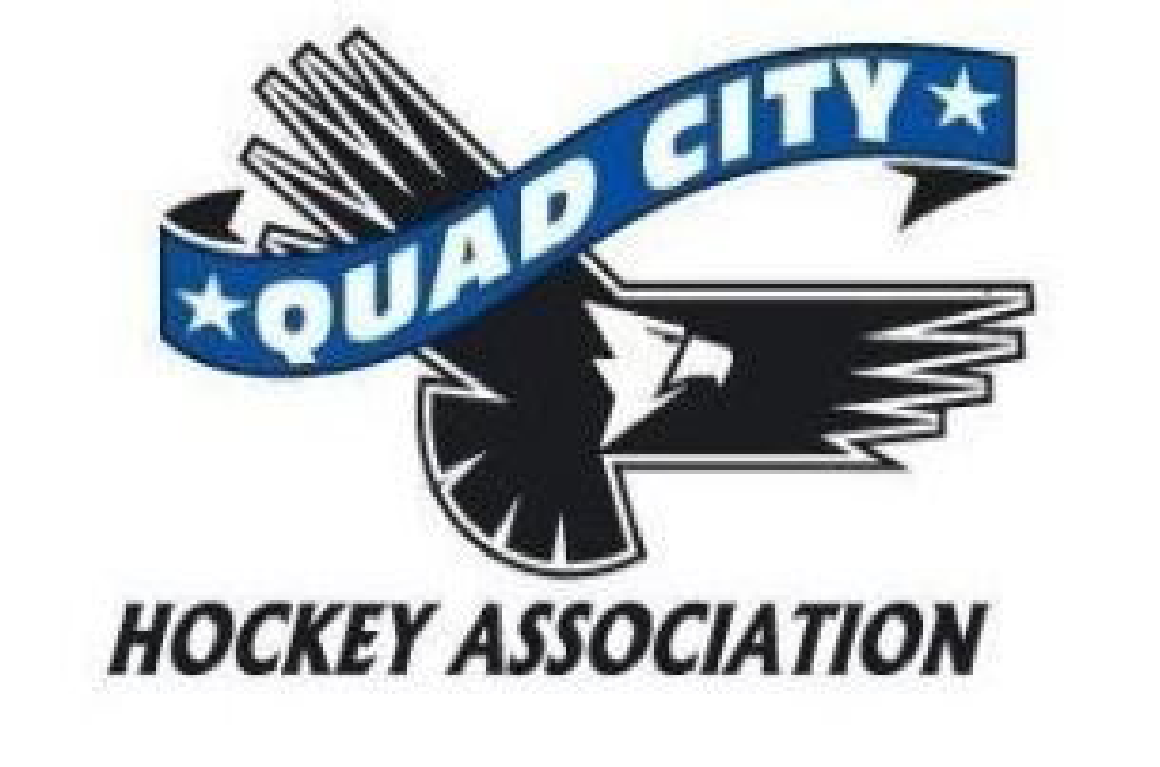
Minutes
Monday, June 12, 2023
6:00 pm River’s Edge Conference Room

10 min | Call to Order: 1803  Approved Absences – Andrew Quinn  Minutes Approved – Motion Kate Oswald, second Todd Ashby passed unanimously
45 min | Director Reports  President – Rich Oswald (15 minutes)  - New board members signing required paperwork  - Sorry about bumping the meeting by a week  - MWAHA summer meeting Rich, and Michelle attending for QCHA and Melody going as a SafeSport representative.  - At the meeting there is likely to be a vote on adding AAA teams joining MWAHA and Rich planning on voting no.  - Second sheet of ice needs to pass one more hurdle with a chiller barrel and then there would be ice starting in September if all goes well.  - July meeting is iffy and we would only have one if there is a contract to be signed with the city about ice costs and the second sheet.  - The Lawsuit is ongoing and is in the hands of the lawyers looking to put this back as a Rule 10 session.  - Thanks to Alaina Toporowski helping with moving some scheduling to help with the flooding.  Vice President – Andrew Quinn  Past President- Melody Wright  - No SafeSport issues at this time  - Centralizing to Des Moines as the place to play all levels of end of the year tournament.  - Group in Kansas that is looking to break off, but they are located farther into Kansas.  Treasurer – Megan Hoffman  - Motion by Melody Wright to make Megan Hoffman the signer on the bank account, Heather Tysma second passed unanimously other than one abstention by Megan Hoffman  - Working on the transition from Anne to Megan  Secretary – Rich Blunk  - WiFi – High on Blunk’s radar and will be looking to have something to the board at the August meeting to discuss in detail.  - Motion by Rich Blunk to align with USA hockey background check standards, the QCHA will no longer require background checks for penalty box workers, second by Melody Wright. Discussion included that all other positions that have been needing background checks will continue to get them, and that penalty box workers do still need SafeSport and a USA hockey number. Motion passed unanimously.  Coaching – Zach Honert (10 minutes)  - Coaches’ seminar at the end of the month hosted by Midwest and Zach has been having Michelle send out reminder messages.  High School – John Gray  - By laws looking to update these over the next few months  - Planning on having a zoom call monthly for communication and feedback  - Refunds that were needed have gone out.  - Gear order is needing to happen soon.  Travel – Kerry Toporowski  - Application for coaches is open until the end of June.  House – Phil Harms  - He has been seeing lots of emails about tournaments, wondering about trying to put in for some of these once coaches are decided.  DHSD – Dillon Fournier - Absent  One Goal – Allen Arndt – no report  At Large – Volunteerism –Heather Tysma  - Still working on a volunteer policy.  - Heather looking at putting a house league volunteer manager at every level to help with enforcing policy and helping to get people into volunteer positions appropriately.  - Survey to get feedback on the upcoming volunteer policy in the next month.  At Large – Asset Management –Libby Montenguise  - Welcome back to hockey night August 10th tentatively. This would help get people resources and questions answered before the season started.  - This could have sessions to understand between house, select, and travel, discussions about equipment sales and what to look for with new hockey parents, the volunteer policy, etc.  - Libby is working on getting equipment and taking stock of what we have.  - Libby has it between 2 different vendors for the vending machine and this is likely to come to fruition before the season starts.  At Large – Community Engagement and Storm Update– Kate Oswald and Storm Staff  - John is happy to help with the Welcome Back to Hockey night and would help with recruiting more players if that is wanted.  - Working on deals with equipment via the Storm and would allow us to tap into discounts.  - The Storm Gear store will have skate sharpening and etc.  - John notes that the Steamwheelers bought a bus that they might be able to discuss working with the QCHA with using it.  At Large- Girls Team- Todd Ashby – no report  Registrar Update - Michelle Arndt  - Board members have to have SafeSport, Background checks done by the end of July.
15 minutes | New Business:
 | Adjournment: Motion by Kate Oswald, second by Megan Hoffman passed unanimously at 1837

Next Meeting: Tentatively Monday, July 10, 2023, 6:00 p.m. River’s Edge Conference Room

