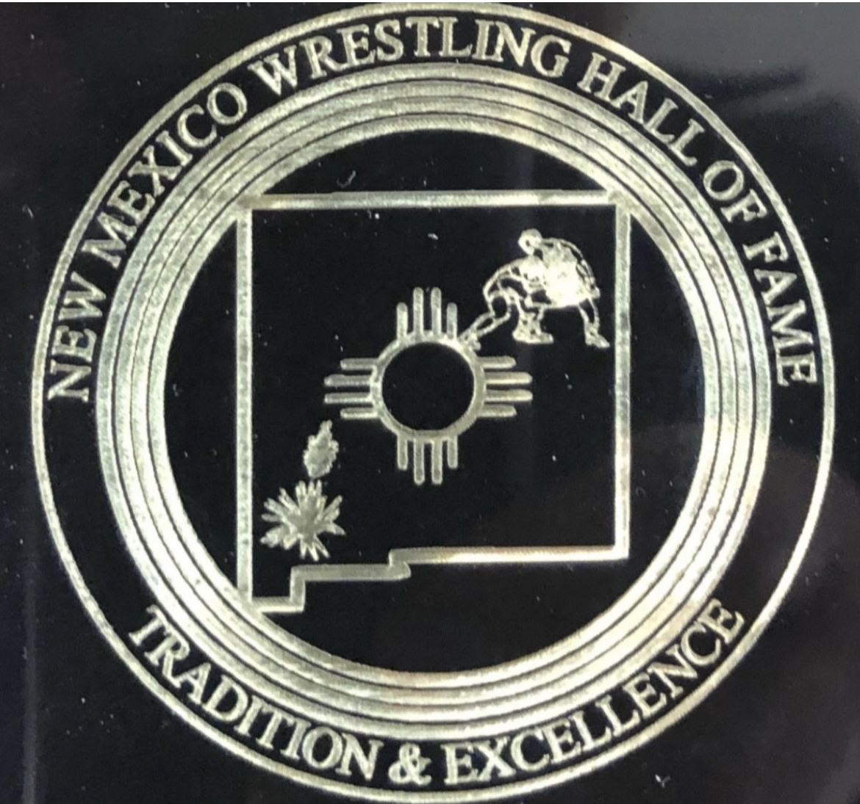
New Mexico
Wrestling Hall of Fame February 12, 2024

The New Mexico Wrestling Hall of Fame is seeking sponsors for our annual induction ceremony in April. The (NMWHOF) is a non-profit organization (EIN-47-5009354) that recognizes individuals who have achieved excellence in the sport of wrestling. The NMWHOF honors selected recipients with a ceremonial luncheon and presentation of their achievements. Funding for securing the venue, providing meals, and obtaining the awards is made by charging attendees a reasonable fee and through NMWHOF Board voluntary contributions.

Two years ago, the NMWHOF included the New Mexico High School Boys Dream Team and Girls State Champions. Recognition of their accomplishment included a plaque, shirt, and gratis meal to each recipient and their guest. The banquet increased from approximately 40 attendees to 190 in 2023. Honoring the additional recipients necessitated a larger venue, additional awards, and approximately 60 gratis meals which greatly increased our costs.

The NMWHOF Board values recognition of New Mexico Wrestling. The acknowledgement and preservation of past accomplishments along with the presentation of High School State Champions goes far in validating the sport of wrestling. It also brings an awareness of the historic excellence of our Hall of Fame Inductees to our younger generation of champions.

The rising cost has forced us to explore other revenue sources. To keep this event affordable, the Board graciously requests your financial assistance to help us defray the cost. Any amount of your generosity will be immensely appreciated.

Our Induction Luncheon Banquet is scheduled for 1:00 pm, April 21, 2024, at the Sheraton Uptown in Albuquerque. As a banquet sponsor, you will be recognized as follows:

$100-Sponsor Certificate
$200-Silver Sponsor Certificate, 2 banquet tickets
$500-Gold Sponsor Certificate, 2 banquet tickets
$1000-Platinum Sponsor Certificate, 4 banquet tickets
$2000-Diamond Sponsor Certificate and Banquet Table for 10

Thank you,

David Luna

Chairman, New Mexico Wrestling Hall of Fame
2032 Cassidy Drive
Las, Vegas, NM 87701
(505) 429-4055
dluna57@hotmail.com

