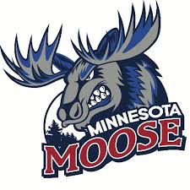
Equipment Intern

The Minnesota Moose Hockey Club, located in Blaine, Minnesota, is seeking a dedicated and hardworking Equipment Intern to join our team for the 2025-2026 season. This internship offers hands-on experience in sports operations and equipment management, providing an excellent opportunity for students interested in sports management or hockey operations. The Equipment Intern will assist in the day-to-day maintenance and preparation of team equipment, helping ensure the team is ready for practices and games.
Key Responsibilities:
- Assist in the preparation, organization, and setup of player equipment for practices and home games.
- Help with the post-game breakdown and inventory of gear, laundry, and general equipment upkeep.
- Support the equipment manager in skate sharpening, minor equipment repairs, and locker room organization.
- Help load/unload team equipment for road games, as needed.
- Ensure locker rooms and equipment areas remain clean, organized, and safe at all times.
Required Qualifications:
- Interested in pursuing a career in sports management or hockey operations.
- Strong organizational and time-management skills.
- Willingness to learn basic equipment maintenance (skate sharpening, repairs, sewing, etc.).
- Comfortable working in a fast-paced, team-oriented environment.
- Availability to work evenings, weekends, and some holidays (game days).
Compensation and Benefits:
- Must be a technical, undergraduate, or graduate student enrolled in a college credit internship program, preferably pursuing a degree in Business, Sports Management, or a related major.
- Direct experience working with a Junior hockey team.
- Networking opportunities within the sports industry.
- Team merchandise and tickets to games.
How to Apply:
To apply, please send your resume and a brief cover letter explaining why you're interested in the Equipment Internship with the Minnesota Moose to minnesotamoosejobs@gmail.com.

