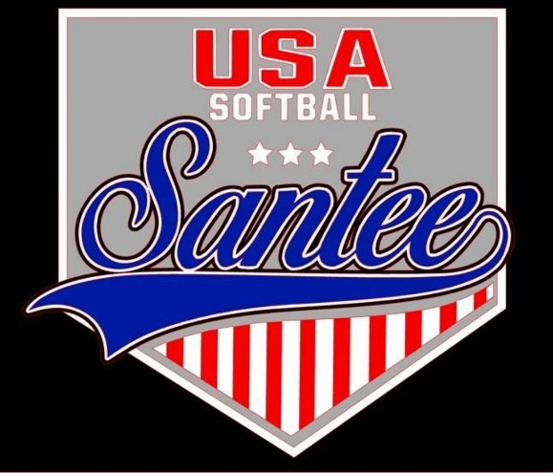
MINUTES TO BE APPROVED AT THE NEXT BOARD MEETING. THESE MINUTES ARE NOT CURRENTLY POSTED AND SHOULD NOT BE DISTRIBUTED UNTIL APPROVED BY USASSCS BOARD.
Board Meeting Minutes September 11, 2023
Location: Santee City Hall
Attendees Shown with Marked Box
President | Jay Strandberg | X | Field Prep | Kevin Hopkins | x
1st VP/ Field Prep | Erik Ruiz | x | Field Prep | Trevor Henton
2nd VP | Kelli Timanus | x | Field Prep | James Timanus | x
Treasurer | Tiffany Lynch | x | Field Prep | Nate Anderson | x
Secretary/Safety Coordinator/Head Scorekeeper | Bryan Scholar | x | Field Prep | Brad Allen
Tax Advisor | Lori Britt |  | Field Prep | Shane Frary | x
Player Agent | Lance Craw | x | Equipment Coordinator | Shane Frary | x
UIC/Parliamentarian | Felicia Leca | x | Head Team Parent Coordinator | Dana Hisaw | x
Field Scheduler/Fall Ball Coordinator | Chris Klima | x | Uniform Coordinator | Jamie DeChant | x
Webmaster/Social Media/All-Star Coordinator | Alexis Ruiz | x | Picnic Coordinator/Pictures | Kat Vecchione | x
BOTH Tournament Coordinator | Kayleigh Ponciano-Ahue | x | Snackbar #1 | Amy Ramirez | x
Sponsorships | Kylee Scholar |  | Snackbar #2
Awards | Janis Aiello | x | Social Media Coordinator | Sophia Vigil | x

Guests: N/A
Meeting called to order: 7:05PM
Meeting Minutes
Kelli motioned to approve minutes from 8/14/23. Chris seconded the motion.
Meeting rule – One Topic at a Time
Financial Update (Tiffany L)
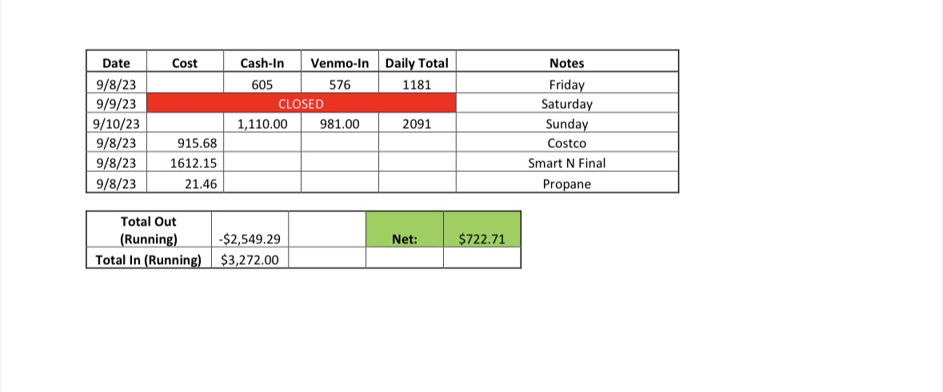

Snack Bar
- 1st weekend of fall ball net sales $722.71
- Purchase extra toilet paper and paper towels to have additional on-hand
- Implementing rules to create a more sanitary environment in the snack bar
- Age to work in the snack bar voted to be 13 years of age
Fall Ball
- Follow up with all coaches for background checks and set a day that all coaches have to be background checked by a 9/15
Fields/Equipment
- Issues
  - Water issue on field 4 and left side of field 3
  - Kayleigh asks about a fence on field 5 and netting on field 3 and field 4
- Kayleigh Ponciano-Ahue or (Bring on the Heat coordinator) has the authority to co-sign on field permits
Spring Rec Sign Up Dates – November 13 – January 5; Banners will be put up at schools on November 1
Meeting Adjourned: 8:52 pm
Next Meeting: October 9

