Kyle Gurnon – Travis Pavoni – Bill Connerton – Jason Krumholz – Mike Smith – Robert Fagan – Justin Coutu
Nick Twesten – Joe Malo – Kate Smith – Mike Gogolen – Tom McCarthy – Keith Martin – Austin Maxwell
Guests: Emily Manz

- Call to order / Roll call
- 2025-26 Season Update - [Mike S]
  - September schedule dropped
  - Parity schedule dropped
  - Competition Committee Nick to represent SRI
- House Update - [Emily] - Place Equipment drop bin starting 10/1
- Equipment swap on 11/1 and 11/8, from 7:30 - 11am
[ ] Add to flyer

  - Need to advertise @ school systems NK - Keith Martin
NK, SK, EG, Westerly, Chariho, EWG EG - Joe Malo
House Dates & Info Westerly, Chariho & EWG - Nick
Social Posts SK -
*Interest form [ ] New house signs

  - Bruins LTP [Nick] - October 11th, 18th, 25th & November 1st @9am
    - Flyers & Signups
- Financial Update [Bobby]
  - Golf Tournament [Mike G]
  - 2025/26 Ice Contract is $245k (I think last year we spent ~$180k on a contract that was similar).
    - Estimated income for 2025/26 of $325k ScheduleWerks add on to publish/select open ice time?
- Fundraising [Travis]
  - RI Grant [Mike S] House league ref grant? Ask Emily
  - Goalie Grant [Mike S] [ ] Increase house league ref pay to $40 per session
  - Prize Calendar (pre-xmas?) [Travis] [ ] Emily pay increase - determine current rate and suggest
    - Prize for calendar sales? Increase to board
- Action Items
  - Send out reminder about volunteer form to all coaches [Mike G]
    - Send out IHS Logins [Mike S]
  - SRI Scrimmage Database [Mike S] [ ] update coaches re scrimmaging and trying for a H&H series
    - Send out spreadsheet to all coaches SRI will be funding
  - Plastic Goaltenders [Kyle]
    - Mike to take estimates to RI Hockey
  - Scholarship [Kate/Austin]
    - Ages? [ ] Create flyer and spam social media
  - Gerstmeyer has a marketing intern we can leverage (not fully loaded)
[ ] School Flyers
  - SRI Hats [ ] Organize photo contest - need a prize (monthly?)
[ ] Conduit to URI Men’s and Women’s teams
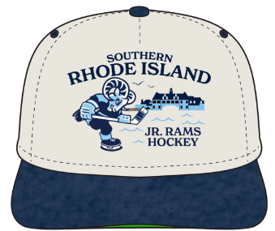 [ ] Hat okay with official name and logo
- Future Meetings / Topics
  - House crossover practices [Nov/Dec] Make X-Over practices standard 1x per month
  - Tryout Changes [Nov/Dec]
    - Handle defense differently for U12 and up, can get lost in forward focused drills. Maybe have dedicated evaluators for defense and forwards or identify the positions in the evaluators sheet to have them grade through an adjusted lens? 3v3 night, heard some negatives of stronger skaters dominating the play and just trying to skate around other players - adjust 3v3 night?

