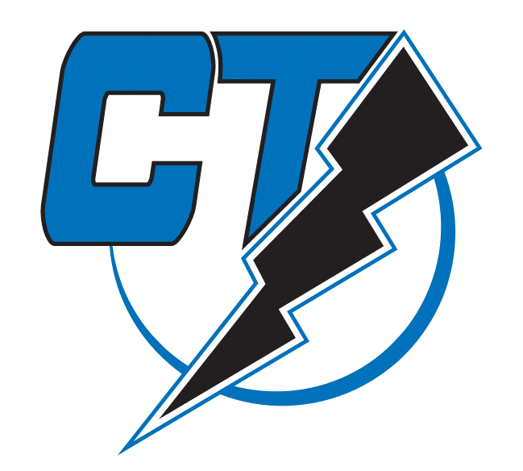
13U Southington Lightning Softball
2024/2025 Season

The CT Lightning 13U is a girl's travel fastpitch softball organization dedicated to educating players about sportsmanship, teamwork, discipline, and integrity through competitive sport.

We are seeking sponsorship from our business community to help support our team for this 2024/2025 softball season. Your sponsorship will significantly help with the purchase of
uniforms, equipment, tournament and league registration fees, indoor training, and much
more. We have three levels of sponsorship to help our team and advertise your business. We
encourage everyone to support those businesses who help make our success possible.

The Grand Slam - $1,000 donation:
Company logo in a preferred location on team banner, logo is larger than Home Run
logos; recognition on our team website; logo on the league homepage website; a plaque
with a team photo acknowledging your sponsorship.

The Home Run - $500 donation:
Company logo on team banner, recognition on our team website; a plaque with team
photo acknowledging your sponsorship.

The Base Hit - $250 donation:
Recognition on our team website.

Through your sponsorship you will have a positive impact on the lives of the players of the
Southington Lighting 13U, their families, and the community. Please follow us on Facebook (CT Lightning 13u) for updates, and shared photos.

Sincerely,

Coach/Manager Alan Fortin
alanfortin6@yahoo.com / 860-794-7424

