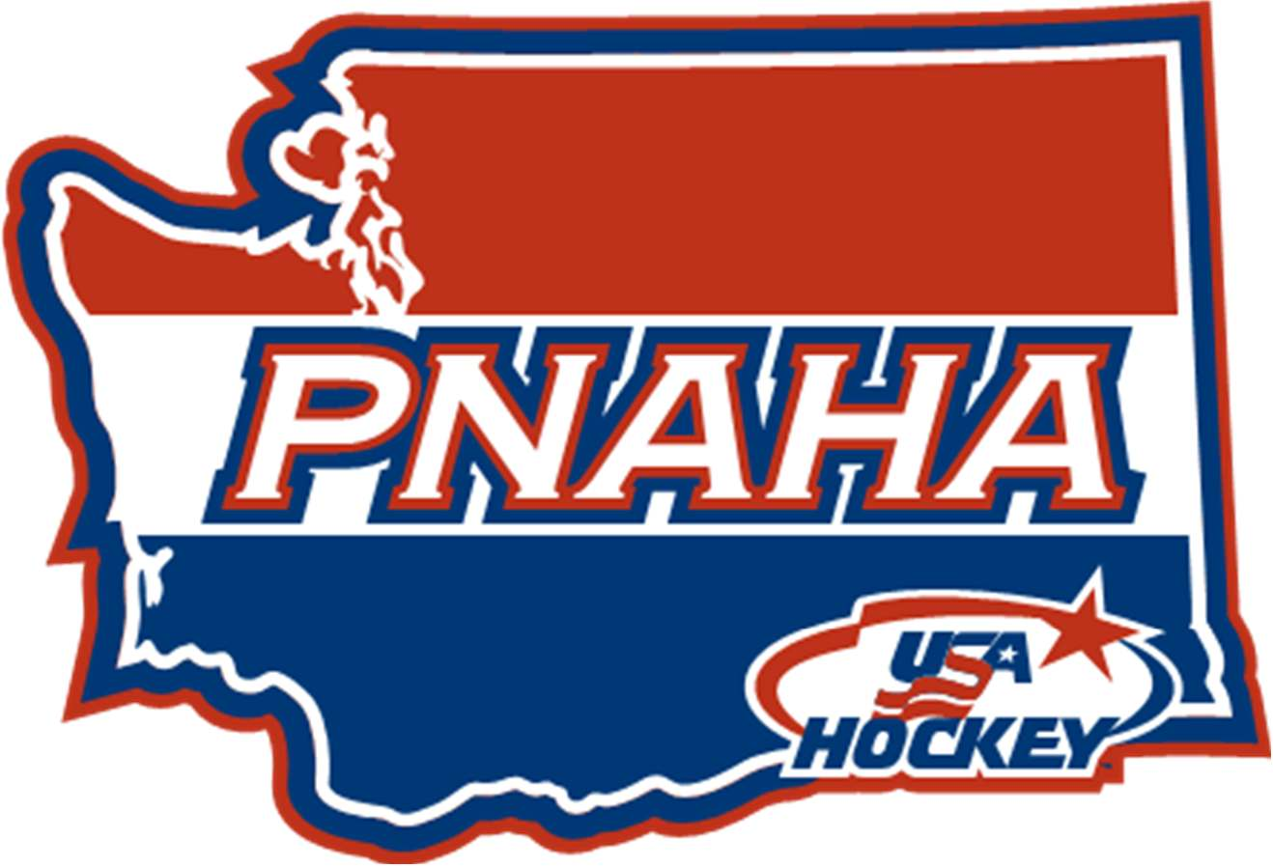
PNAHA OCTOBER STEERING COMMITTEE MEETING
THURSDAY, OCTOBER 26, 2023

- President, Jody Carpenter, Call to Order 6:03 pm
Roll call– Jody Carpenter, Tom Ogee, Nicole Adams, Debbie Didzerekis, Rob Kaufman, Donna Kaufman, Gordon Hancock, Savannah Pierone, Katelyn Parker and Katie Sieck
Officer Reports
- President – Jody Carpenter
- 1st Vice President – Tom Ogee
- Committees Reports
- Competition Committee, Gordon Hancock
no committee meeting
no one responding Nicoles ask on making associations whole around concerns around 10U ice costs, not equal across associations. Need a plan going forward.
- Discipline Committee, Nicole Adams
First committee meeting great group and had first review, good group, and committee goals. Potential rule change and language. Email group definition and committee.
- Finance Committee, Debbie Didzerekis
initial meeting to discuss plan, no follow up meeting yet or defining goals and plans.
- Girls Hockey Development Committee – Katelyn Parker
Girl’s camp, Kristen wright USA Hockey, finalizing ice schedule out with SJ and Ian. Most impactful, contacting Jordan James, standard warm up, camp date 21-23, Alex Morgan, in attendance, from PD girls’ group. On ice bench coach is evaluating. Great having both in PD for development meeting.
- Governance Committee – Donna Kaufman
re write ADM move ups at 8 and 10, previously ADM approved, now ADM is lumped under Player development so, Policy someone needs to approve anything over 2. Girls deal with girls and youth deals with boys. Player Development needs to get anything over 2 players play ups and include Katelyn when it has Female group. Bylaw structure, meet next week out by 6th of November, put on floor in January and vote in January. Needs 60 days prior to meeting. Rule change 30 days prior to meeting so Dec 6 needs out before Jan 6. Governance needs them next Wednesday for bylaws review Nov 1, for rules review need them by November 29 for review.
Fire: - Define Recruitment from other members and Arbitration – define in guidebook and discuss.
- Membership Committee – Penny Delbarto (not present)
Did something go out to Inland Empire (Nicole)
- Public Relations Committee, Katie Sieck
Committee of 3 going to ask Tony ? from Spokane, committee goals she will send out and share, put together the monthly meetings and agendas and hosts, Try hockey for free events, will start sharing more organically, brackets for girls development camp for both youth and boys want to hire a photographer to help so we have more photos of our events. Wants to create a contact library, also attempted to generate a generic photo with AI and it went wrong, wants more participation.
- Player Development Committee – Rob Kaufman
Player development meeting at PD, round table with everyone and sharing ideas with what they all do, WA seems to have a great product just need to add some of the other elements.
Invitation going out by Dec 15. Camp Jan 15,16,17, 2024 in Tacoma. Jordan James, Nutritionist to speak to group (finalizing team leaders and evaluators) May have some Friday night skill sessions (2 games 3 skills, goalie session by age group instead of one.) 4 or 5 USA Hockey personal come in and speak and will try to add new coaches to the mix, 2 team leaders per team. Trying to ensure that we can do exit interview with players it went well at 13’s. adding to 15, 16 camp. Ramping up and organized.
- Tournament Committee, Savannah Pierone
Tournament has not met, working to setup a state meeting to review 10U/12U to work through this group to ensure a good State Tournament. Donna can help you significantly. Zoom meeting with a tournament host with each tournament, talk to them about the things they need to do and be done. Punch list, timing should be etc. First week of December to have the meeting. Tier I some teams will have to have a play off, best of 3 between the 2 associations. Include Tri – SJHA – and Kraken.
- Old Business
  - Committee Descriptions for the guidebook – Due 29th and will go under Bylaw changes, committees defined go in Bylaws.
  - Committee scopes for the guidebook – Oct 29
  - Publishing the committees on the website along with a spot for them to post meeting minutes. – following weekend November 11 pages for each committee.
- New Business
  - 10U fees current year (need to address)
  - 10U fee structure for reciprocal ice (when fees don’t match across the board) – Super weekend proposals (do away with 10U league scheduling, everyone does there own thing and comes back to state festival)
- Adjournment 7:50 motion by Gordon Hancock, 2nd by Katie Sieck. All approved.

