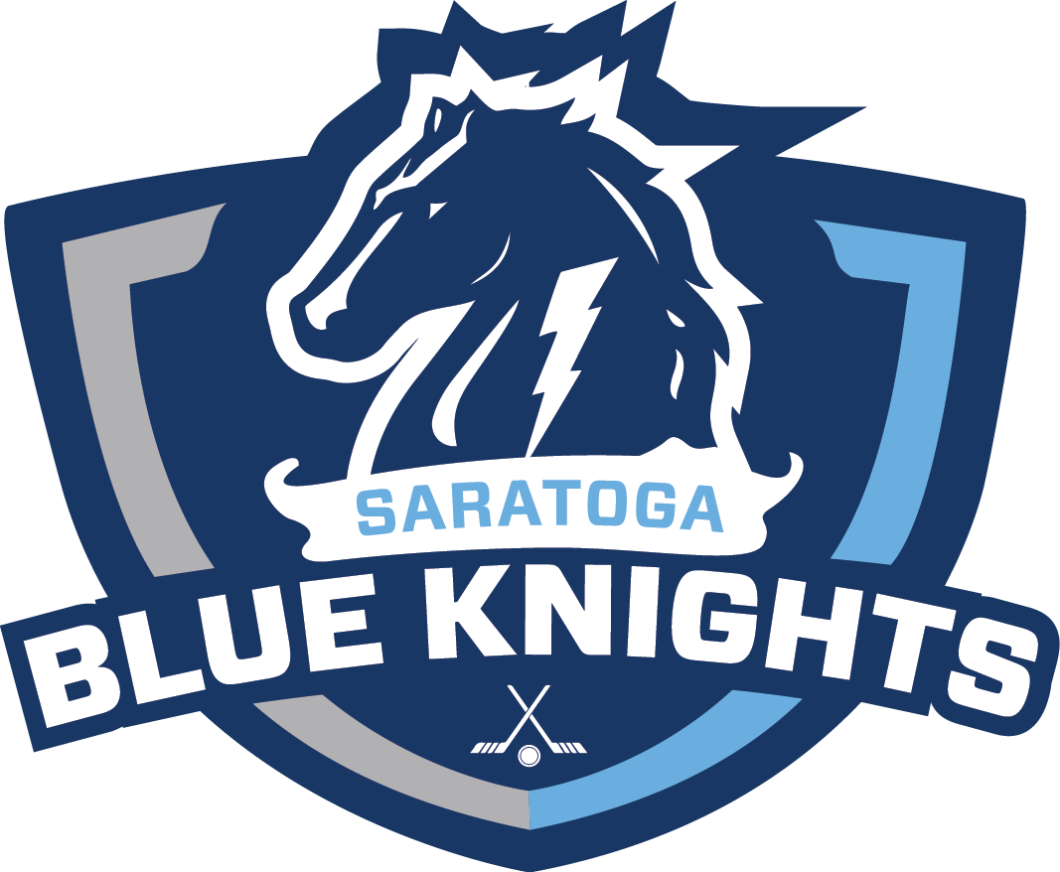
PLAYER CODE OF CONDUCT/ETHICS 2019-20 SEASON
(UPDATED 09/21/2018)

The following Code of Ethics/Conduct will be in effect for all Saratoga Youth Hockey (SYHI) sponsored events, including games, practices, scrimmages, team meetings or any other SYHI events-on and off the ice surface.

- Take pride in yourself and your team; follow directions of the coaching staff; work hard in practice and games; and be willing to accept constructive criticism.
- Be a competitor; perform up to your ability and contribute to team unity. Compliment teammates and let the coach handle criticism.
- Show respect towards referees, coaches, players, parents, and fans of both teams.
- Good conduct on and off the ice. If it wouldn’t be tolerated at home or at school, it will not be tolerated at SYHI sponsored events. This also includes but is not limited to social media content such as email, text messaging or internet postings.
- PARTICIPATION AT ALL GAMES AND PRACTICES IS EXPECTED. You should notify coaches of absences as soon as possible prior to any planned event.
- Use proper equipment; keep it clean and in good repair. Ensure compliance with all USA Hockey and Saratoga Youth Hockey standards, i.e. expiration dates of helmets.
- A responsible attitude toward your health-be aware of, and adhere to, the USA Hockey, New York State Amateur Youth Hockey, and the SYHI policies on drinking, tobacco usage and drugs.
- Good school behavior, habits, grades, attendance etc.

The players rights include:

- Participation at a level commensurate with maturity and ability in a safe and healthy environment.
- To be treated fairly and with dignity.
- To be taught fundamentals and sportsmanship, have the opportunity to develop both hockey skills and “life skills”, and strive for success.

SYHI follows the attributes from the USA Hockey Zero Tolerance criteria used for players, parents and coaches on and off the ice. Examples of non-compliancy of the Codes of Conduct are:

- Visually demonstrating any sign of dissatisfaction with any game or team official in a manner that openly embarrasses the Official and/or challenges his/her judgment.
- Use of profane, obscene, abusive or vulgar language, gestures, racial/ethnic slurs including inappropriate language, in a boisterous manner at ANYONE at ANY time, on the ice or anywhere in the rink before, during and after a game or practice.
- During stoppage of a game, intentionally knocks, throws or shoots the puck out of reach of an official who is retrieving it.
- Deliberate throwing of a stick, garbage or other equipment into the players’ boxes, spectators viewing area, penalty box, or on-ice surface that in ANY manner creates a safety hazard.
- Interference in any nonphysical manner with any Game Official including other Players, Referees, Coaches, Timekeepers, other Parents, or Goal Judges in the performance of their duties.
- Touching or holding the referee, Linesman or any other Game Official with his/her hand or stick.
- Deliberately inflicting physical harm to any Game Official, Player and/or Parent in ANY manner or attempts to do so.
- Behavior in ANY manner that is critically detrimental to the conduction of the game, including spitting at opponents and/or spectators, Game Officials or verbally threatening a Game Official with physical harm.
- Taunting players, coaches, Officials or other spectators by mean of baiting, ridiculing, threatening physical violence, or physical violence. This includes physical or verbal “bullying” of other teammates/players in locker rooms.

This is by no means a complete list of violations. EVERY SYHI member is required to follow the code of conduct policies. If a violation does occur, procedures of first, second, and third offenses are followed. PLEASE NOTE: Based on the seriousness of the offense, the Board holds the right to take further action, including immediate suspension and/or permanent dismissal from SYHI activities.

I agree to follow these principals as a member of the SYHI team to which I am assigned. Consistent action deviating from these values, or which disrupt the teams’ ability to function, other players’ ability to learn, or the coach’s ability to teach, will not be tolerated. I agree to the following procedures:

- FIRST OFFENSE: I agree that my coach may limit my playing time, up to one (1) game maximum, and notify the Level Director and the SYHI Board of Directors on my actions. Based on the seriousness, the Board may take further actions.

- SECOND OFFENSE: Upon the second offense in the same season, the SYHI Conduct Review Board will be notified. This Review Board, consisting of the President, VP of Hockey Operations, and the ACE Coordinator, will conduct a hearing with the player’s parent(s), the player(optional), level director, and the coach. Discipline consistent with the violation may be given, as well as placement on probation.

- THIRD OFFENSE: Suspension from all team activities for the remainder of the season, following an SYHI Board of Directors hearing. NO REFUNDS WILL BE GIVEN SHOULD THE REVIEW BOARD RULE AGAINST THE PLAYER.

I agree to abide by the Saratoga Youth Hockey Player Code of Conduct for the season. This Code of Conduct supports NYSAYHA and SYHI core values of: RESPECT, INTEGRITY, PURSUIT OF EXCELLANCE, ENJOYMENT, LOYALTY, and TEAMOWRK.

Signing of this agreement by both the player and parent(s) is a requirement to play in SYHI.

Parent(s) Signature & Date Player’s Signature & Date

Print Parent(s) Name Print Player’s Name

