Entering Duals Rosters through USAW
- Login to www.usawmembership.com. NOTE: Only club admins can access duals registration rosters.
- In the top menu, hover over MANAGE and choose “CLUBS.” Select “MANAGE CLUB” next to the appropriate club.
- In the left menu, select “DUAL TEAM ROSTERS.” Click the event name of the dual you want to enter a roster for.

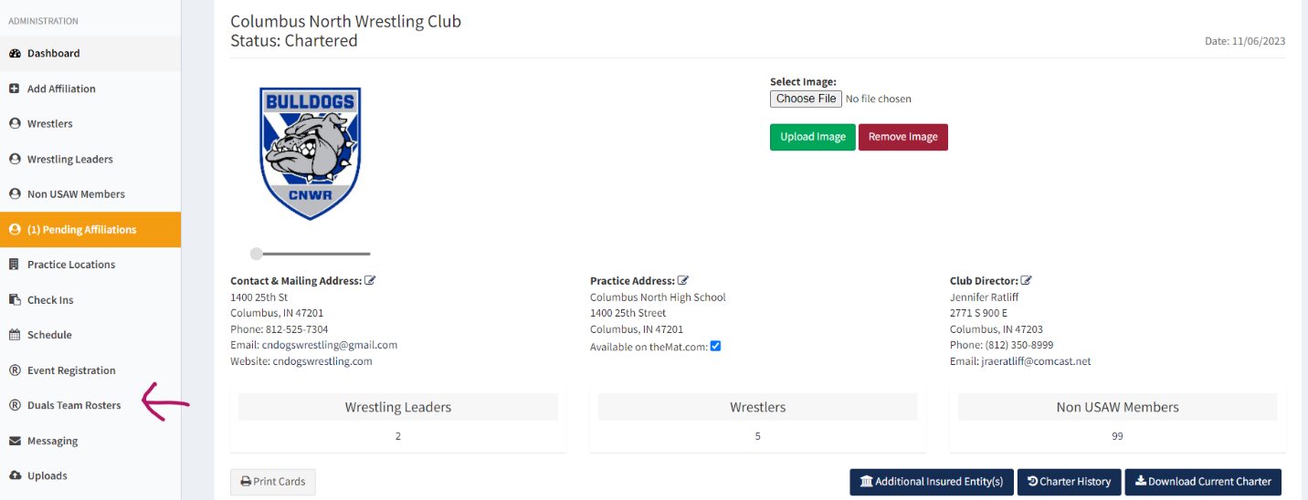

- Search for wrestlers by name or USAW ID in the participants box. (For common names, entering the wrestler’s USAW ID, found in your club wrestler list, will ensure the proper wrestler is added.) Select options for style and weight, then select “ADD to ROSTER.” Only wrestlers with a current USAW membership can be added to the roster.
*All Star/Wildcard wrestlers, if allowed, will be restricted according to limits established by the tournament director and are indicated by a “yes” in the All Star column.
*Coaches with a current USAW leader membership can be added in the same way. The number of coaches allowed per team may be restricted to limits established by the tournament director.

