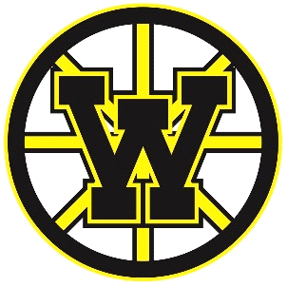

WHA Meeting Agenda
Date: April 12, 2022
Location: Second Street Station
Time: 7:00pm

Call to Order

- AGENDA: Review, Add, Approve

MINUTES: March/Special Meeting Board Meeting

- Build It Now (BIN) Update

- Dueling Pianos Event Update – April 16th

- Coaching Development Update

- Synthetic Ice – Grant Application

- WHA Bank Changes

- Player Transfers

- Committee & Chair Updates:

Coaching (Jason Kasuske, VP; Lucas Deutsch, Staff)
Finance (Debbie Melville, Treasurer; Maddie Engen, Staff)
DIBS (Tonya Holien, Chair & Amber Dahl, Secretary)
Marketing (Molly Randall, Chair)
Fundraising (Molly Randall, Chair)

- General Committees:

Calendar Committee (Todd Randall, Chair)
Growth & Retention (OPEN)

8. Facilities
9. Association Wide Information
a. Tentative: Bylaw Discussion
b. Security

10. Additional Executive Session (if needed)

Adjourn
General Discussion

Next Meeting Date: May 10th, 2022, at 7:00pm @ 2nd Street Station

