SLPYHA Board Meeting Agenda
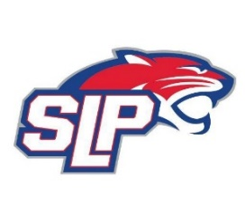
Date: 10/21/20
Roadside
7:30pm

- President Report: Bob Roloff
- Call to order: 7:30pm
- Approve agenda
- Approve minutes from 9/23/20 meeting
- Vice President Report: Michelle Rice/Scott Lichter
  - D10 COVID Guidelines
  - Parents at practices – SR (no parents at practices for Squirt and above) vs. Fogerty (Parents allowed at practices)
- Treasurer Report/Gambling Report: Mike Mliner
  - Motion to move funds from gambling account to hockey account for FHIT, motion Mliner, move, Lichter
- Secretary Report: Corey Piekarski
- Traveling Director Report: Jason Shipman/Chris Mueller
- Girls Traveling Director Report: Kevin Mitties
  - Open hockey on Wednesday’s for the girls
- Mite Director Report: John Pitzl
  - Mite numbers – 101, down 5 from last year
  - Cubs – 19 to date, up 19 over prior year
  - Preskates and evaluations start 10/19, teams posted 11/1
  - Jerseys – Panther jerseys for A/B and MIAC for C/D
  - Team declared – 1A, 1B, 4C, and 3D
  - Mite Tourneys?
  - Cubs – additional help from older players/coaches
  - Lease at Roadside – name change?
  - SR1 rink update
- Coaching Director Report: Jeremy Flaten
  - Coaches meeting agenda, hockey systems, player development update
- New/ongoing Business:
- Motion to dismiss: 9:00pm motion, Shipman, move, Mitties

