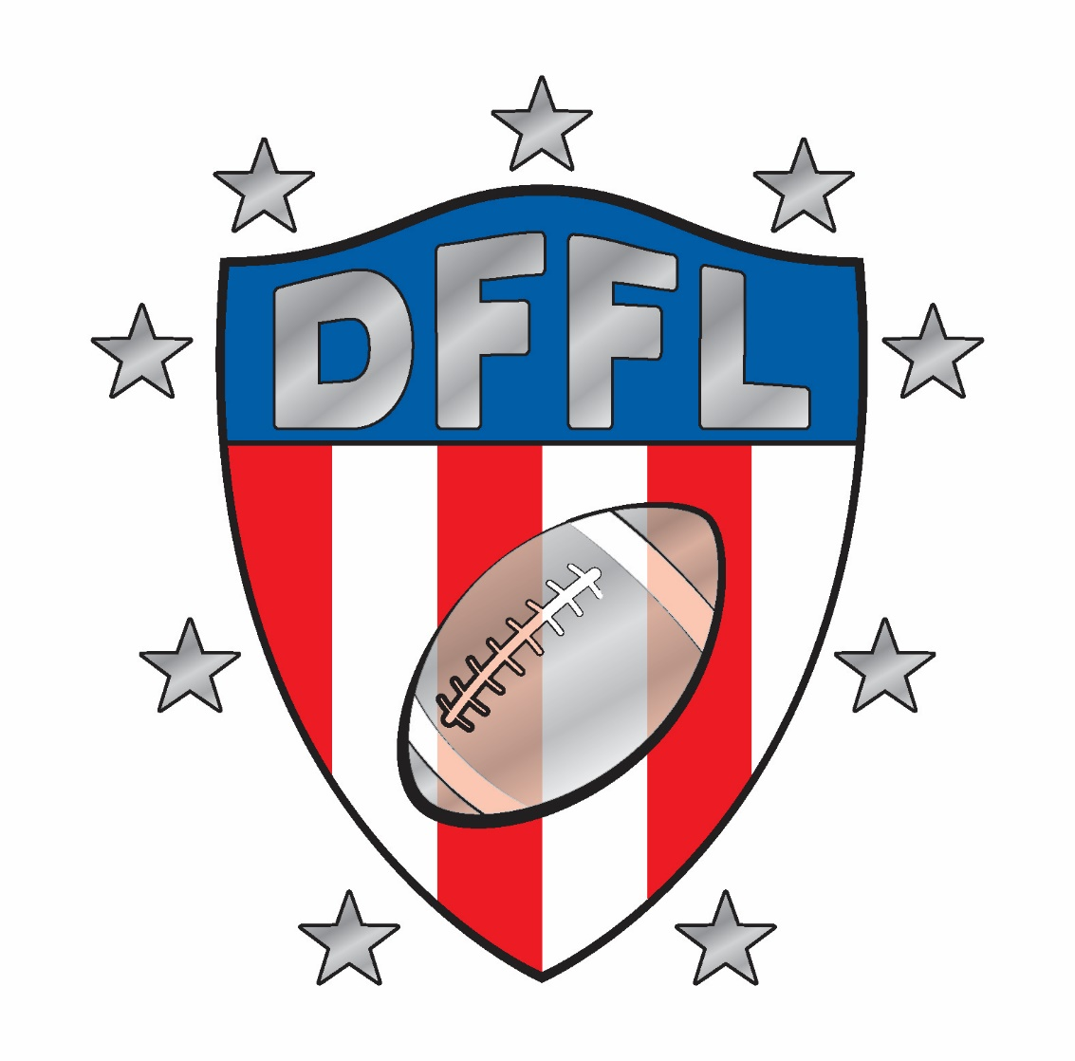

DOTHAN FLAG FOOTBALL OFFICIAL RULES

BASIC FLAG FOOTBALL RULES
- Games will be 5 on 5 for younger age divisions (4u, 6u, 8u). Games will be 7 on 7 for all other divisions (10u, 12u, 15u, 18u).
- 2 - 20 minute halves, running clock. Halftime is 5 minutes. 1st Half – Continuous clock unless timeout called. 2nd Half - Clock runs first 18 minutes unless timeout called. Stops on incomplete pass, out of bounds, first down, etc. during the last two minutes. Two 30 sec timeouts per half, no carryover. Each time the ball is spotted, a team has 30 seconds to snap the ball (45 second play clock for 4u & 6u only). The head referee will notify the offense with 10 seconds remaining on the play clock. Teams will receive one warning before a delay-of-game penalty is enforced.
- The offensive team takes possession of the ball at its 5-yard line and has four (4) plays to cross midfield. Once a team crosses midfield, it has four (4) plays to score a touchdown. If the offense fails to score, the ball changes possession and the new offensive team takes over on its 5-yard line.
- If the offensive team fails to cross midfield, possession of the ball changes and the opposition starts its drive from its 5-yard line.
- All possession changes, except interceptions, start on the offense’s 5-yard line. On interceptions, ball will be spotted at the point of the intercepting defensive player being down.
- Touchdown: 6 points
  - Extra point: Team Choice
    - 1 point (played from 5-yard line) or
    - 2 points (played from 10-yard line)
- Safety: 2 points
- Teams must field a minimum of five (5) players at all times.
  - Recommended Offense – 1 QB, 1 RB, 2 WR, 1 C
  - Recommended Defense – 2 DL, 2 CB, 1 S
- Offense must start with at least two for 5v5 or three for 7v7 on the line of scrimmage, including the center.
- Mercy Rule: In the event either team falls behind to a 28 point or greater deficit at any period of the game, the mercy rule will be in effect at which the clock will run continuously for the remainder of the game regardless if deficit shrinks below 28 point margin. Timeouts are allowed to be taken, however, the clock will not stop until 0:00 at the conclusion of the 2nd half.

COACH AS QUARTERBACK (4u, 6u & 8u Divisions Only)
- Offense team coach will assume the position of Quarterback for the entire game. 5 kids + coach vs 5 kids on defense
- The purpose of this is to allow for more offensive possession in the teams zone.
- The Coach QB must adhere to the 7 Second Pass Clock and is limited to pass or hand off directly to another offensive player.
- He/She is not an eligible receiver, may not block, or interfere in any way with a defensive player attempting to tackle (after a hand off).
4u & 6u Age Division Age Specific Rules and Goals
- 45 second play clock.
- One coach (6u) is allowed on the field for defense to allow for setup of the defensive players – defensive coach should be sure as not to impede the play after the ball is snapped or to create undue delay in the game. It is understood the offense is at an advantage with a coach on the offensive side. The defensive coach will assist with the initial setup and can back away to coach as if from the sideline. (No more than 2 coaches on the field for 4u)
- In this division we want to get the players lined up properly and running in the right direction. We want to be flexible with the rules and teach the players the proper fundamentals of football.
- The defense cannot cross the line of scrimmage until the ball is handed off. If the offensive player remains behind the line of scrimmage without the ball, the defensive player shall not cross the line of scrimmage until he has possession of the ball. Example: Offensive team has a “safety valve” player A on a pass play that remains in the back field next to the coach. The defensive player B (man defense) will not be allowed to cover player A until player A has possession of the ball or crosses the line of scrimmage.
- On the PAT, 4u & 6u can either run or pass on the 1pt and 2pt attempt. The No-Run Zone will not apply on PAT only.
- For the 4u Division, in the event of a non-contact penalty, the ball will be placed at the spot of the foul. No penalty yardage and no loss of down. It is expected the 4u kids will flag guard, have false starts, etc. Such penalties will be opportunities for coaching. Illegal contact and unnecessary roughness will be penalized, though very likely unintentional, must be discouraged. Illegal contact is at the discretion of the referee, 6u and even older kids will often fall to the ground while their flags are pulled resulting what would appear to be a tackle yet is often not the case.

BASIC GAMEPLAY
- The ball must be snapped between the legs, or off to one side, to start play.
- All players are eligible to receive forward passes or pitches.
- “No-running zones,” located 5 yards from each end zone and 5 yards on either side of midfield, are designed to avoid short-yardage, power running situations. Once across midfield, the goal line is the new line to gain, therefore, a running play is allowed on any part of the field outside of the 5 yard line. (Example: Team A possesses the ball and gains a 1st down at midfield. It is now 1st and goal. On the next ensuing play, Team A receives an offensive penalty forcing them back across the midfield line and to replay 1st down. The line to gain remains the goal line, it is 1st and goal beyond midfield and any run or pass play is allowed up until the 5 yard boundary is reached.)
- When in the “No-running zones,” passes must go beyond the line of scrimmage. No short forward flips behind the line of scrimmage.
- For younger age divisions (4u,6u,8u), No laterals or pitches of any kind beyond the line of scrimmage. Only one forward pass allowed. Downfield laterals are allowed in older age divisions (10u, 12u, 15u, 18u)
- Play is ruled “dead” when: — Ball carrier’s flag is pulled. — Ball carrier steps out of bounds. — Touchdown or safety is scored.— Ball carrier’s knee or arm hits the ground. — Ball carrier’s flag falls out. —The ball hits the ground.
Please note: There are no fumbles. The ball is spotted where the ball hits the ground and the team does not lose possession. If the ball is fumbled forward, the ball is spotted where the ball-carrier’s feet were at the time of the fumble. If the ball hits the ground as a result of a bad snap, the ball is then placed where the ball hits the ground. If occurring in the offense’s own endzone, the play will result in a safety.
- A ball carrier may not guard his/her flag other than "spinning" to avoid being deflagged. No jumping or diving by the offensive player.
- The ball is spotted where the ball carrier's forward-most grounded foot is when the flag is pulled, not where the ball is.
- One player at a time may go in motion 1-yard behind and parallel to the line of scrimmage. No motion is allowed toward the line of scrimmage.
- The center must snap the ball with a rapid and continuous motion between the legs or to the side to a player in the backfield and the ball must completely leave his/her hands. No Center Sneaks allowed.
- The offensive coach will be allowed in the offensive huddle to allow for the calling of the play only. Once the team breaks the huddle, the coach must step back away from the offensive team at least 10 yards. No defensive coaches will be on the field for any age division and can coach from the sideline only (*4u & 6u exception).

- For 7v7 format only: SCREEN BLOCKING
- Offensive blocking will be by screening only, that is, a blocker must hinder a defender's movement through positioning rather than body contact. Screen Blocking shall be defined as obstructing the rusher’s path to the quarterback or ball carrier, as long as it is done behind the L.O.S., with any part of the body except head, hips, and legs. During a block, the body must remain upright with elbows and hands touching the body at the side or behind the back. There can be no independent movement of the elbows. Screeners must have his thumbs hooked in his pants and holding the flag belt with each hand or the screener must hold his arms behind his back with arms locked together in some manner. A screener may not leave his feet to screen or use a screen to initiate any form of contact with the rusher. The screeners feet must be set and planted when in proximity with the rusher.
  - The main responsibility of avoiding contact lies with the rusher, however the screener may not step into the rusher or initiate contact in any way.
  - Moving screens shall be penalized from the end of run (E.O.R.) or the point of infraction (P.O.I.), whichever hurts the offensive team the most. If the illegal screen is judged to have caused excessive contact, it will be penalized 10 yards and loss of down.

RUSHING THE PASSER
- All players who rush the passer must be a minimum of seven yards from the line of scrimmage when the ball is snapped. Any number of players can rush the quarterback. Players not rushing the quarterback can defend on the line of scrimmage (2 yard buffer). Note: No rushing the passer in younger age division (6u & 8u). 7 second pass clock utilized.
- Once the ball is handed off, the seven-yard rule no longer is in effect and all defenders may go behind the line of scrimmage.
- A special marker, or the referee, will designate a rush line seven yards from the line of scrimmage. Defensive players should verify they are in the correct position with the official on every play. The 2 yard buffer neutral zone will also be marked by the officials.
- Down field blocking is illegal. Once a catch is made or a player rushes beyond the line of scrimmage, offensive players may set a stationary screen, but no use of hands.
- While incidental contact may occur; blocking/rushing penalties will be called against the player who initiates excessive contact. Both the defensive rusher and offensive blocker should make every attempt to have as little contact as possible.
- When rushing the passer, the defensive player is allowed to pull the passer’s flag or block the ball in the air. However, the defensive player is not allowed to block the passer’s arm to prevent a pass. In the event of forcible contact initiated by the defense (referee judgment) with the passer’s arm, without first touching the ball, a defensive penalty of Illegal Contact will be called. (Example1: Team A passer is scrambling behind the line of scrimmage and begins to pass the ball. Team B defender reaches up to block the pass but instead strikes the passer on the elbow/forearm causing the ball to flutter to the ground. 10 yard penalty and automatic 1st down.) (Example2: Team A passer is scrambling behind the line of scrimmage and begins to pass the ball. Team B defender reaches to pull the flag of the Team A passer. While following through with his throwing motion, Team A passer strikes Team B defender on the shoulder. No penalty should be incurred as the contact was not initiated by the defender and was not attempting to impede the normal throwing motion.)
FLAG PULLING
- A legal flag pull takes place when the ball-carrier is in full possession of the ball.
- Defenders can dive to pull flags but cannot tackle, hold or run through the ball-carrier when pulling flags.
- It is illegal to attempt to strip or pull the ball from the ball-carrier’s possession at any time.
- If a player’s flag inadvertently falls off during the play, the player is down immediately upon possession of the ball and the play ends. The ball is placed where the flag lands.
- A defensive player may not intentionally pull the flags off of a player who is not in possession of the ball.
- Flag guarding is an attempt by the ball-carrier to obstruct the defender’s access to the flags by stiff arming, dropping the head, hand, arm or shoulder or intentionally covering the flags with the football jerseys. All jerseys must be tucked in before play begins. The flags must be on the player’s hips and free from obstruction. Players must wear shorts or pants without belt loops or pockets and the drawstring must be tucked inside (Player Safety).
OVERTIME
- No overtime for the 6U & 8U division due to time constraints on the games.
- If the score is tied at the end of regulation in the older divisions (10U and above), teams move into overtime.
- Overtime is a one point or two point conversion competition for the first two possessions. Both teams will take turns attempting one or two point conversions for the first two attempts unless a winner is determined. On the 3rd and subsequent overtimes, both teams must begin from the two point line.
- Captains will meet at midfield for a coin toss. Winner can choose whether to go on offense or defense first. Loser can choose the end of the field on which play will occur during the entire overtime period.
- If the score remains tied after the first overtime period, the team that lost the overtime coin toss has the choice of offense or defense at the start of the second overtime. The choice of possession will alternate in each subsequent overtime period.
- During overtime, an interception may be returned.
- All applicable regulation period rules and penalties are in effect.
- There are no time-outs in overtime.

FIELD
- For younger age divisions, the fields are 30 yards by 70 yards (provided field space allows) with two 10-yard end zones. Every field will have a midfield line-to-gain and no-running zones that precede each line-to-gain by 5 yards. For older age divisions, the fields are 40 yards by 70 yards.
- No-run zones are in place to prevent teams from conducting power run plays. While in the no-run zones (a 5-yard imaginary zone before midfield and before the end zone), teams cannot run the ball in any fashion. All plays must be pass, even with a handoff.
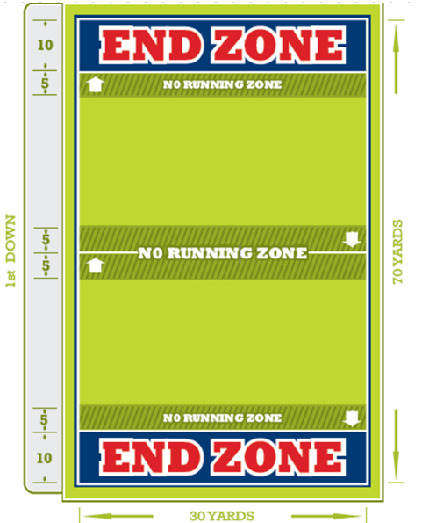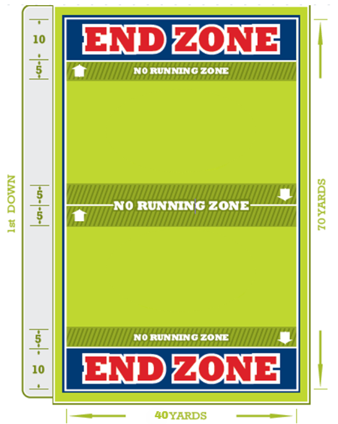
5V5 FIELD 7V7 FIELD

PENALTIES
• DEFENSIVE SPOT FOULS
1. Defensive pass interference | +10 yards and automatic 1stdown
2. Holding an offensive player with the ball | +10 yards and automatic 1stdown
3. Stripping of the football | +10 yards and automatic 1stdown
• OFFENSIVE SPOT FOULS
1. Flag guarding | -10 yards and loss of down
2. Charging | -10 yards and loss of down
3. Illegal Contact | -10 yards and loss of down
• DEFENSIVE PENALTIES
1. Defensive unnecessary roughness / Illegal Contact | +10 yards and automatic 1stdown
2. Defensive unsportsmanlike conduct | +10 yards and automatic 1stdown
3. Offside | +5 yards from LOS
4. Illegal Rush (starting rush from inside 7-yard marker) | +10 yards from LOS
5. Illegal Flag Pull | +5 yards from LOS
6. Roughing the Passer | +10 yards and automatic 1stdown
• OFFENSIVE PENALTIES
1. Offensive unnecessary roughness / Illegal Contact |  | -10 yards and loss of down
2. Offensive unsportsmanlike conduct |  | -10 yards and loss of down
3. Offside / false start |  | -5 yards from LOS
4. Illegal forward pass |  | -5 yards from LOS and loss of down
5. Offensive Pass Interference |  | -10 yards from LOS and loss of down
6. Illegal Motion (More than one person in motion) |  | -5 yards from LOS
7. Delay of game |  | -5 yards from LOS
8. Exceeding the 7-second pass clock (younger division only) |  | Loss of down only
6. Illegal Run in No-Run Zone |  | -5 yards from LOS and loss of down

- For the 4u Division, in the event of a penalty, the ball will be placed at the spot of the foul. No penalty yardage and no loss of down. It is expected the 4u kids will flag guard, have false starts, etc. Such penalties will be opportunities for coaching. Illegal contact and unnecessary roughness will be penalized, though very likely unintentional, must be discouraged. Illegal contact is at the discretion of the referee, 6u and even older kids will often fall to the ground while their flags are pulled resulting what would appear to be a tackle yet is often not the case.

