**CHART 2: Diagnosed Concussion - Stages and Responsibilities**

Student:

**CONCUSSION DIAGNOSED**

**Student returns to school to begin the School Concussion Management Plan – Return to School (RTS) and Return to Physical Activity (RTPA) Plan(Appendix C-5) – completed at school**

**Home Preparation for   
Return to School (RTS)   
and Return to   
Physical Activity (RTPA) Plan (Appendix C-4)–   
completed at home**

Parent/guardian:

**Reports to principal/designate that student has completed:**

* **Stage 2 RTS**
* **Stage 2b RTPA**

Principal/designate:

**Informs appropriate school staff of the diagnosis, and meets with parent/guardian to provide and explain the Home Preparation for RTS and RTPA Plan (Appendix C-4)**

Principal/designate:

**Meets with parent/guardian to: provide and explain the purpose of Appendix C-5,explain the Collaborative Team approach and their role on the team**

Student:

**Returns to School**

**Student conference to develop RTS and RTPA Plan**

**Return to School –   
Stage 3a**

Student: attends school (2 hours) with adaptations of learning strategies and/or approaches

**Return to Physical Activity –**

**Stage 3**

Student: simple locomotor activities/sport-specific exercise   
to add movement

**At the completion of each stage student progress is documented with results shared between school and home. Parent/guardian confirms completion of each stage by returning C-5 with a signature.At each stage student is monitored for return of symptoms, new and worsening symptoms. During RTS Stages 1- 4b and RTPA 1-4, if the student exhibits/reports return of symptomsor newsymptoms student must return to the previous stage for a minimum of 24 hours. If during any Stage the student exhibits or reports worsening symptoms, student must return to medical doctor/nurse practitioner.**

**Return to School –**

**Stage 3b**

Student: attendsschool(half time) with moderate workload

**Return to School –**

**Stage 4a**

Student: attends full day school with adaptations of learning strategies and/or approaches

**Return to Physical Activity –**

**Stage 4**

Student: increase physical activity, non-contact training drills to add coordination and increase thinking

***Collaborative Team Lead/Designate:   
Report to parent/guardian completion of Stage 4b RTS and Stage 4 RTPA and provides Documentation for Medical Clearance (e.g., Appendix C-6)***

**Return to School –**

**Stage 4b**

Student: attends full day school without adaptations of learning strategies and/or approaches

**RTS - Complete**

***Parent/guardian:   
Provides principal/designate with signed Medical Clearance (e.g. Appendix C-6 )***

© Ophea 2018

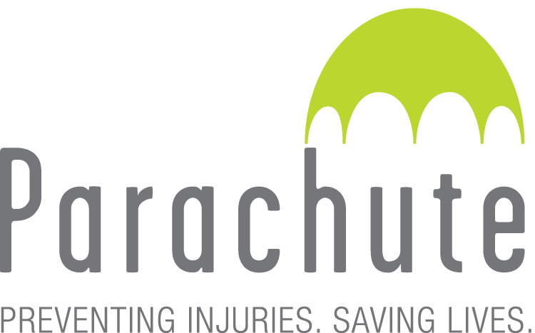

**Return to Physical Activity –**

**Stage 5**

Student: full participation in physical activities (physical education, intramurals, non-contact interschool sports) and full contact training/practice in contact sports

***During RTPA Stages 5 and 6, if student exhibits a return of symptoms or new symptoms the student must obtain Medical Clearance reassessment***



© Ophea 2018

**Return to Physical Activity –**

**Stage 6**

Student: unrestricted return to contact sports

**RTPA - Complete**

© Ophea 2018



© Ophea 2018



© Ophea 2018



© Ophea 2018

