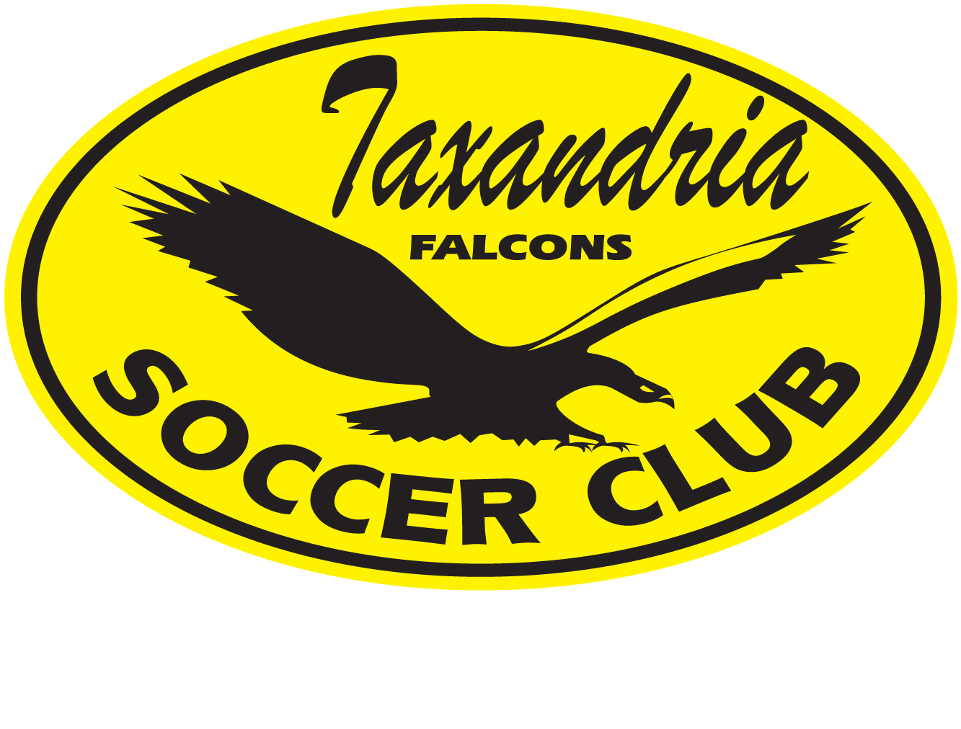
TAXANDRIA FALCONS SOCCER CLUB

CODE OF CONDUCT TO PROTECT CHILDREN

Effective: May, 2024

Taxandria Falcons Soccer Club (hereinafter “Taxandria”) has established a Child Protection Policy to ensure the safety and well-being of children involved in their soccer programs. The policy outlines the expected behavior of coaches, team officials, and staff when interacting with children, and includes the following guidelines:

- Communication with children should be directed to or indirectly (CC) via the parent/guardian, and club and team-based group communication sites such as email and team apps should be utilized whenever possible. Direct communication with children through phone or social media channels such as email, Facebook, Instagram, Snapchat, texting, etc. is not allowed.

- Meetings with individual players should be conducted in the presence of another adult such as the team manager, assistant coach, and/or the player's parent or guardian. Ad-hoc direct feedback before, during, or after games/practice scenarios is encouraged but must always be done at the training ground or similar venues within a visible setting.

- Coaches/team officials/staff should not be alone with a child in a non-visible place and/or enclosed space, such as a car, change room, or similar area, or provide transportation to and from practices, tournaments, festivals, and games to children unless accompanied by the child's guardian or with the guardian's consent.

- Coaches/team officials/staff should not leave children alone after a game or practice if their parent/guardian has not arrived to pick them up. In such cases, the coach and/or team manager must remain with the child in a visible place until the player is picked up.

- Practices should be conducted in a visible area, and there should be parents/guardians or other adults who have children on the team present in the immediate vicinity from arrival at the session to departure. Wherever possible, practices should not be conducted alone with a team.

- Coaches/team officials/staff should not use profanity, ridicule, verbal abuse, or engage in any unwarranted physical contact with a child.

The policy also includes general rules of behavior for staff/volunteers of Taxandria, which include guidelines on physical contact, communication, behavior that goes against Taxandria's mandate or policies, conducting investigations into allegations or suspicions of potentially illegal or inappropriate behavior, inappropriate communication, inappropriate contact, favoritism, taking personal photos/videos, telling sexual jokes or making suggestive comments to a child, showing sexual material to a child, intimidating or threatening a child, and making fun of a child.
Reporting Requirements: All staff and volunteers must report suspected child sexual abuse, inappropriate behavior, or incidents that they become aware of, whether witnessed personally or not. Reports should be made to the designated person, Child Welfare Agency, or law enforcement.

It is important for all coaches, team officials, and staff of Taxandria to be familiar with and adhere to this Child Protection Policy, as well as keep up-to-date with all requirements as part of Ontario Soccer, including the Respect in Soccer Program and Protecting Children & Youth in Sport. Any concerns or doubts about the appropriateness of behavior should be discussed with a member of the Taxandria Board of Directors.

If you have any questions or concerns regarding this policy, please contact our board at taxandriasoccer@gmail.com.

