Collectors Knives- Buck/Case Knife or Similar
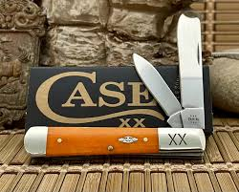

Goldfish Heights- Swim Party for 20-
Donated: Tommy & Rosalie Philips
https://goldfishswimschool.com/houston-heights/contact-us/

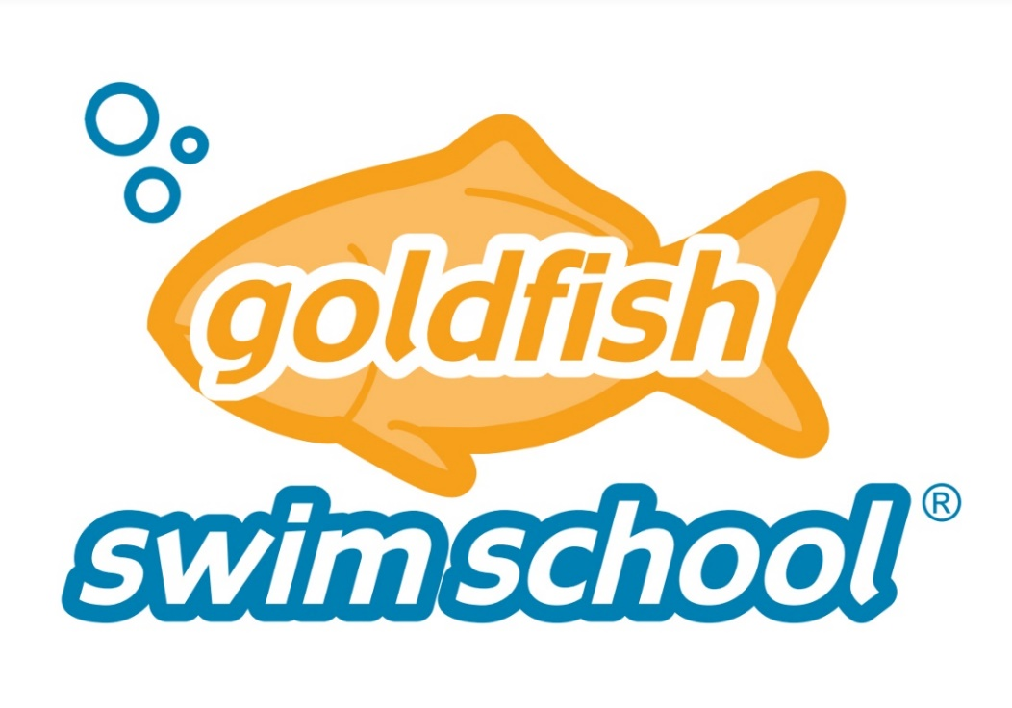

White Wine- 1 case (12 bottles)- hand selected-
Donated: Keith Livingston- Winesellers, Ltd.

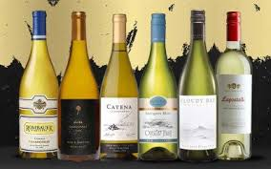

Oaks Dads’ Club- reserved parking for 1 year- any park, any spot
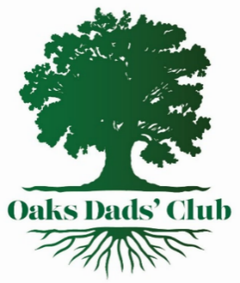

YETI M30- Soft Tote Cooler- United Rentals Trench Safety

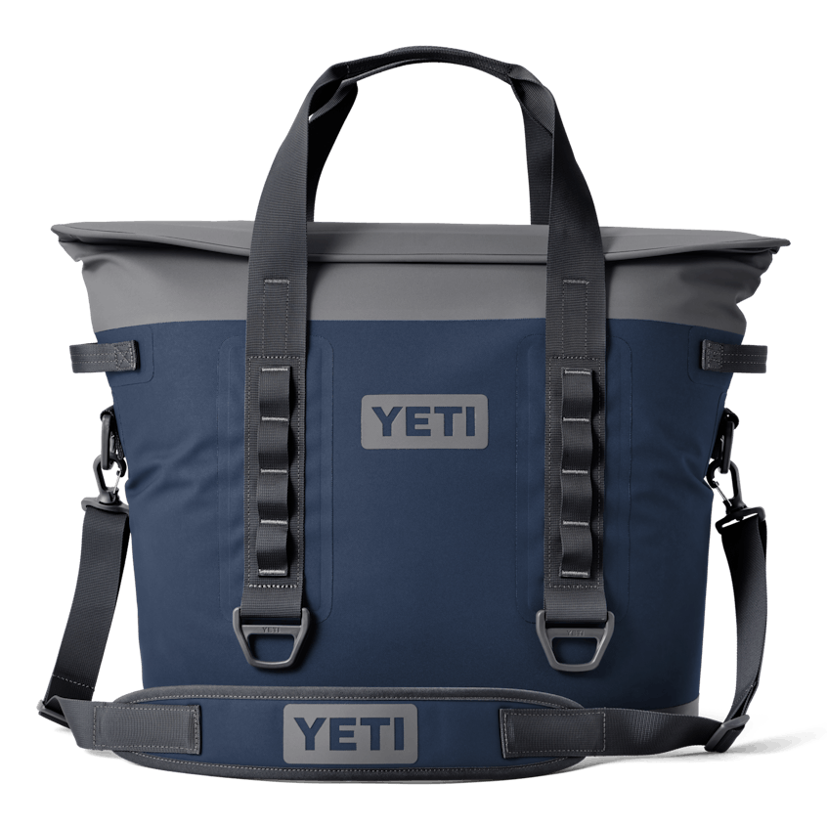

Fly your flag! 1 year of any flag of your choice at ODC Main or Candlelight Park


Astros- Gallagher Club - 8 seats – game TBD
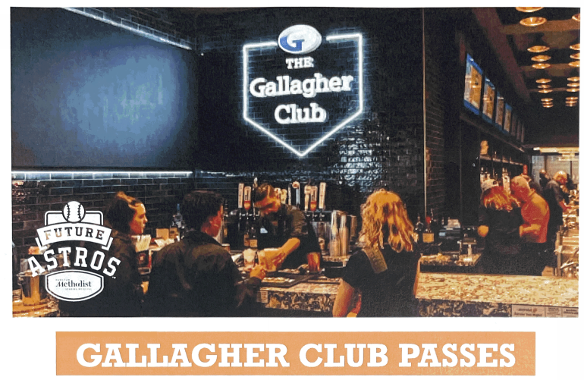

Red Wine- 1 case (12 bottles)- hand selected-
Donated: Keith Livingston- Winesellers, Ltd.


Oak Island Lodge- Anahuac, TX on Trinity Bay
2 day/2 night retreat- Sleeps 40!!!! (11 bedrooms- 38 beds)
(2) Lighted Fishing Piers, Boat slips
Dates: April- August; Monday-Thursday
home cooked meals included
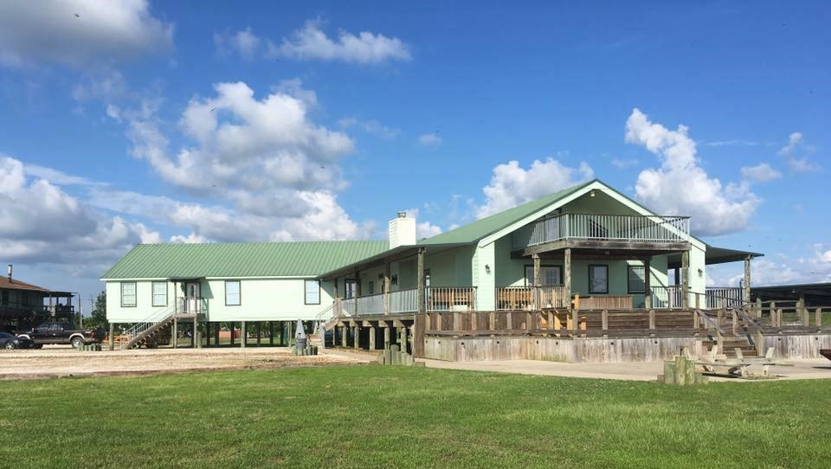
https://www.oakislandlodge.net/
Donated: Tony Cirillo & ODC

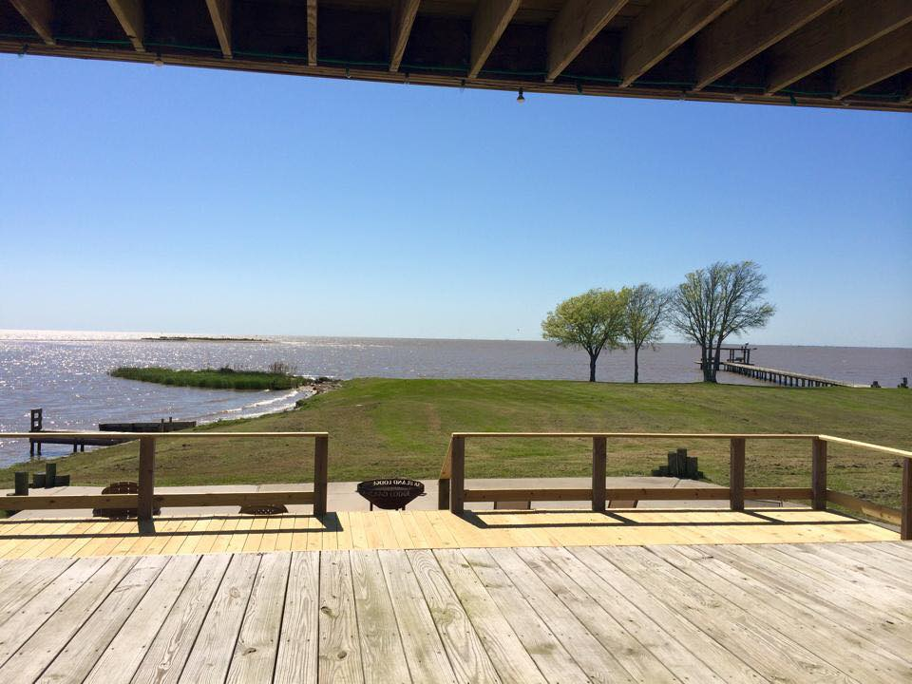

HLSR- Tickets- Keith & Lori Baumgarten- Show TBD



Urban Air Heights- Bounce Party for 20-
Tommy & Rosalie Philips
https://www.urbanair.com/texas-houston-heights/



Lake Livingston Lake House-
(2- night summer weekday, or Non-summer weekend)
5 BR/3.5 Bath- sleeps 14
Dual Master Suites, bunk room, detached Casita
Recently Renovated! Add’l nights may be added at discount
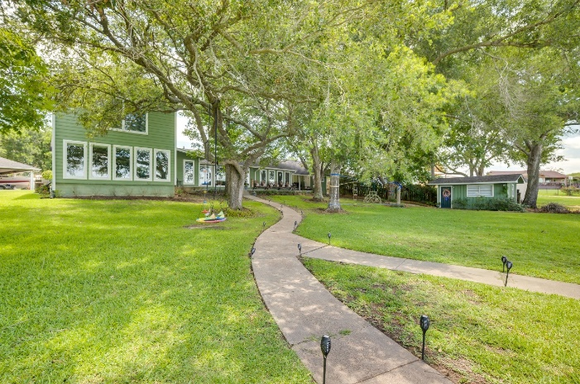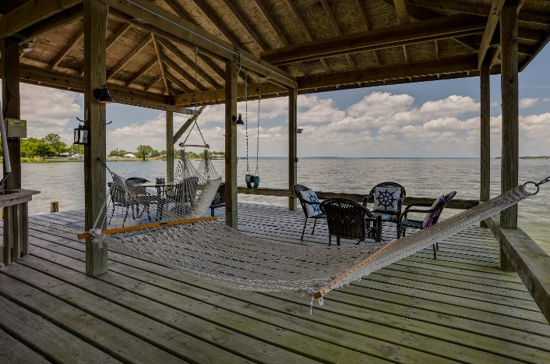
(Black out dates may include holidays)

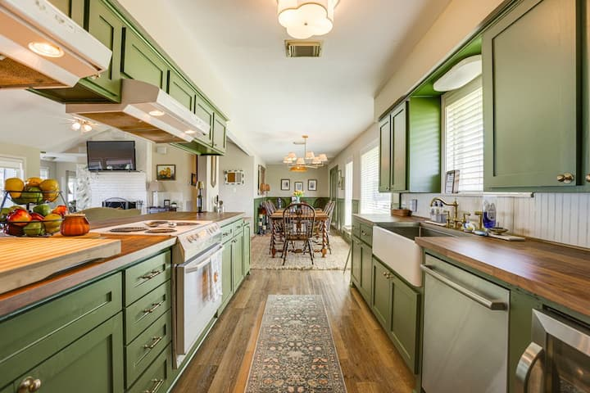
Home in Livingston · ★4.88 · 5 bedrooms · 13 beds · 3.5 baths
airbnb.com

https://www.airbnb.com/rooms/51018976?guests=1&adults=1&s=67&unique_share_id=6edc4401-0701-4c1a-b4d8-bfc48f011ae5
Donated: Amy & Austin Lee
Astros Suite- 25 seat suite -date TBD
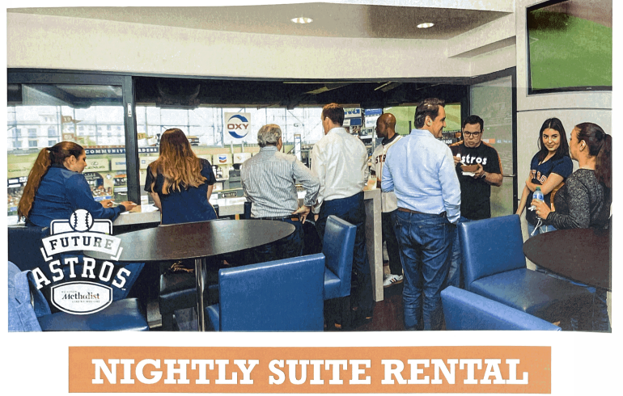
(does not include food or drinks)

Houston Rockets- 4 Suite level tickets w/ Parking- KHOU- Kali & Elizabeth Gipson

ODC Birthday Party- Includes ODC field rental, hotdogs/hamburgers, drinks, & cake for 20-ish kids

-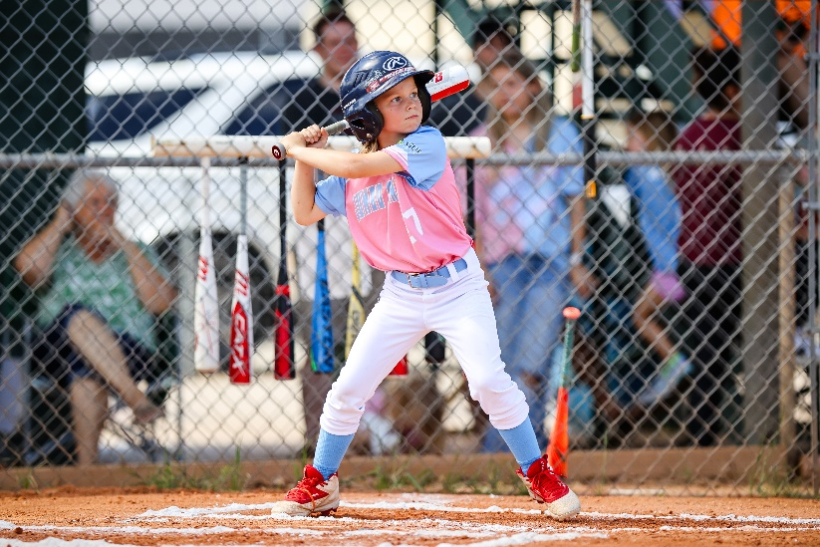

SPA 146- Items TBD- Dr. Theresa Harring



