Roll Call: Terry Johnson, Jesse Viall, Sean McCabe, Travis Steele, TJ Johnson, Adam Hoffman, John Klimek, Steve Hagen, RJ Schriefer, Brooks Savage, Jim Zgoda, Kristi Woodwick, Jaimie Schuster, Bernadette Schaffer
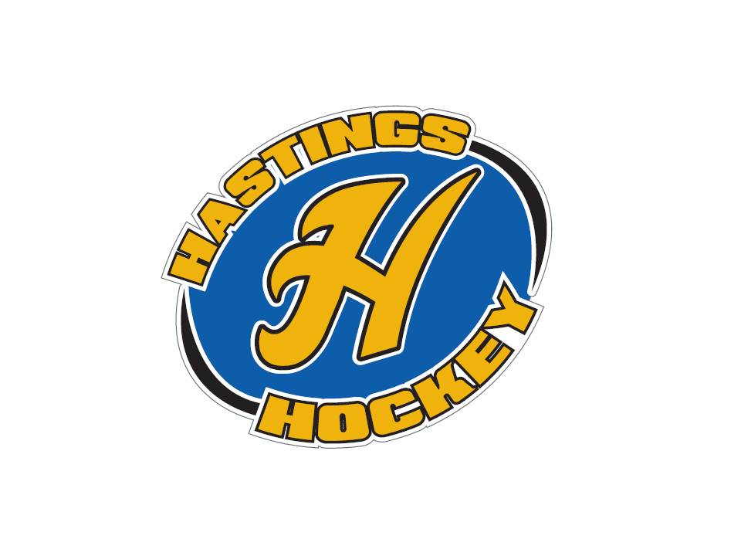

Not in attendance: Josh Colvin, Shannon Callahan, Randy Kruse, Steve DeBus

Not in attendance: Josh Colvin
- Approval of Agenda Sean made the motion – Kristi seconded and the motion passed
- Approval of Minutes Will approve next month

Coordinator Reports
- Referee – John Klimek –so wanted to clarify the referee reimbursement – can not directly pay the refs – must go through the HHB – if opposing teams are going to pay then ask that team to write the check to HHB
Approval for 15B to have 3 refs at scrimmages???? Adam made the motion Jesse Viall seconded – motion passed
- Registrar – Shannon Callahan All teams rostered except squirt travel and Junior Gold – have people check the rosters
Big jump on birth certificates – great work!
Coaches doing a nice job so far
- Technology – Randy Kruse not in attendance
- Tournament Director – All tournaments are full
Need a River Rumble Coordinator – Sean is willing but will like to get some guidance
- Sponsorships – Lisa McDowell not in attendance
Sent out 130 letters to local businesses and have had 6,7 reply already
Strauss will be Bantam
Miller will be River Rumble and Mites sponsorships
Rother will be Sugar and Spice
- District 8 – Adam Hoffman
04 and 05 can be nominated for HP
Girls 15a going to district 2 and 15b – haven’t established a boundary yet
Rosters in before they hit the rink
Interstate forms must be turned in
All head coaches are required to check D8 schedule and make sure it is correct
Coach will not need to go to the board and be penalized the $250 due to minutes of penalties for the team

- Goalie – Steve DeBus not in attendance
Monday nights are good so far – good attendance
- Secretary – Bernadette Schaffer
Nothing to report
- Recruitment- Josh Colvin not in attendance
Learn to skate program for older kids???? Will look into this for next year
Recruitment is up this year!! Yeah

Officer Reports:
- President – Terry Johnson- Miller Orthodontics
- Vice President – Adam Hoffman
Picture day is up on schedule
Team schedules – is working on them – waiting for U16, Jr Gold and U15 before he can get the rest of the schedule out
If you have a game change – someone on the team needs to pay and will then get reimbursed
Weather cancellations are not penalized
Will have 12B districts
Make sure you let Adam know if you have something scheduled
- Treasurer – Jaimie Schuster (Approval of the Financial Statements)
Sean made the motion, Kristi seconded and motion passed
Pictures will be a bit different - Names, team and # will be on the pictures this year
We need to come up with a better plan with how we hand out equipment for learn to skate programs……

Director Reports:
- Volunteers – Shannon Callahan
- Director of Hockey – RJ Schriefer
Stop worrying about other organizations, please think about what works best for Hastings
- Operations – Jim Zgoda
Team jerseys and equipment is out – waiting for Jr Gold and U16 teams
Will look into the cost of replacing squirt jerseys
Mite jerseys will need replacing soon as well
Mini sticks? Will do them for tournaments?
Dryland room is cleaned out
Will be updating the dryland schedule, and potentially outdoor rink

- In-House Girls – Kristi Woodwick
So far so good
U6 and U8

- Travel Girls – Travis Steele
Wave in from Cottage Grove
Goalie waved out at 12U

- Ter-Mites – Tom Johnson
139 kids in
1 moving up to mite 1, more will possibly happen in the next few weeks

- Mighty/Super Mites – Jesse Viall
Good to go

- Squirts – Steve Hagen
Teams and managers in place
A player has just asked to join the C team and that will put them into a situation with 3 goalies??
Discussion was had and might not be fair for the 2 goalies that already signed up??

- Peewees – Sean McCabe
Season up and going

- Bantams/Jr. Gold/U16 – Brooks Savage
Up and running with Bantams – Jr Gold and U16 will start after high school tryouts

Old Business:
New Business:

Hockey Night Friday February 8th

Coaching approvals
15 B assistants
Travis Steele, Mike Bernard, Matt Riches, Mike Steinke(goalie)

12 A head coach Adam Hoffman
12A assistants
RJ Schriefer
Mal McDowell
Levi Muhl
Mike Steinke (goalie)
Adam made the motion and Brooks seconded – motion passed

12B Head coach Jason Carl
Assistants John Townsend Joey Schweich Rob Judge

10A assistants John Thurmes Shane Lanning

10 B head coach Adam Newton
Assistants RJ Schreifer, Rob Judge, Jeff Wagner, Greg Jacobson (goalie)

PeeWee C Ben Lamb, Morgan Sweeney and student coach Tyler McCarville
PeeWee B2 Jeff Seubert Alex Dohman Adam Hoffman
B1 Rob Zietlow

Adam Hoffman made the motion, Brooks seconded and motion passed

Bantam B
JT Malm

Bantam C
Joe Stark
Brandon West

Travis made the motion and Jesse seconded – motion passed
Ref Reimbursements

Board Comment:
Membership Comment:
Adjournment: 9:30
Next Meeting: December 2nd 2018

