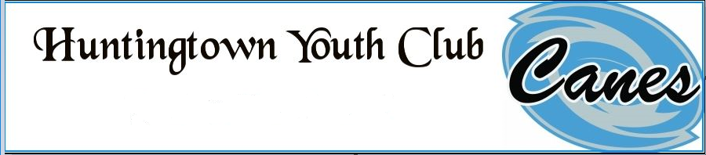
CODE OF CONDUCT
COACHES
✓ Coaches will remain unconditionally supportive of HYC’s commitment to the ideals of good sportsmanship, team play, honesty, loyalty, courage and respect for authority. Likewise, coaches will remain sensitive to the physical and emotional well-being of the players on his/her team. In order to adhere to these doctrines, the coaches agree as follows:
✓ Coaches will be positive role models.
✓ Coaches will display and instill in their players the principals of good sportsmanship and team play.
✓ Coaches will conduct themselves in a manner that best serves the interests of the players.
✓ Coaches will do their best to provide the players a positive experience.
✓ Coaches will ensure that winning and/or losing teams do so in a manner, which exhibits respect and good sportsmanship.
✓ Coaches will maintain a safe and productive youth sports program for the benefit of our young athletes.
✓ Coaches will ensure each child receive fair and consistent coaching, without prejudice, nepotism, racism or favoritism.
✓ Coaches will treat all players, parents, spectators and league officials with respect regardless of race, sex, creed, or ability.
✓ Coaches will provide instruction in a manner that is constructive and supportive.
✓ Coaches will not ridicule or demean players, referees or league officials.
✓ Coaches will not tolerate behavior that endangers the health or well-being of a child.
✓ Coaches will comply with the decisions of league officials and observe all rules, policy and procedure as established or endorsed by HYC.
✓ Coaches will teach the respective sport to the best of their ability. They will know the rules of the game and teach them to the players. Read the league rulebook and attend any clinics offered to enhance your knowledge of the game.
✓ Coaches will abide by the rules of the game according to their respective league guidelines.
✓ Coach all players (beginners and advanced) with equal vigor.
✓ Coaches to enforce Mandatory Play Rule, allowing all players more than their required playing time according to their league rules, promoting fair play at all levels.
✓ Coaches will be drug and alcohol free while at any HYC athletic event.
✓ Coaches will not use any tobacco products while at any HYC practice, game or event.
✓ Coaches acknowledge the need to demonstrate fundamental proficiencies with their respected sport and first aid. Consequently, all coaches agree to attend, any skill sessions that may be required by the Board of Directors and moreover, any first aid courses that may be mandated by the Board.
✓ Coaches are required to submit a background check through Calvert County Parks and Recreation.
✓ Coaches are required to obtain NAYS certification through the National Alliance for Youth Sports (visit www.nays.org to complete online test in order to obtain your certification number).

PARENTS, SPECTATORS, AND VOLUNTEERS
The Parent and Spectator will support the players, coaches, and league officials. Parents and Spectators will not “coach” or “officiate”. Parents and Spectators agree as follows:
✓ Parents and Spectators will be positive role models.
✓ Parents and Spectators will display and instill in all players, the principals of good sportsmanship and team play.
✓ Parents and Spectators will conduct themselves in a manner that best serves the interests of the players.
✓ Parents and Spectators will do their best to provide the players a positive experience.
✓ Parents will make certain that their children show respect for all other players, coaches, officials and spectators regardless of race, sex, creed, or ability.
✓ Parents and Spectators agree not to ridicule or demean players, coaches, or referees or league officials in any public forum.
✓ Parents agree to inform the coach of any disability or ailment that may affect the safety of their child.
✓ Parents and Spectators agree to treat all players, coaches and referees fairly and with respect.
✓ Parents and Spectators will comply with the decisions of league officials.
✓ Parents will support the rules, regulations and bylaws as established or endorsed by HYC.
✓ Parents and Spectators will not question an official’s call.
✓ Parents and Spectators will respect the opponent and avoid any confrontation with opposing players, spectators, or coaches.
✓ Parents and Spectators will be drug and alcohol free while at any HYC events.
✓ Parents and Spectators will refrain from the use of tobacco products at HYC events.
✓ Parents will insist that their child play in a safe and healthy environment.

PLAYERS
Players will…
✓ Display good sportsmanship and team play at all times.
✓ Follow the direction of the Coaching Staff.
✓ Respect all, coaches, players, league officials, and spectators regardless of race, sex, creed, or ability.
✓ Make every attempt to be on time and ready to play for all games and practices.

Players will not…
✓ Use abusive or profane language.
✓ Taunt or humiliate any other player.
✓ Question an official’s call.
✓ Abuse, mistreat or mishandle any HYC equipment or property.
✓ Be in possession or under the influence of any drug, alcohol, or tobacco product.

CONSEQUENCES
All members of the Huntingtown Youth Club are subject to consequences which may lead to discipline or possible termination of membership as determined necessary by the HYC Board of Directors, due to failure to comply with the Code of Conduct. All members agree to abide by these rules as part of their registration in the program. It is the responsibility of all members to be familiar with the guidelines set forth in the Code of Conduct.

