CHSAA Code of Conduct

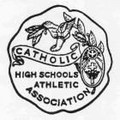
It is the purpose of the Catholic High School Athletic Association to promote the highest standards of fair play and sportsmanship at all times, keeping in mind the Catholic beliefs of all our member schools.
All players, coaches, and spectators will adhere to the Code of Conduct as put forth in our by-laws. Violators of this code, including spectators, are subject to ejection from our game as well as suspension from further games.
Please be reminded that this game is being videotaped.
At this time, the players and coaches of both teams will shake hands as a sign of the importance we place on sportsmanship in today’s game.

