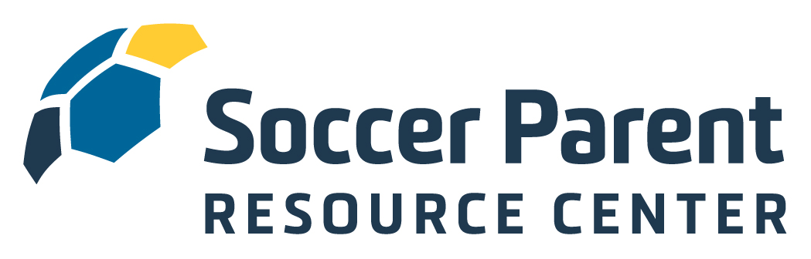

Welcome to the SoccerParentResourceCenter.com!

Walnut Creek Surf SC understands the importance of engaging and educating soccer parents and has therefore secured a club-wide membership to the SoccerParentResourceCenter.com, the parent education platform from the Soccer Parenting Association. You now have complete and free access to the interviews, articles, webinars, e-books, courses and amazing community of level-headed parents at the SoccerParentingResourceCenter.com.

To activate your free membership, simply copy this link into your browser:
https://soccerparentresourcecenter.com/register/club-membership/walnutcreeksurfsc/

The mission of the Soccer Parenting Association is to inspire players by empowering parents.

- We believe youth soccer parents will be difference makers when it comes to improving the game.
- We believe when parents seek information about how to best support their player, great things will happen.
- We believe a collaborative environment between coach, parent, club, and player is in the best interest of player development.
- We believe a strong and supportive community of level-headed and like-minded parents and coaches will inspire players.

Like you, I am a soccer parent. I am also a former professional player, collegiate coach, and active youth soccer coach, speaker and coach educator. I am positive that the information you now have access to on the SoccerParentResourceCenter.com platform will help your child thrive and feel inspired on the field and in life.

I look forward to connecting with you on our Soccer Parenting member-only Community Facebook page. If you have any questions, suggestions, or ideas for articles, please don’t hesitate in reaching out.

Let’s Keep Going,

-skye

Skye Eddy Bruce
Founder, Soccer Parenting Association
Skye@SoccerParenting.com

