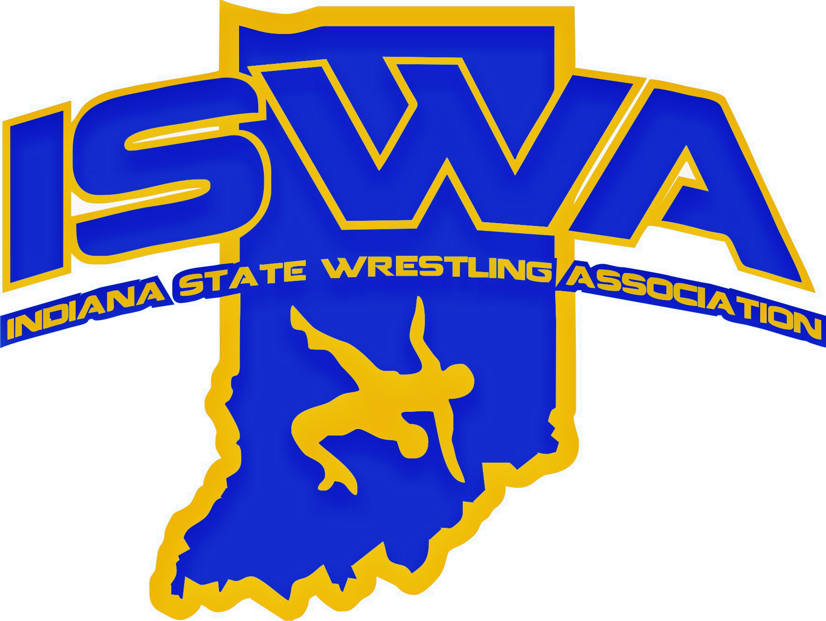
INDIANA STATE WRESTLING ASSOCIATION, INC.
P.O. Box 157, Beech Grove, IN 46107 Phone: 317-780-1885

2024-25 ISWA VICE CHAIR (ADMINISTRATION)
ANNUAL REPORT

The 2024–2025 season marked another year of growth, increased operational efficiencies, and community engagement for the Indiana State Wrestling Association (ISWA). I am proud that our organization not only maintained its momentum but also made significant strides in expanding participation, improving event execution, and strengthening our administrative infrastructure.

This season saw a measurable increase in participation across all levels of competition. Membership numbers rose steadily, reflecting the growing enthusiasm for wrestling throughout Indiana. Our sanctioned clubs played a pivotal role in this growth, hosting a greater number of events than in previous years. These events were well attended and efficiently managed, thanks to the dedication of club leaders and volunteers.

We continued to see the development of our pairing and mat officials with many interested in advancement, and actively pursuing higher rankings and additional training. This commitment to professional development ensures that our events are staffed by well trained and knowledgeable officials

On the national stage, the ISWA once again demonstrated its capacity to host premier events. In January, we successfully hosted the Kid’s Folkstyle Nationals in Fort Wayne for the second consecutive year. The event was well attended and executed, reflecting the ISWA’s growing expertise in managing large-scale competitions.
In June, we proudly hosted the Women’s 14U/16U/Junior National Duals at Grand Park in Westfield, IN. This event not only showcased Indiana’s hospitality and organizational capabilities but also reinforced our commitment to supporting the growth of women’s wrestling at all levels.
Each of these national events provided valuable insights that we are actively applying to future planning.

As we look toward the 2025–2026 season, the ISWA is well-positioned to build on this year’s successes.
We are excited about the opportunities ahead and remain committed to fostering a culture of excellence, inclusion, and growth within Indiana wrestling.

Respectfully submitted,

Jennifer Pierson
ISWA Vice Chair – Administration

