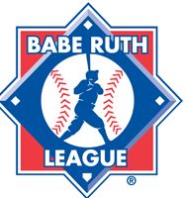
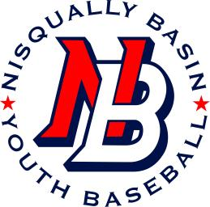
Nisqually Basin Youth Baseball
Representing Yelm and Surrounding Communities
Website and Facebook Photo Release
I hereby grant permission to Nisqually Basin Youth Baseball to use images of my children listed as participants in this league on its website and/or Facebook without further consideration. I understand that no names will be used.

I understand that once any image is posted to the Nisqually Basin Youth Baseball’s website or Facebook, the image can be downloaded by any computer user around the world. This consent is effective until such time as I revoke it in writing or the end of the current baseball season.

___________________________________________
Player Name (printed)

___________________________________________ ____________________
Parent Signature Date

___________________________________________
Printed Name

