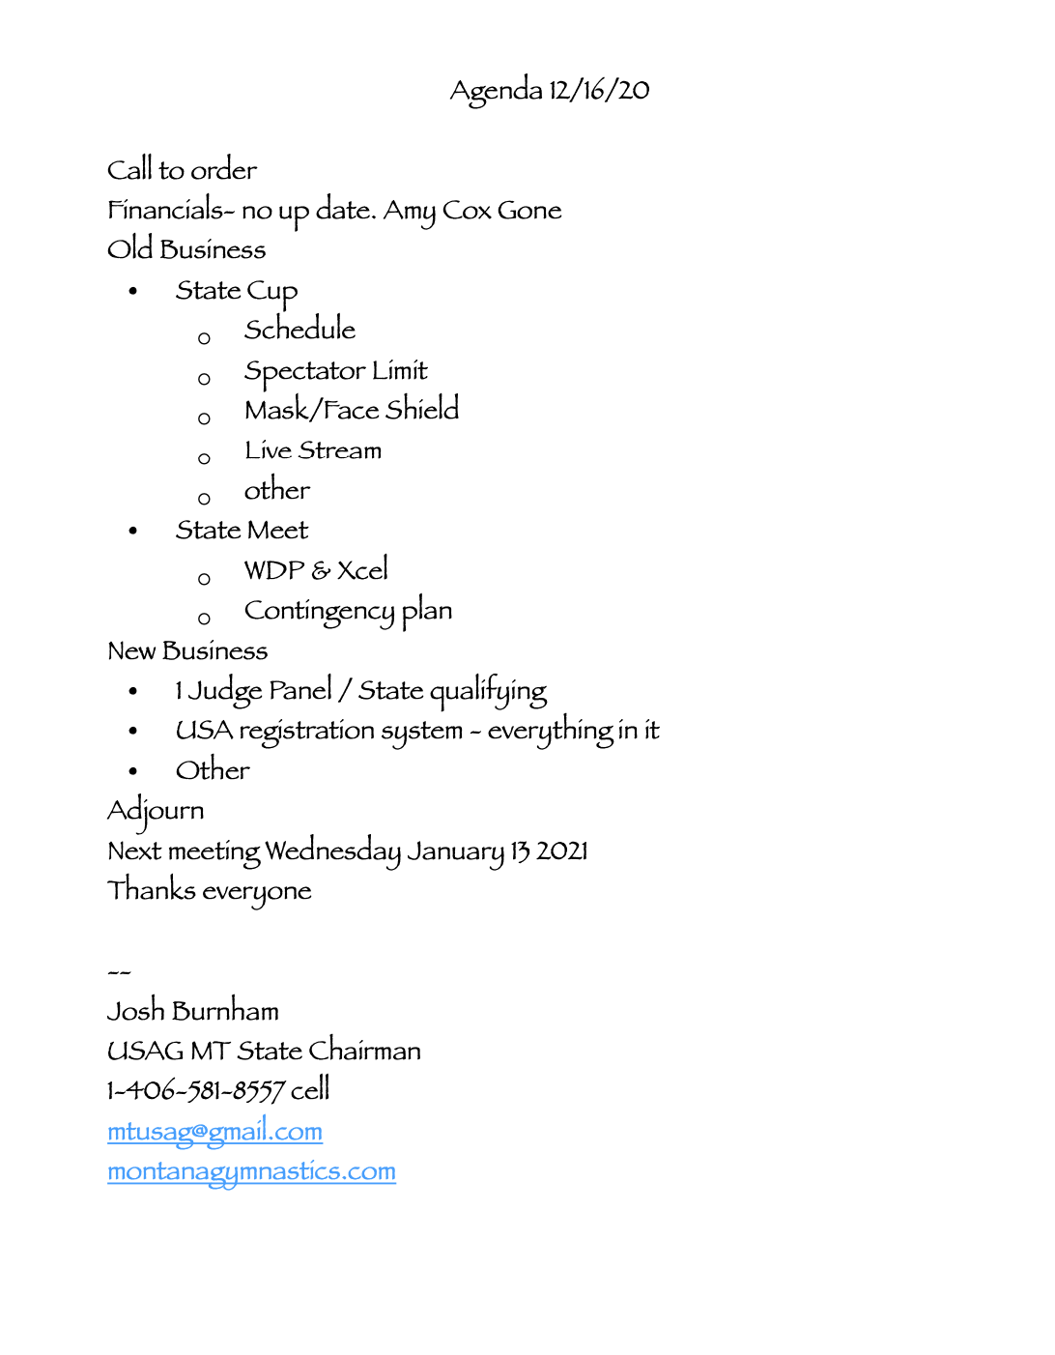

SAC - MT
Meeting Minutes
December 16, 2020

Call to Order: Josh Burnham (SACC) called to order the regular meeting of the SAC-MT at 8:52 p.m. on December 16, 2020.

Roll call: Josh Burnham, Jeanine Henneford, Denis Berry, and Sharon Mozer.

Announcements:
- Financials - No updates at this time.

- Moved to approve Minutes from 11/11/20.
TABLED

Old Business:
- State Cup 2021 (January 8-10, 2021). Kelly of MISMO has put together a tentative meet schedule for the board to review. The board reviewed the schedule and made suggestions as listed below. Times for each session will be adjusted accordingly. The idea is to keep the number of sessions low in order to be in compliance with the County Health Department.

- Kelly is permitting one spectator per athlete on site.

Friday 8th | Saturday 9th | Sunday 10th
Starts at 3:30 pm | Starts at 8:00 am | Starts at 8:00 am
Lvl 5 | Lvl 3 | Lvl 2
Lvl 6 | Lvl 4 | Bronze
xx | Lvl 7 & Platinum | Silver
xx | Lvl 8/9/10 | Gold

- Mask/Face Shield
  - To require regardless of what happens with the mask mandate, for it may change after the new year, that all attendees to the State Cup 2021 must wear a mask. Attendees include athletes, coaches, judges, spectators, and volunteers. Athletes may remove masks while warming up and competing.
Motion: Sharon Mozer
Second: Jeanine Henneford
PASSED (Approved Unanimously)

- Awards - State Cup 2021 - Awards will be prepared for coaches to pick up after the meet, or they will be mailed out. The top three placements on the AA, and first place on individual events will be announced.

5. Zoom Webinar Live Stream
- To have the state committee purchase a Zoom Webinar account for the 2020-2021 competitive season, and allow all clubs to use the account to live stream their meets/invitationals.
Motion: Denis Berry
Second: Sharon Mozer
PASSED

New Business:
- State Championships 2021
  - As a contingency plan if the LMG cannot host both Women’s Development Program and Xcel State Championships, on the same weekend (related to the County Health Department mandates for small gatherings), the state proposed the following:

⇢March 19-21, 2020 for State Xcel
⇢March 26-28, 2020 for State Levels 2-10 (Set date, cannot change)

- To have the 2020-2021 competitive season to have a 1-judge panel for Level 5 for state qualifiers.
Motion: Denis Berry
Second: Jeanine Henneford
PASSED

- Josh wanted the board to be aware of a new change with the USAGym meet registration system where meet directors must include names of all coaches and judges/officials who are on the field of play during a meet. Meet directors will have to log on to the meet registration system to fill out, edit, and complete the form for accurate information as required by USAGym.

- The Hall of Fame idea was proposed to recognized retired coaches who have impacted gymnastics in Montana and beyond.
TABLED

Adjournment:
To have the meeting be adjourned. The meeting adjourned at 11:30 p.m.
Motion: Denis Berry
Second: Jeanine Henneford
PASSED
Next Meeting: January 13, 2021
Minutes submitted by Sharon Mozer

