ARAA HOUSE VOLLEYBALL
PARENT AND COACH GUIDE

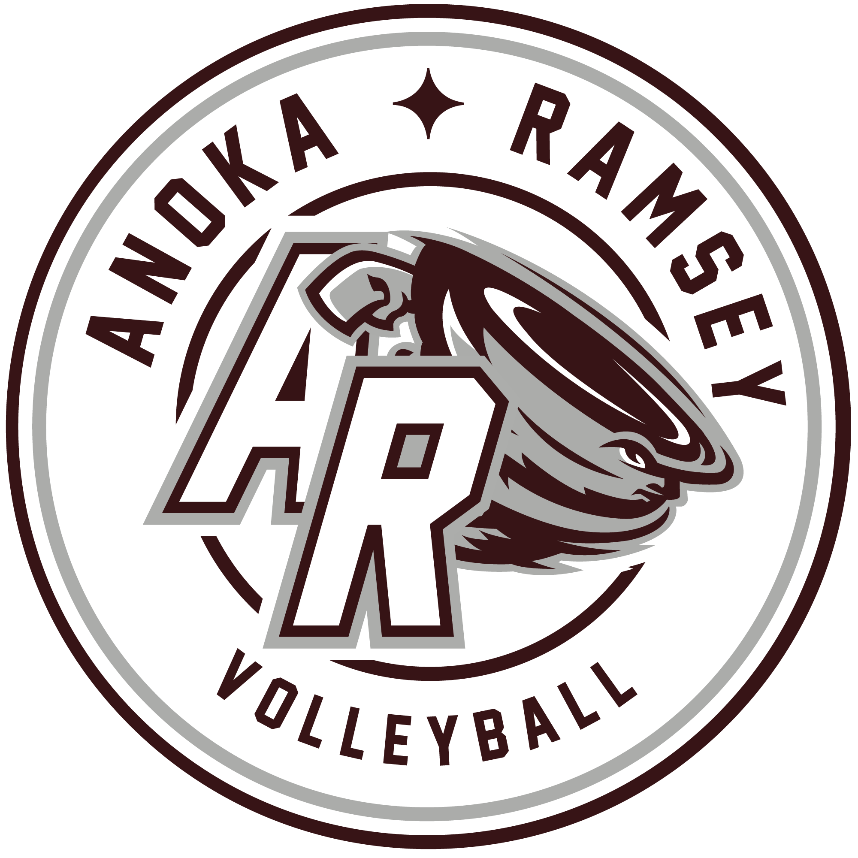

Anoka Ramsey Athletic Association-Volleyball
arsports.org/volleyball
Revised September 2023
Volleyball Board
Name | Position | Email Address
Jennifer Shimek | Commissioner | volleyball@arsports.org
Diane Fowler | Equipment & Uniform | araavolleyballeu@gmail.com
Jessica Perez | Treasurer | araavolleyballtreasury@gmail.com
Jackie Hime | JO Director | araajovolleyball@gmail.com
Katie Jensen | JO Director | araajovolleyball@gmail.com
Alex St John | House Director | araahousevolleyball@gmail.com
LaRae Olsson | Communications | araavolleyballcomm@gmail.com

Gym Locations
Anoka/Ramsey
LOL South | Lord of Life Church | 14501 Nowthen Blvd NW, Ramsey, MN 55303
LOL Middle | Lord of Life Church | 14501 Nowthen Blvd NW, Ramsey, MN 55303
LOL North | Lord of Life Church | 14501 Nowthen Blvd NW, Ramsey, MN 55303
AMS 1 | Anoka Middle School | 1523 S 5th Ave, Anoka, MN 55303
AMS 2 | Anoka Middle School | 1523 S 5th Ave, Anoka, MN 55303
AMS 3/4 | Anoka Middle School | 1523 S 5th Ave, Anoka, MN 55303
Ramsey N | Ramsey Elementary Door 4 | 15000 County Hwy 5, Ramsey, MN 55303
Ramsey S | Ramsey Elementary Door 14 | 15000 County Hwy 5, Ramsey, MN 55303
Brookside N | Brookside Elementary Door 1 | 17003 Nowthen Blvd NW, Ramsey, MN 55303
Brookside S | Brookside Elementary Door 1 | 17003 Nowthen Blvd NW, Ramsey, MN 55303
Andover
Andover HS 1 | Andover High School | 2115 Andover Blvd NW, Andover, MN 55304
Andover HS 2 | Andover High School | 2115 Andover Blvd NW, Andover, MN 55304
Andover HS 3 | Andover High School | 2115 Andover Blvd NW, Andover, MN 55304
Champlin/Dayton
Rebels 1 | Champlin/Brooklyn Park Academy | 6100 109th Ave. N, Champlin, MN 55316
Rebels 2 | Champlin/Brooklyn Park Academy | 6100 109th Ave. N, Champlin, MN 55316
Oxb East | Oxbow Elementary | 6505 109th Ave. N, Champlin, MN 55316
Oxb West | Oxbow Elementary | 6505 109th Avenue N, Champlin, MN 55316
Dayton | Dayton Elementary | 12000 S. Diamond Lake Rd, Dayton, MN 55327
Jax Lower | Jackson Middle School | 6000 109th Ave. N, Champlin, MN 55316
Jax Upper | Jackson Middle School | 6000 109th Ave. N, Champlin, MN 55316
Elk River
Rogers
 | Rogers High School | 21000 141st Ave N, Rogers, MN 55374

Schedules
- Practice/game schedules may need to be changed due to conflicts with school and facility events that arise after publication of the schedule. This is out of ARAA’s control and changes will be communicated to parents by coaches as soon as the information is available.
- If a change occurs, an updated schedule will be sent to all coaches with the following information:
- Team(s) affected
- Summary of changes and reason for the change (i.e. school took gym space away or teams agreed to modify their schedule due to mutual conflicts)
- Games will be scheduled against Andover, Champlin/Dayton, Elk River and Rogers Associations. Travel to these neighboring associations will occur.

Teams
- Coach requests will be considered in team formation but cannot be guaranteed.
- Player requests will be honored to the extent possible.
- The number of registrants and volunteer coaches will ultimately decide the number and sizes of teams.
- Each team is formed based on the child’s grade level to the extent possible. In the event there are not enough players registered, grade levels may be combined to create a team.
- Our goal is to place no more than 10 players on each team to allow more play time for participants. If the number of players on a team results in having fewer than six players on game night; the rules allow a team to play with fewer than six players (see rules).
- This is a developmental league and there is no try-out process. Teams are formed based on player/coach requests and ideal team size. As a result, some teams may be slightly mismatched. Please keep in mind because this is a developmental league the emphasis is on learning the proper fundamentals of volleyball and having fun; not winning.
- Each team will be identified by a number for scheduling purposes (grade level and team number). If you have a question for a board member regarding your team; please refer to the team’s number in your email.

Goals
3/4th Grade
- Introduction to volleyball; court, positions and game rules.
- Do not let the ball hit the floor.
- Communication with team mates (i.e. “mine”, “got it”, “out”, etc.).
- Proper passing technique with controlled passes/bumping.
- Overhand serves from the 10 foot line.
- Coaches begin teaching players to set the ball.

5/6th Grade
- Do not let the ball hit the floor.
- Communication with team mates (i.e. “mine” “got it” “out” etc.).
- Multiple touches per side.
- Overhand serves from behind the 10 foot line.
- Coaches begin teaching hitting, tipping and blocking.

7/8th Grade
- All items from 3rd through 6th grade. (see above)
- 3 touches per side; pass, set and hit or tip.
- Blocking
- Overhand serves from the end line.
- Introduce rotations and positions (advanced teams).

9th-12th Grade
- All items from above.
- 3 touches per side; pass, set and hit or tip
- Blocking
- Overhand serves from the endline
- Rotations and positions (advanced teams).

Overall Season Goals
- Improving volleyball skills and building the player’s confidence level on the volleyball court
- Scoring and winning the game is less important than ensuring that skills being taught in practice are attempted during games even if this means losing the point.
- Overall improvement of each player’s skill from the beginning of the season to the end of the season is more important than the win/loss record.
- Have fun; we want our players to love the game and look forward to playing again next year.

Coaches
- All coaches will have a background check completed each year.
- Please keep in touch with your player’s parents; send reminders and provide parents with your email address or cell phone number (whichever means is best to contact you) so that questions regarding practice and games can be answered in a prompt manner.
- You will be provided with 10 balls, a coach bag, pump and needle, first aid kit and scoreboard. We will schedule a turn-in date following the season. Extra balls will be given if the team has more than 10 players.
- Please communicate our goals to parents the first night your team meets for practice. A short team meeting at the first practice to go over our program’s goals, your expectations as a coach, and providing parent’s with your contact information is generally a good way to kick off the season.
- Coaches are responsible for making sure that the volleyball net is set at the correct height for their age group.
- Create a rotation schedule at the beginning of the season and continue with it throughout the season. Not changing the rotation (except in 7th-12th grade if the coach believes that their team’s skills are advanced) will allow the kids to focus their attention on skills and development.

Game Night
Net height should be at the following height/ letter:
- 3rd/4th grade: 6’ 4” (J - look at mark on pole)
- 5th/6th grade: 7’ (J plus hand - between J & W)
- 7th-12th grade: 7' 4 ⅛” (W)
- Nets are typically set up for teams to practice/play. It will be the responsibility of the coaches to make sure their nets are at the appropriate height.
- Shared court warm-up for 5 minute, then each team gets an additional 2 minutes each to warm-up serving. Allow 45 minutes to play as many games as you can to 25 points.
- During warm-up coaches/players meet for coin toss with ref. The coin toss by the referee determines which team will serve first. Teams will not choose sides, they will play on the side they arrived on. The winner of the coin toss wins the serve. First serve alternates each game.
- During the coach meeting, coaches and refs should discuss rules, any modifications to the game they feel are necessary based on team ability and ask and answer any questions to ensure all are on the same page.
- Please find parents (normally one from each team) to act as line judges. No one under 16 should be acting as line judge.
- Find a parent to keep score. No one under 16 should be responsible for the scoreboard. No one is perfect, if the score is inaccurate please refrain from yelling at the score-keeper. Remember, this is a developmental league, our focus is on learning skills, not winning the match. In the long run, this will make your child a better volleyball player.
- ARAA Volleyball will do their best to provide a referee for each game. If a referee is not assigned or unable to make it to the game a coach from one of the teams will act as ref.
- Referees are instructed to be lenient with calls at the younger ages and less lenient as age level increases.

General Rules
- The purpose of this league is to teach each player fundamental skills and to have fun while learning the game of volleyball.
- Less emphasis on the score of the game and more emphasis on encouraging players to practice skills even if it means losing a point; progress is the goal.
- Parents and coaches must conduct themselves in a manner that encourages players and builds their self-confidence.
- Coaches may ask the referee why a certain call was made but may not challenge the call or argue with officiating staff.
- All parents/guardians, players, coaches and spectators must abide by the ARAA Code of Conduct. Absolutely no parent may argue with the referee’s call or yell at the referee. If this occurs the coach should ask the parent to leave the gym.

Rules of Play
- Six players on the court during game play. If you are short a player you may use 5 and it is acceptable to borrow players if the other team has more than enough; the kids are here to learn skills and get play time. The more play time each player gets the better.
- The coin toss by the referee determines which team will serve first. Teams will not choose sides, they will play on the side they arrived on. The winner of the coin toss wins the serve. First serve alternates each game.
- Teams will not be switching court sides after each game.
- Rally scoring is used. A point is scored regardless of which team served the ball. The team winning the point serves the next ball. If a team scores five points in a row off the serve, the ball is given to the other team to serve.
- Play games to 25 points. A team must win by two points with a 27 point cap.
- No 2-hand attack. Players may not hit the ball over their heads with both hands to push/slap/throw or hit the ball over the net.
- No blocking the serve.
- Back row attack is only allowed if done from behind the ten foot line. (Back row player hitting/spiking the ball in front of the 10 foot line is not allowed)
- Only 3 contacts can be made before the ball goes back over the net. Any more than 3 results in a point for the other team.
- A player may not contact the ball 2 consecutive times. If a player touches the ball 2 times in a row, a point will be awarded to the other team.
- Refs will use their best judgment on passing/setting faults. If a fault is called, coaches can take time to explain to their player why the call was made. Coaches cannot contest calls; only ask why a particular call was made.
- A player may serve up to 5 times in a row. If the serving team wins the point on the fifth serve; the ball is given to the other team for serving.

Serving
- Players are encouraged to overhand serve. We want players to get used to the overhand technique but not get discouraged or frustrated. Encourage the player’s first serve to always be overhand. If the ball doesn’t go over the net on the first serve they can opt to serve underhand.
- Serving “do-overs” will only occur if the ball does not go over the net. If the ball goes over the net but lands out of bounds there will be no do-over.
- Players can serve from any area behind the serve line within the side boundary lines. Younger/smaller players may be allowed to serve closer to the net, but never in front of the ten foot line.
- If a server can serve consistently and with power, challenge them by having them move further back from the net. If a server is having trouble getting their serve over the net, have them move closer but never in front of the 10 foot line.
- A serve that hits the net and falls over to the other side is a successful serve.
- Foot faults will not be called for the younger age groups. If a player steps on or over the line on a serve, coaches should use this as a teaching moment and remind the player to not cross over the line.
- One re-toss on a serve is allowed. A ball caught after thrown up to serve is a balk but will not be called side-out. Coaches should use this as a teaching moment and remind the player to let the ball drop.

If questions arise and you do not feel the rules provided sufficiently cover all situations, please share your concern/situation with the ARAA Volleyball Board so that the rules can be modified.

