Go to stowbaseball.org and make sure you are logged in. Check the upper right corner, if it looks like below, you are logged in. If not, it will say “Sign In”. Use the email that you registered your team with (the one this email was sent to). If you can not sign in, check your spam folder for an invitation that I sent out and then let me know you accepted the invitation so I can set the proper permissions for you.
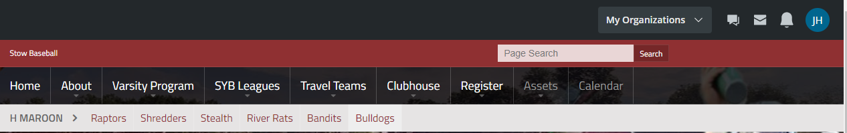

Hover (do not click) over the menu tab that reads “SYB Leagues”

Click on the league that you registered for. Currently, it will bring up the Spring Session. Once we get closer to the Fall Session, it will switch to go directly to the Fall Session. To get to the Fall Session until it switches, click on the black box that says “Spring 2020”. It will drop down where you can select “Fall”.

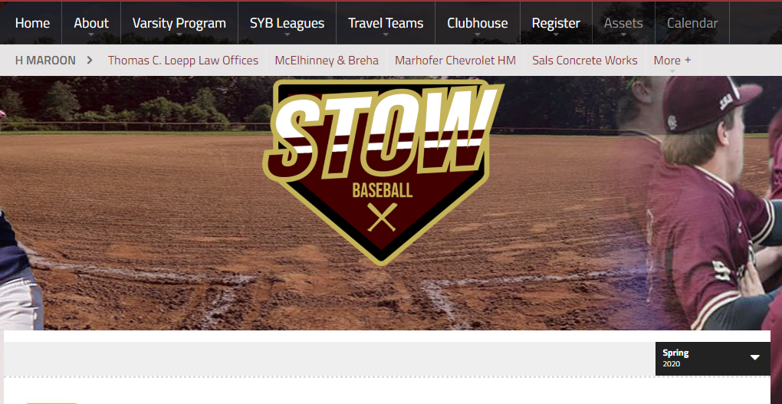
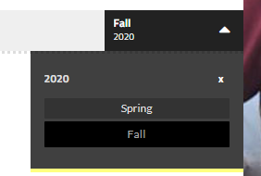
You will now see the Fall teams at the top of the screen. Click on your team.
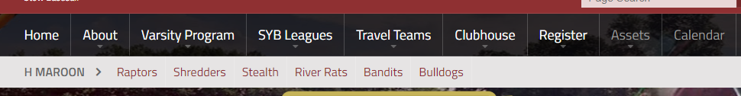

Once your team loads, click on “Roster”
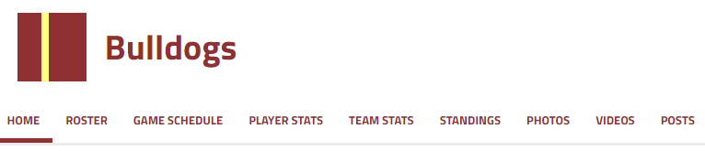

Make sure your “Edit” is on. It will be located in the upper left corner.
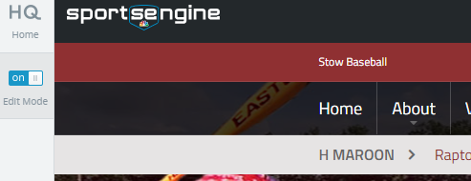

Here you can click on “Add Player” to add to your rosters.
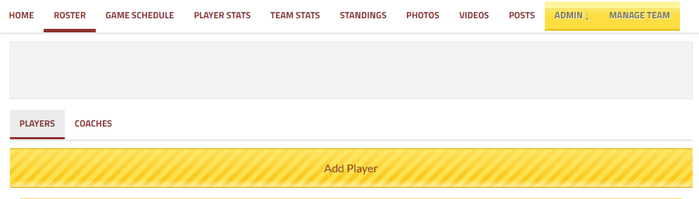

Click on ‘Create New Player From Scratch’
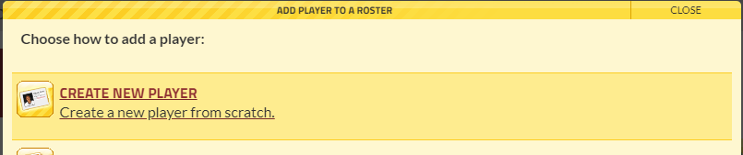

Please enter the players First Name, Last Name, Jersey Number and Email address. By entering the email address, the player will be invited to the team site. When everyone is entered, you can message your whole team, set up your practice schedule and track RSVPs. The game schedule will be entered once complete and will give your team a central place to view the schedule.
