Recognition /Investigation / Enforcement

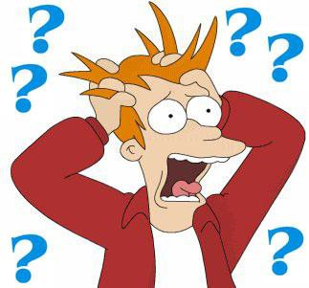

Thanks to Scott Gray from MN for content!

INVESTIGATE
REPORT

HEARING

SAFETY OF MEMBERSHIP

Regardless of the validity of the complaint, handle when possible as a means of accomplishing 10 goals by reasonably assisting complaint towards satisfactory conclusion. View as an opportunity not an annoyance.

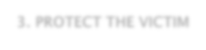GOALS CONTENT
1. STOP THE ABUSE
2. STOP ABUSE FROM RECURRING
3. PROTECT THE VICTIM
4. SANCTION THE ABUSER
5. CREATE CUSTOMER SATISFACTION
6. LIMIT LIABILITY
7. LIMIT BAD PUBLICITY
8. PRESERVE INTEGRITY OF SAFE SPORT
9. PRESERVE INTEGRITY OF ORGANIZATION
10. USE AS A LEARNING TOOL

Sexual
Abuse
Hazing
Physical Abuse
Bullying, Threats, and Harassment
Emotional Abuse

Personal Complaint

Complaint on behalf of another

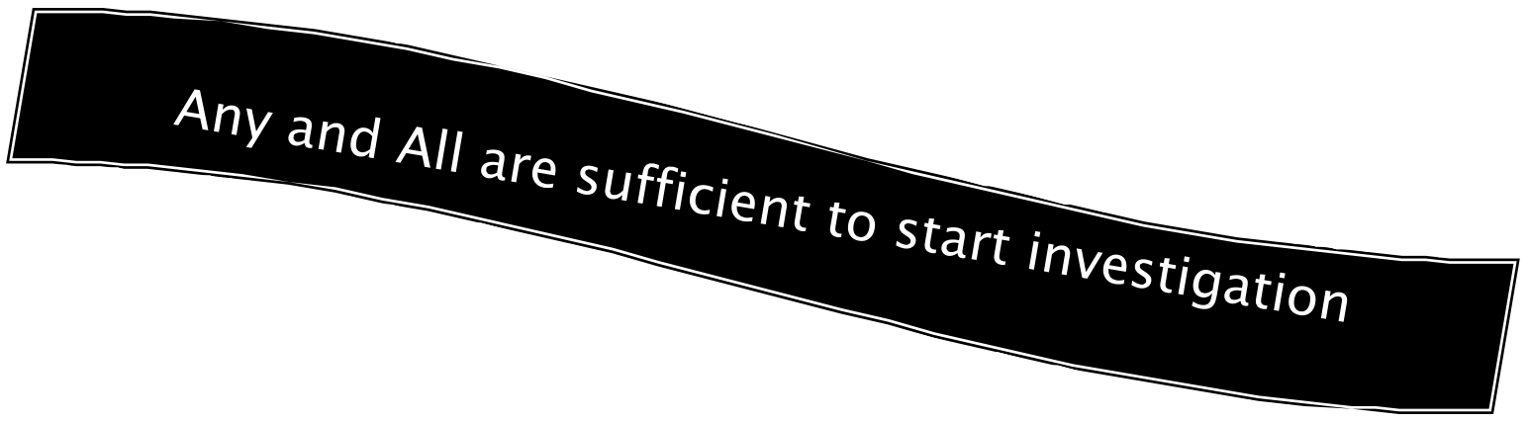
Personal Observation
Report of Observation

Is Association comfortable with investigation? ASSOCIATION INVESTIGATES

Does complaint include acts/omissions of someone in
the Association? LEAGUE INVESTIGATES

Are there concerns re: impartiality of association? LEAGUE OR AFFILIATE INVESTIGATES

Are accusations a crime?
LAW ENFORCEMENT INVESTIGATES

Does the issue require Affiliate involvement? AFFILIATE INVESTIGATES

2.Analyze Allegations
3. Contact Witnesses

4. Obtain written
statements

5. Evaluate the Work Product
1. Contact Complainant

6. Contact Accused

- If kid, then coach
- If Coach, then Association
- If
Association,
then District
- If District, then USA

Determine who will investigate
- Hospital / Immediate Danger ➔ Summary Suspension
- Call Police
- Name
- Contact Info
- What can they offer
- Apology / Suspension / criminal charges

Learn Urgency / current status of victim

Is there a police issue?
Obtain Preliminary Witness List
Assess complainant’s wishes

Perceived or Specific
Isolated or Chronic

Can they be Verified
Additional SafeSport Violations

► Who are you, what is your position
► Inform of SafeSport
► Inform of Issue
► Stress Confidentiality
► Identify Goals (What will happen)
► Caution about Retaliation

► What is the history behind the accusation?
► Use written statements:
- Eliminates denial
- Reduces Misunderstanding
- Can be compared to additional statements
- Can analyze for content
- Saves time

► Tell them who you are and why you are calling
► Explain accusation / Can be written
► Note an admission or counterclaim
► Note “complete confusion”
► Denial
► What are they willing to do

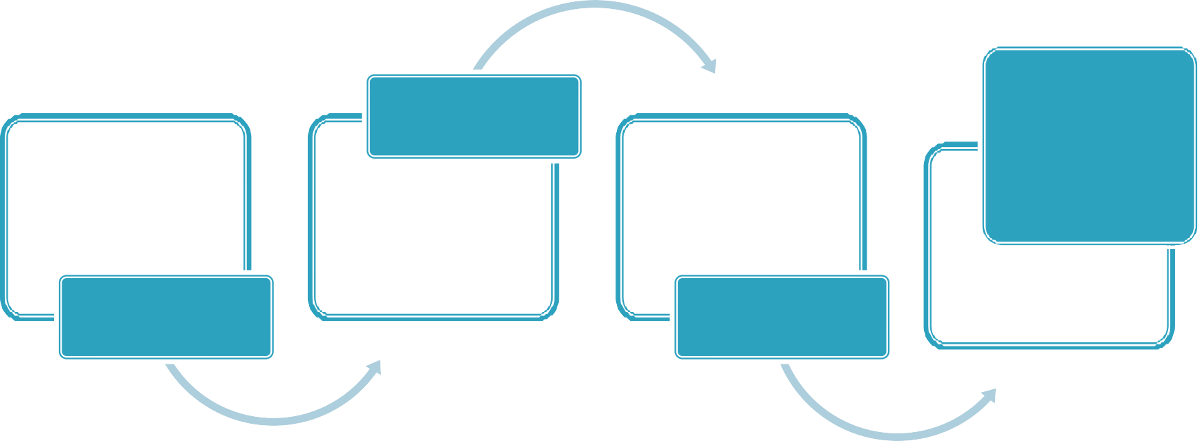
League Hearing
BYLAW 10
Association Hearing
Affiliate Hearing

Follow USA Hockey Bylaw 10
- Summary Suspensions
- Hearings
- Notifications

When in doubt about the process, ask…
“In all cases, the disciplinary procedures and actions of USA Hockey and its Affiliates and local programs shall be proportionate, reasonable and applied fairly and equally.”

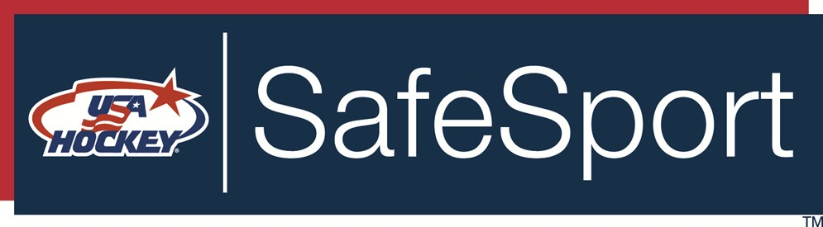

Elgine McArdle
2139 Market Street
Wheeling, WV 26003
(304) 232-0700 (work)
(304) 312-6076 (cell)
elgine@mcardlelawoffice.com

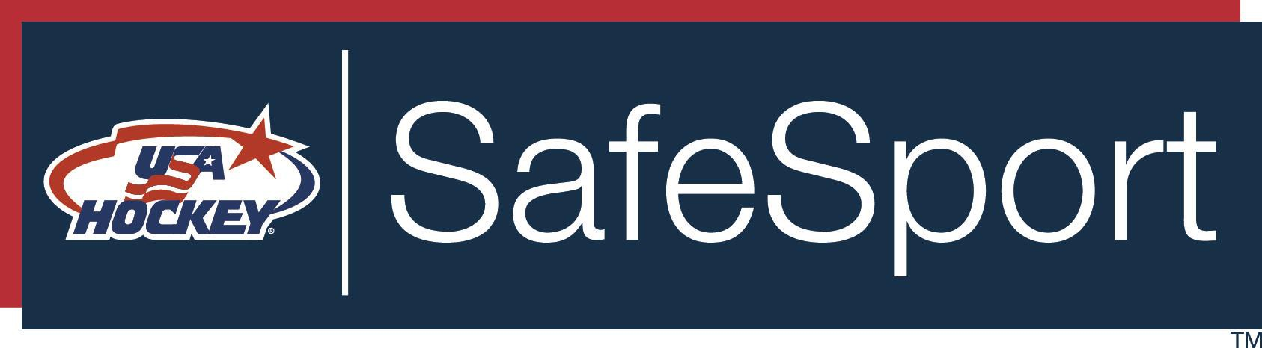

Jennifer Boulden
District 6 SafeSport Rep
952-212-2725
Jennifer.boulden@yahoo.com

Casey Jorgensen
USA Hockey General Counsel
719-538-1143
cjorgensen@usahockey.org

Joyce Kulpinski
USA Hockey SafeSport and Legal
Administrator
719-538-1145
joycek@usahockey.org

