

INFORMATION FOR ROCK HILL SPORTS CENTER
FYI: Region staff will be unavailable to answer questions or emails within 48 hrs of the event. We will be setting up. Emergency contact- have club director call the host
Welcome to the Rock Hill Sports Center, in partnership with USA Volleyball Palmetto Region, we host 7-8 tournaments annually. This is one of the finest facilities in South Carolina.

Seating: Seats are provided for Spectators. DO NOT SAVE SEATS: Utilize them while YOUR team is playing. When your team is OFF or working as an officiating team, leave the seats around the court so the participating teams can view their children's play. No sports chairs allowed.

Food: No team food may be brought into the facility unless you are ordering from the Power House Food Court. Individual families may bring in outside food, but teams can not bring in and set up team tables. There are limited tables in the large room adjacent to the courts, these are only to be used for a limited time to have a meal or break between matches. Teams or families can not “camp out” there for the day or extended time. PLEASE DISPOSE OF YOUR TRASH. The RH Sports Facility does have a canteen with limited food options.

Additional Discounts: https://www.visityorkcounty.com/sports/athletes-discount-codes-promotions/

Gate Tickets Tickets can be purchased at the door.
Adults 18 and older: $15 per day Children 17 and younger: Free
PAYMENT OPTIONS: Plan ahead- CASH or CHECKS ATM is available
ALL MUST WEAR WRIST BANDS EACH DAY
PARKING is now Free using parking decks A or B

Restaurants: There are a number of NEW restaurants within walking distance.
Power House is similar to a Mall Food Court: https://www.powerhousefoodhall.com/
See below information on what Power House can offer teams or individuals.
Also new is : https://www.everbowl.com/acai-bowl-locations/rock-hill
Additional restaurants: https://www.cityofrockhill.com/visitors/attractions/restaurants

NO TOLERANCE POLICY
The Palmetto Region has a No Tolerance Policy on screaming, yelling, or making any
derogatory remarks to ANY official (R1, R2, Scorer, or Line Judges). Keep in mind, they are
human, and many times they are kids. Penalty is immediate dismissal from the playing site,
no warning. Region teams may face sanction to participate in future tournaments. Coaches’
improper behavior or misconduct between spectators, coaches, and/or players can lead to
sanctions from the region for the individual and/or team.

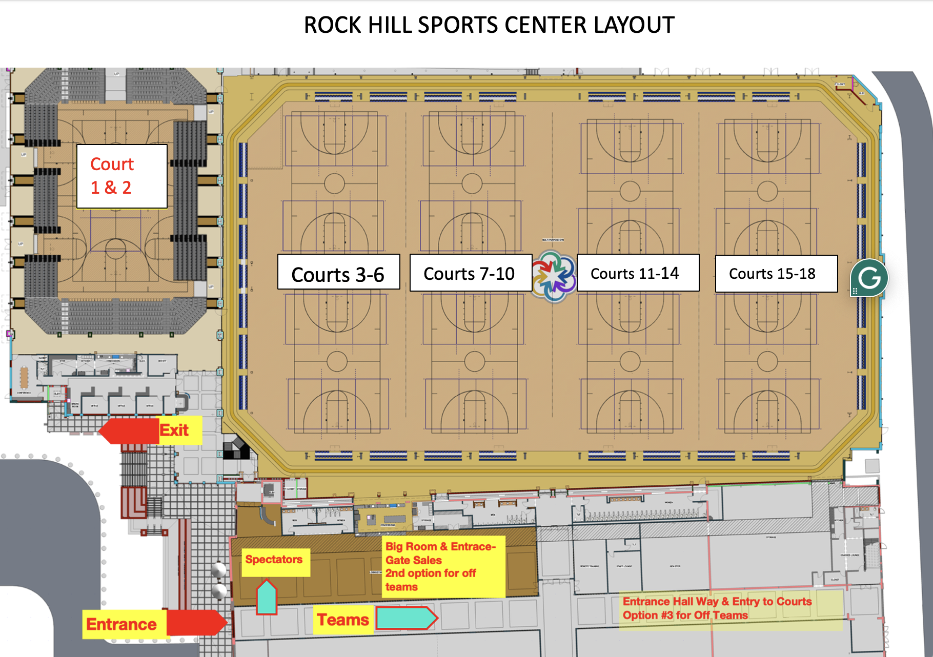
ALL enter right of main entrance.
Spectators/parents to the left.
Teams- Coaches continue straight down the hallway.

VERY IMPORTANT:
Cars can NOT stop and drop off in front of the facility. This causes back up

Hotel Information and Room Blocks

Palmetto Region negotiated with the city of Rock Hill and the local hotels to create blocks of rooms at the contracted lowest rates during the weekends of our events. To obtain these rates, you must use the links below.

HOTEL Room Blocks 2025
Hotel Links only for these tournaments associated with Large Venues
JAn 4-5th ROCK HILL Appalachian Boys / Girls – Icebreaker:
& some divisions of Southern Classic Club from Jan 18-19
https://groups.reservetravel.com/group.aspx?id=80270

Jan 18-19th Rock Hill Southern Classic Club
– https://groups.reservetravel.com/group.aspx?id=80271

Jan 25-26th Rock Hill Southern Classic Power –
https://groups.reservetravel.com/group.aspx?id=80272

FEb 1-2nd ROCK HILL Rumble at the Rock
https://groups.reservetravel.com/group.aspx?id=80650

Feb 22-23rd Rock Hill Crosstown Throwdown
https://groups.reservetravel.com/group.aspx?id=81369

March 8-9th ROCK HILL CSRA Winter Heat Augusta Power
https://groups.reservetravel.com/group.aspx?id=80273

The below Championships are REQUIRED TO USE THESE HOTELS
MArch 28-30 Rock Hill PVA Championships Week 1 – https://groups.reservetravel.com/group.aspx?id=80274
MArch 28-30th PVA Championships Week 1 – Spartanburg
https://groups.reservetravel.com/group.aspx?id=81084

APril 1-3 Rock Hill PVA Championships Week 2 –
https://groups.reservetravel.com/group.aspx?id=80275


Catered Boxed Lunch Menu
Located in the same building of the facility

OLD TOWN CHOPPER SALAD $12

Mixed Lettuces, Tomato, Cucumber, Cheddar, Bacon, Ranch Breadcrumbs,
choice of homemade buttermilk ranch or balsamic pecan dressings

grilled chicken +$5
KINDA CLASSIC CAESAR SALAD $11
Mixed Lettuces, House Focaccia Croutons, Parm, Calabrian Caesar Dressing

grilled chicken +$5
HAND BREADED CHICKEN TENDERS $13

Four Tenders, Battered Fries, Choice of buttermilk ranch or honey mustard

BANG BANG CHICKEN SANDWICH $13

Fried Chicken Breast in our Sweet & Spicy Bang Bang Sauce, with
LTOP, Black Eye Pea Salad, and Martin’s Bun
STANDARD BURGER $12

Beef Burger, Applewood Bacon, Cheddar, LTOP, Burger Sauce, and Martin’s Bun

OLD TOWN BLT $12

Applewood Bacon, Lettuce, Tomato, Roasted Garlic Aioli, Texas Toast
(All Sandwiches served w/ a bag of chips & apple or sub fries for $3)

Allow our Chef Drew Carter and his team of talented chefs to create boxed meals that are both drool-inducing and Insta-worthy for your next tournament in Rock Hill. In an attempt to make your visit more seamless come lunch time, we are offering this to all teams competing in the Rock Hill Sports & Athletic Facility.
Orders must be placed 24 hours ahead of the pickup time. To place your order, please email the order sheet to
info@oldtownrockhill.com. Orders will be picked up from our to-go window at the entrance of the restaurant.

Orders come with napkins and cutlery kits, 6 cups provided per gallon drink.

oldtownrockhill.com 803.980.6852 300 Technology Center Way STE 203

PARKING- 2025 Parking is Free

