Novant Health Sports Medicine
Cold Weather Guidelines
Introduction:
Exposure to severe cold weather cannot only be uncomfortable for athletes, but can potentially impair performance and even become life threatening. Environments with cold, wet, or windy conditions (or a combination of these), can potentially expose athletes to the risk of cold-related injuries and conditions. The occurrence of these injuries depends on the combination of 2 factors: low air or water temperatures (or both) and the influence of wind on the body’s ability to maintain a normal thermal core temperature, due to localized exposure of the extremities to cold air or surfaces.
A few of the cold-related injuries created by cold exposure include frostbite and hypothermia. Wind chill, which is the perceived decrease in air temperature felt by the body on exposed skin due to the flow of air, can impair performance when muscle temperature declines. When temperature or wind-chill (which is lower than actual temperature) reaches 25° F, frostbite can occur in 30 minutes or less. Hypothermia frequently occurs at temperatures above freezing. A wet and windy 30‐50 degree exposure may be as serious as a subzero exposure.
For this reason, Novant Health Sports Medicine is developing a severe cold weather guiedelines using both the wind chill factor and ambient temperature. Wind speed interacts with ambient temperature to significantly increase body cooling.
Frostbite is the freezing of superficial tissues, usually of the face, ears, fingers, and toes. Hypothermia, a significant drop in body temperature, can lead to profound exhaustion and energy depletion. The resulting failure to the temperature‐regulating mechanisms constitutes a medical emergency.
Precipitation can have an added effect on body temperature. When the body and clothing are wet (whether from sweat, rain, snow, or immersion), the cooling is even more pronounced due to evaporation of the water held close to the skin by the wet clothing.
Clothing is one of the most important aspects of keeping the athlete’s body warm. Athletes should dress in layers and try to stay dry. Layers can be added or removed depending on temperature activity and wind chill. Moisture, whether from perspiration or precipitation, significantly increases body heat loss. Athletes should layer themselves with wicking fabric next to the body, followed by lightweight pile or wool layers for warmth. Athletes should use a wind-block garment to avoid wind chill during workouts. Heat loss from the head and neck may be as much as 50% of total heat loss; therefore, the head and neck should be covered during cold conditions. Other extremities should be covered at all times to protect from the wind chill.
Also coaches and athletes should be aware that hydration is important during cold weather activity. Cold exposure/activity requires similar hydration to room temperature; however, the thirst reflex is not activated. It is recommended that athletes make concerted efforts before and after practice to hydrate. Cold exposure/activity requires more energy from the body therefore an additional calorie intake may be required.
Recognizing early signs of cold-induced stress may prove to be important in preventing cold weather-related injuries. The following signs and symptoms are considered to be early warning signs:
- Shivering
- Abnormal sensation in the extremities (e.g. numbness, pain, or burning sensation)
- Disorientation
- Slurred speech
Athlete trainers should constantly evaluate weather conditions when there are outside activities scheduled to take place. Evaluate immediate and projected weather information, including air temperature, wind, and chance of precipitation. Identify activity intensity requirements and clothing requirements for each individual. Have alternate plans in place for deteriorating conditions and activities that must be adjusted or cancelled.
The following precautions will be in effect for all outdoor practices and team workouts. Games will be governed by game officials and NCHSAA rules and regulations. Athletic trainers should encourage proper warming apparel and use of sideline warming devices, if available.
Wind Chill Factor 30° and below
- Be aware for the possibility of cold-related injuries.
- Outside participation allowed with appropriate attire
- Conditions should be constantly reevaluated for change in risk, including the presence of precipitation
Wind Chill Factor 15°-25° F
- Athletes must be dressed in additional layered, protective clothing
- Cover as much exposed skin as practical
- Keep clothing dry particularly socks and gloves
- Provide opportunities and facilities for rewarming.
Wind Chill Factor 0°-15°
- 45 minutes of outside exposure then 20 minutes inside a gym or locker room (may return outside after 20 minute warm-up period
- Strongly consider moving all practices inside
Wind Chill Factor below 0°
- All outdoor practices are prohibited

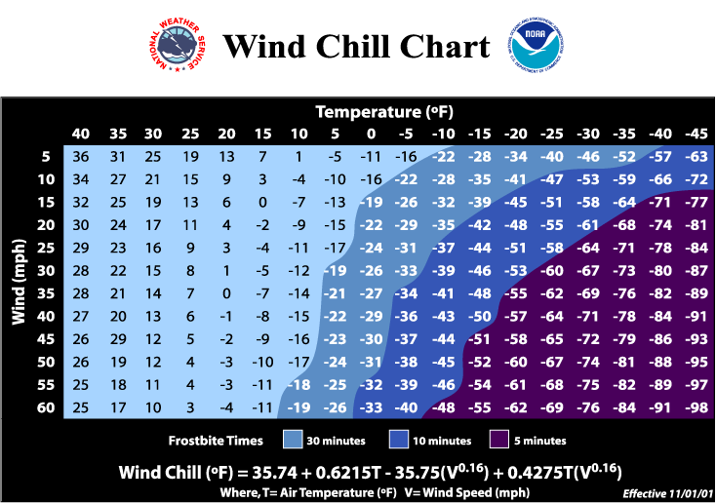

Signs and Symptoms of Cold-related Injuries
Mild Hypothermia
- Core temperature 98.66F to 956F (376C–356C);
- Amnesia;
- Lethargy;
- Vigorous shivering;
- Impaired fine motor control;
- Cold extremities
- Typically conscious
- Blood pressure within normal limits
Moderate Hypothermia
- Core temperature 946F to 906F (346C–326C)
- Depressed respiration and pulse
- Cardiac arrhythmias
- Cyanosis
- Cessation of shivering
- Impaired mental function
- Slurred speech
- Impaired gross motor control
- Loss of consciousness
- Muscle rigidity
- Dilated pupils
- Blood pressure decreased or difficult to measure
Severe Hypothermia
- Core temperature below 906F (326C)
- Rigidity
- Severely depressed respiration
- Spontaneous ventricular fibrillation or cardiac arrest
- Usually comatose
Mild/superficial Frostbite
- Dry, waxy skin
- Erythema
- Edema
- Transient tingling or burning sensation
- Skin contains white or blue-gray colored patches
- Affected area feels cold and firm to the touch
- Limited movement of affected area
Deep Frostbite
- Skin is hard and cold and may be waxy and immobile
- Skin color is white, gray, black, or purple
- Vesicles present
- Burning aching, throbbing, or shooting pain
- Poor circulation in affected area
- Progressive tissue necrosis
- Hemorrhagic blistering develops within 36 to 72 hours
- Muscle, peripheral nerve, and joint damage likely
Chilblain
- Red or cyanotic lesions
- Swelling
- Increased temperature
- Tenderness
- Itching, numbness, burning, or tingling
- Skin necrosis
- Skin sloughing
Not all patients will display all signs and symptoms of the condition.
Treatment: Cold Exposure
- Remove the athlete from the cold environment to a warm area.
    - Athlete’s vital signs should be evaluated and athlete should be constantly monitored for worsening symptoms.
- Raise Body Temperature
    - In case of frostbite, wrap the area in a soft, loose cloth and seek medical attention right away. If medical care is not nearby, hold the affected area under warm, but not scalding, water until normal skin color returns. Don`t cause additional tissue damage by rubbing the area affected by frostbite.
    - In case of hypothermia, wrap him or her in warm, dry blankets. Be sure to remove any wet clothing first.
- Provide warm liquids
    - Provide warm liquids such as tea or hot soup or hot chicken broth if the person is alert and aware of his or her surroundings.
- Constantly monitor vital signs
- Seek medical help if any of the following is true:
    - The person's fingers, toes, nose, or ears are numb.
    - The affected body part looks yellow-white or patchy blue.
- Call 911 immediately if the victim has any of the following:
    - Exceptionally cold skin
    - Drowsiness, disorientation, or loss of consciousness
    - Loss of muscle control
    - While you wait for help reassure the person, assess vital signs and treat for shock or provide rescue breathing and/or CPR in needed.
References:
NATA Position Statement:
https://www.nata.org/sites/default/files/EnvironmentalColdInjuries.pdf

UCPS Communication
Each school’s Athletic Trainer will regularly check the WBGT/Heat Index, and when one school moves into a new higher‐risk zone, a communication will be sent to Huston Mattson, LAT. Communication from Huston will occur by the following means:
- Via text and email to: All Union County ATC’s, James Oglesby and Nelson Garner
- All athletic trainers are responsible for communicating to the coaches at their school
- Nelson will communicate with all Union County Athletic Directors

