Team Reports Form for ISWA Member Guide
Team: 14U Team Indiana – Greco-Roman

Team Leaders & ISWA Title: Steve Livingston – 14U Team Leader

Coaches: Charles Taylor, Joe Wilson, and Tanner Boman

Volunteers & Others You'd Like to Thank: A huge thank you goes out to Terri Shaw who worked the table at each of our duals helping run Track Wrestling and/or operating the camera. Ben Davis High School stepped up and hosted our camp.

Team Results: 4-4 and placed 3rd the Copper/Bronze Pool (11th overall)
Indiana defeated Delaware 63-21
Indiana defeated Pennsylvania Red 41-38
Michigan Blue defeated Indiana 50-33
Utah defeated Indiana 42-41
Colorado defeated Indiana 44-39
Indiana defeated Maryland 49-35
California defeated Indiana 57-25
Indiana defeated New Jersey 45-37

Roster:
71 – Colton Wiseman (7-1)
77 – Haedyn Cochran (5-3)
83 – Landon Burkett (2-6)
87 – Deacon Gibbs (4-4)
92 – Eli Kincaide (2-6)
92 – Reese Nunn (Team X)
97 – Jaxon Smiley (0-8)
102 – Jeremy Carver (8-0) ALL DUALS TEAM
106 – Camden Hook (6-2)
110 – JJ Doty (2-6)
114 – Caleb Asa (7-1)
119 – Andrew Wilkins (0-8)
125 – Joseph Paun (6-2)
130 – Emmit Abernathy (2-6)
130 – Charles Faurote (Team X)
136 – Lincoln Hinchman (7-1)
149 – Bane Metcalfe (0-8)
165 – Austin Manley (4-4)
187 – Giovanni Celis (5-3)
250 – Shawn Jackson (4-4)

Narrative: Team Indiana began the tournament in Pool D where we were able to finish in third place. That moved us to the Copper/Bronze pool where we finished in third as well. Our wrestlers continued to improve throughout the tournament and wrestled their best matches in the later rounds of the tournament. There is a lot of grit and resilience among this group of athletes. There are great things in store for many of these wrestlers. The team was led by Jeremy Carver who concluded his second 14U Greco-Roman National Duals tournament undefeated and made the All Duals team.

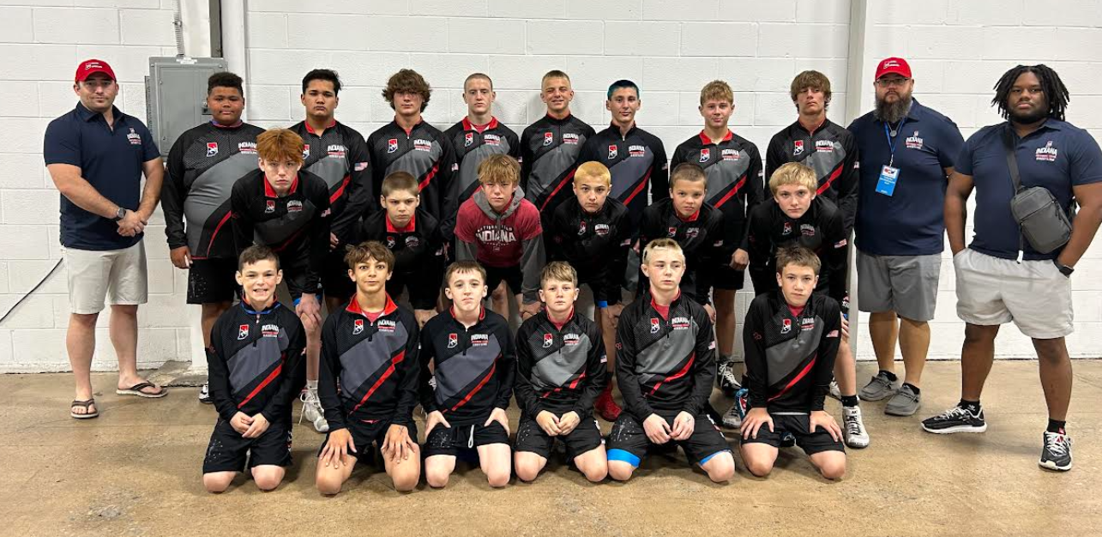
-Back Row: (L to R) Coach Tanner Boman, Shawn Jackson, Giovanni Celis, Austin Manley, Joseph Paun, Emmit Abernathy, Lincoln Hinchman, Bane Metcalfe, Charles Faurote, Coach Charles Taylor, Coach Joe Wilson
-Middle Row: Caleb Asa, Eli Kincaide, Camden Hook, JJ Doty, Jaxon Smiley, Andrew Wilkins
-Front Row: Haedyn Cochran, Deacon Gibbs, Colton Wiseman, Landon Burkett, Jeremy Carver, Reese Nunn

