U5/U6 Pilot session
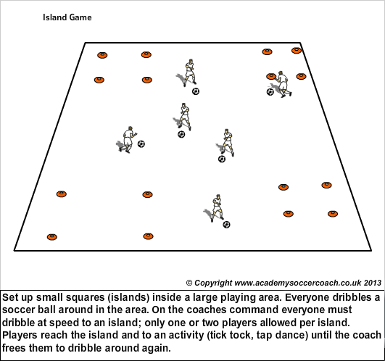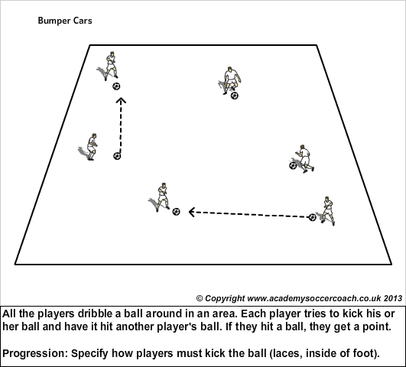
Bingo A number of tall cones are distributed throughout the field. Designate two "replacers" (coaches). Each player has a ball. The players dribble around and try to knock down as many cones as they can yelling "bingo!" as they do. The replacers stand the cones back up immediately. Who can get the most bingos? Progression: Must be 3 yards away to knock cones over, must strike ball with laces.

