Formation and What to Expect from Each Position

Thomas Hunt
Topeka Select Gunner 2018-2019 Season

Formation:
1-3-2-3. 1 Goalkeeper - 3 defenders – 2 central midfielders - 2 wide forwards & 1 striker

The following is a quick summary of what I expect from each position. It would be good for the boys to know multiple positions as everyone will play at least two different positions regularly.

Defenders:
We have three defenders so the 1st 2nd and 3rd defender principles. The new part here is the 3rd defender who’s roll is to pick up the addition threats beyond the player with the ball and his most likely options.
- Positional play comes into factor here a lot. The defenders need to constantly be talking to each other to maintain an even defensive line to trap forwards in offsides.
- Do not be afraid to slide in the tackle! A lot of times a challenge can be won clearly with a strong sliding tackle. It is something I want to work on more this year.
- When the keeper gets the ball, if you are one of the wide defenders get out wide to allow the keeper to play an easy outlet ball to you. Punting it up field when the keeper has it is good sometimes, but too much keeps us from building any possession.
- Do not enter the final 1/3rd of the field and look to provide a “drop” if necessary to more forward players.
Attacking Wide Forwards:

- STAY WIDE coming to the middle of the field reduces the space for the midfielders/striker and leaves us lacking an option when the ball is in the central of the field or when our defenders have the ball.
- Be helpful of the “fullback” [defender] on your side when possible. If there is an extra man in his area do what you can to help [either calling a midfielder to pick up the extra attacker or track back yourself if necessary]
- When the opposing team has the ball in our first third of the field, the primary job is to be an outlet for when we win the ball back [getting open] and then tracking back to defend if necessary.
- Look to get in behind the opposing team’s fullbacks either on the outside or just on the inside of them in the “channel” [the channel is the area of the field between the widest part and the central area].
- If you get a defender isolated in the attacking half do not be afraid to take them on! Remember even if you fail 8 times out of 10, if those two times you succeed and we score it is worth it.
- For crosses: try and get your plant foot around the ball as to get the cross back across the box to an area where we can attack it. Last year far too often our wings did not do this and crosses went out for goal kicks or straight to the keeper more than I would prefer.
Striker:
This position stays relatively the same
- The striker rarely comes deep in our own half. His job is to defender the opposing team’s defenders and force mistakes from them. He can be a little more risky with his defending and jump in as it is low risk if he gets beat.
- When we have the ball in our own box the striker acts as our outlet. He needs to be aware of where the ball will be played out so he can be in a good position to provide that outlet ball.
- Shoot, do not be afraid to shoot especially with both feet.
- Do not be afraid to take defenders on when they are isolated.
- Look for your wings and attacking midfield to be making runs beyond you and play the ball in behind to them.
- Look to get in behind the defenders when possible. If we always look to play to feet than the opposing team will stuff out our midfield. We need to play the ball over the top every now and then so look for that through ball.
Midfielders:
- The midfielders need to work together as they control much of the field being in the central part of the field. We DO NOT want to get caught with both of our midfielders forward as then our defenders will be exposed to fast on running attackers. THUS, if one midfielder is forward the other should remain further behind.
- I want the midfielders to interchange as to who gets forward and who does not as it will help to keep them “fresh”.
- For the further forward midfielder: look to run beyond the striker when possible as defenders will have difficulty “marking” you when doing such.
- If we are in our own starting third of the field take more caution [simple passes, safe dribbling, do we need to clear it or play a safe through ball?]
- If we are in the opposing half of the field or final third do not be afraid to take more risk [penetration via the pass or dribble].
- Have in your mind to “switch the field” by receiving the ball and possible looking to play it to the other side of the field when possible as there may be additional space.
- Try and stay in the central part of the field as to allow the wide defenders and wide forwards space in the wide positions.
Goalkeeper:
Mistakes will be made and I am okay with such. This is a position we will not emphasis as much in practice due to wanting the boys to all develop their skills for the “field positions”.
- Do not be afraid to come off your line, many times it is better to come out and try and address the situation than staying on your goal line and making it easier for the attacker.
- Look to offer your defenders a drop pass if possible and general distribution play to defenders. When it doubt, clear it!
- Be strong If attackers know you are going to come in with your body once, they know you will again and back off later in the game.
- Goal kicks: look to play it quickly to a defender or play it up the field and wide. Anything played across the box or in the middle opens us up to an immediate counter attack.
- Be loud and demanding! In this position you can see all of the field so direct your defenders as necessary and let this know what they cannot see. If you are coming for a ball let them know, YELL!

Full Formation – 1-3-2-3
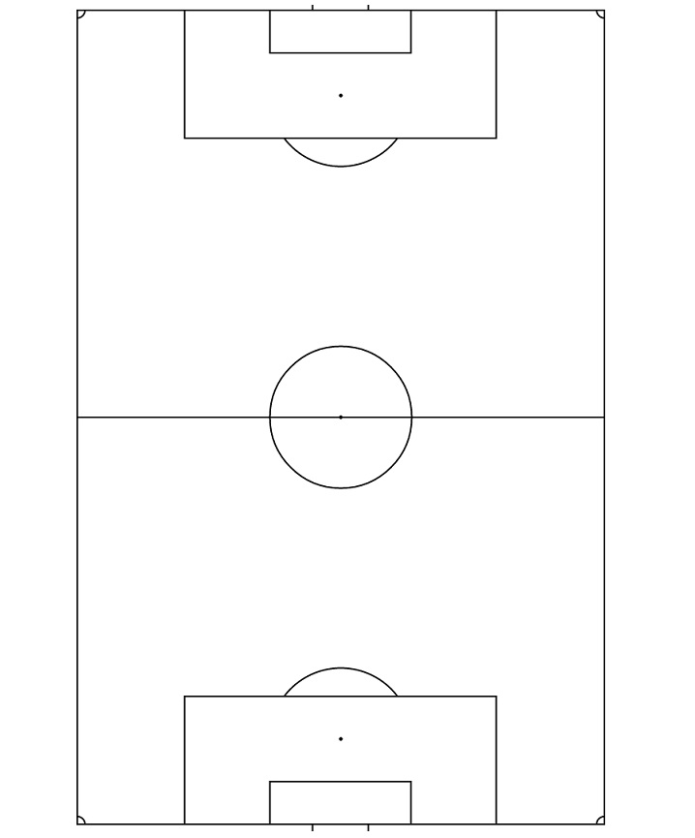

The following is “area covered” by each position. This is a generalization and exceptions do occur.

Goalkeeper [area covered]

Defenders [area covered]

Midfielders [area covered]

Wide Forwards [area covered]

Striker [area covered]

