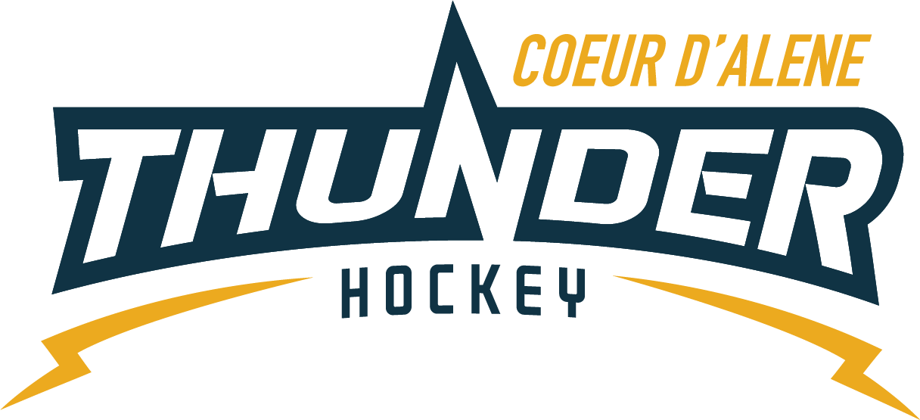

CDAHA

Meeting minutes
Location: Frontier Ice Rink Date: November 17, 2020
Attendees: Bob Nelson, Elliot Taub, April Hocking, Meghan Smith, Bart Barrett, Jarrod Hansen, Matt Fisher, Josh Leppert, Matt Creighton, Jackie G, Torsten, Kami Winfrey, Jackie P, Matt Pelz
Time: 7:04PM
- Call to order
Bob Nelson, President called meeting to order 11/17/20 7:04PM
- Roll call
All present
Guests Matt Pelz, Kami, Jackie G, Jackie P
- Approval of minutes from last meeting
Behind on minutes
- Open issues
  - TRESURER UPDATE
    - Looking good money coming in from game payment. Bill for refs paid in Oct. Nothing major or outstanding. Have another check.
  - REGISTRAR UPDATE
    - Need to determine if there will be a cut off date
  - COVID GUIDELINES
    - Jackie P will emailed us rough draft that Bob read
    - The cameras at the rink are working great
    - Suggest keeping the Figure Skaters on the N side of the rink and hockey players S side for enforcement
    - Who is essential, how many coaches/managers at the games
  - COACHING COMMITTEE
    - Matt C said SAYHA cancelled Eagles until Dec 14th, games are still up and running. Vince and mite/cristero games cancelled to avoid 250 people. There has been under 50 Mites at the practices. We gave them their extra ice and they are not showing up. Need to ask our coaches more questions.
  - SQUIRTS
    - About ¼ of them are frustrated that people are not masking up and asking for consistency per Gov. rule
      - Josh suggested pushing stricter guidelines right now.
        - Our spectators have to wear a mask, everyone wants to continue playing hockey we can’t force you, but do it in the name of hockey, when the doors close due to our selfishness as our neighbors have closed.
        - Copy/paste the Gov order into blast, revisit on the 14th and understand we will be done if we can’t cooperate.
- Adjournment
Bob adjourned the meeting at 8:46pm.
Minutes submitted by: April Hocking
Minutes approved by: CDAHA BOD
- Next Meeting
  - December 1, 2020 7PM

