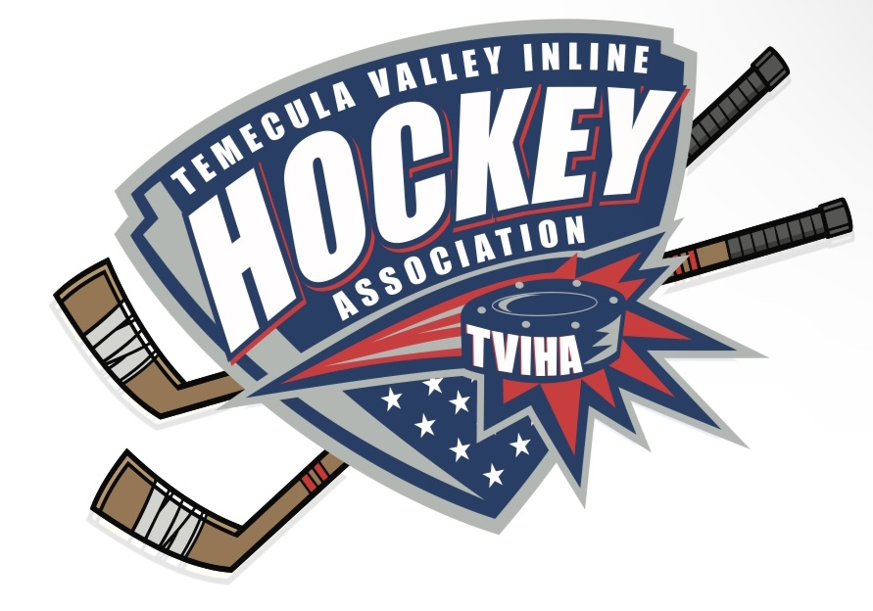
Meeting Minutes of the Temecula Valley Inline Hockey
Association Board Meeting November 15th, 2022

- President Matt McCaffrey called the meeting to order at 5:34pm.
- The following people were present: Jeff Martin, Geoff Bricker, Ryann McCaffrey, Justin Kalnas, and Matt McCaffrey.
- Matt McCaffrey made a motion to approve the August 2022 minutes. Jeff Martin seconded the motion. Minutes for the August 2022 meeting were approved by the board members.

Treasurer Report - Geoff Bricker: SEPTEMBER 2022 and OCTOBER 2022 financials will be approved at the November 22nd Board Meeting.

League Update

- Justin Kalnas updated the board on the plans for the Ronald Reagan Rink construction. He explained the project is out of the city’s hands now and with the construction/ engineer company. Justin will continue to keep in contact with Stacy and project teams.
- The board discussed possible options for upcoming seasons if we are limited on rink time due to construction at Ronald Reagan. Possibilities included: two 15 minute periods instead of three, practices at other locations (tennis courts, epic, basketball courts), and utilizing Saturdays for practices.
- Matt McCaffrey proposed a November board meeting with all of the membership and board members invited. Ryann McCaffrey will post information for the meeting on the website and email board members.
- The league’s score board broke and a television was purchased for a temporary solution. Jim Day, the school director, welded a mount and installed plexi-glass to help protect and hang the new scoreboard. An app (IceHockey Score) is being used for scorekeeping. The league needs to get a donated phone or tablet to keep in the bin to control the scoreboard app. Ryann McCaffrey will communicate with Anne Mollman about training the scorekeepers on the app and new scoreboard set up.
- The board decided to keep the rec division at 3 penalties for a game ejection.
- Justin Kalnas proposed a coaches and ref meeting with Justin Moldenhauer, Martin LaRouche, Jim Day, the board and all participating refs/ coaches for the 2023 School League Division. This will help explain expectations and keep everyone on the same page for the upcoming season.
- Justin Moldenhauer and Justin Kalnas will work together to develop some type of coaches training.
- Jeff Martin shared the production crew will be out at the rink Thursday November 17th and Friday November 18th. Jeff Martin will email coaches so they can update their parents about the filming.

Meeting Adjournment: 6:20 pm

