Warriors COBA Youth Basketball
Game Day COVID Procedures & Protocols – 2020-2021
Players, Coaches, Spectators, & Volunteers
▪ The Youth Basketball Warriors will follow all requirements set forth by OHSAA and the LCL, the Licking County Health Department, and Watkins Memorial Schools regarding the expectations and mandates that must be followed by spectators/parents, student-athletes, coaches, and administration.
▪ Players, coaches, spectators, and volunteers are not permitted to attend an event if exhibiting any symptoms of COVID-19 including but not limited to: fever, cough, shortness of breath, sore
throat, sudden change in taste or smell, muscle aches or pains, had close contact with someone
who has COVID-19, or are awaiting the results of a COVID-19 test.
▪ Any player, coach, spectator, and volunteer who becomes symptomatic during a practice or
game, will be asked to leave the venue, and we will sanitize the area they occupied after they
have left. Persons who cannot leave immediately will wait in an isolated area.
▪ Any person who is symptomatic is highly encouraged to seek medical attention as soon as
possible. If your athlete tests positive for Covid-19, either the parent or coach must contact the youth director so that it can be communicated to the Licking County Health Department.
▪ Carpooling is discouraged, however if it must be done, mask wearing is strongly encouraged
▪ Players, coaches, volunteers, and spectators for the Watkins Warriors will enter/exit through the front doors at Watkins MS in the main lobby.
▪ Players, coaches, volunteers, and spectators for the visiting team will enter/exit through the side door.
▪ Everyone in attendance must follow the designated traffic pattern outlined.
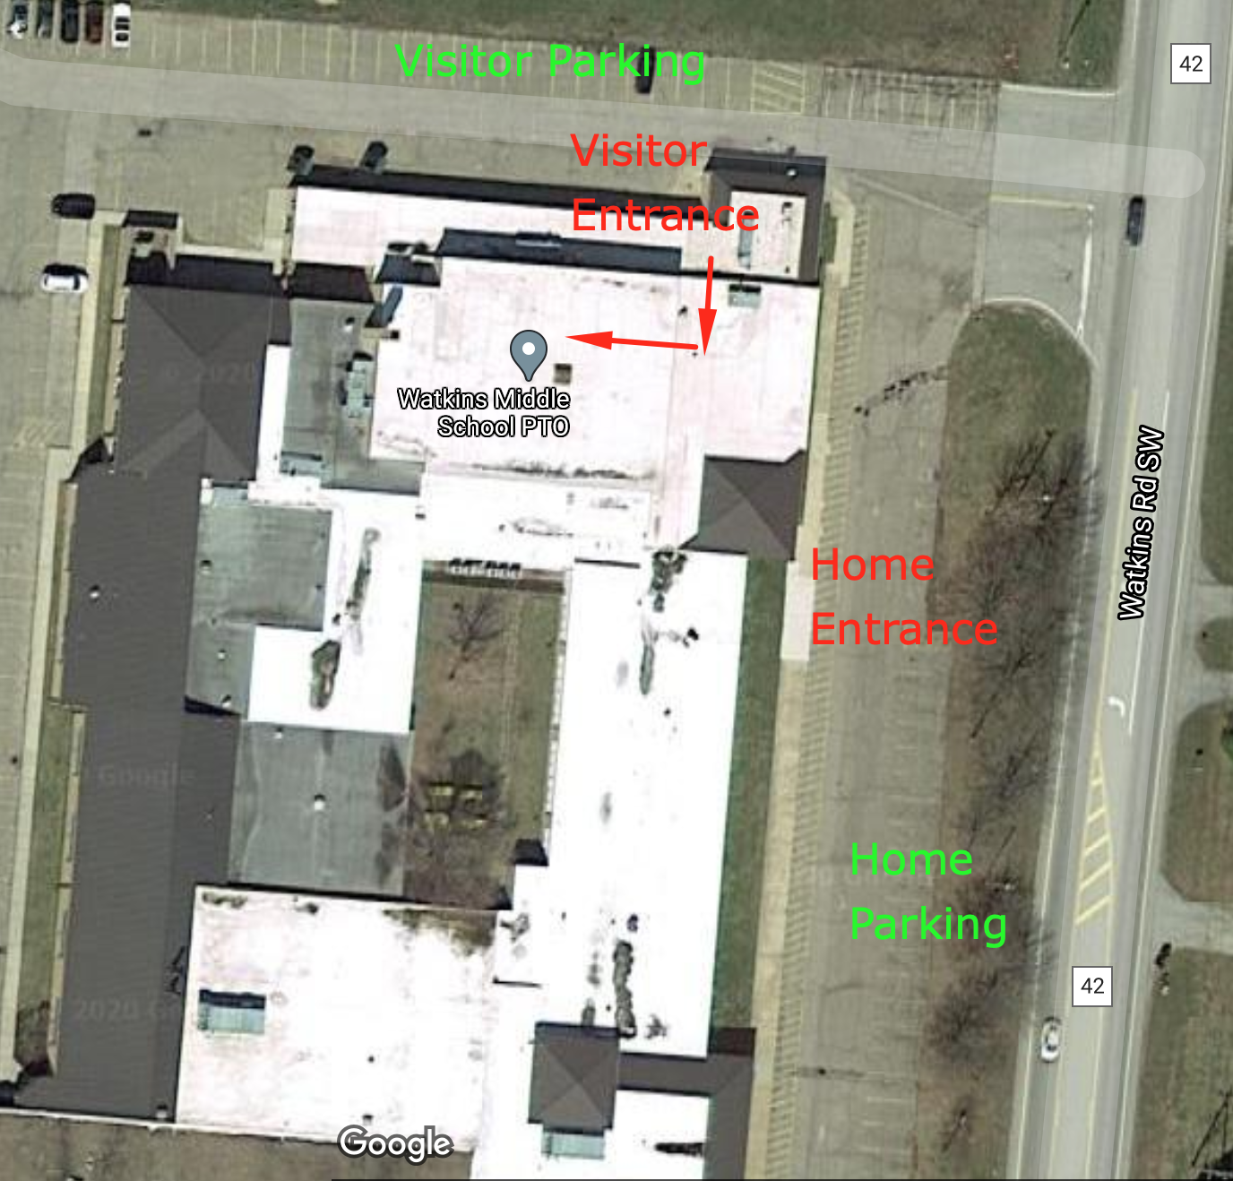

Watkins Youth Basketball
Game Day COVID Procedures & Protocols – 2020-2021
Spectators Only
▪ Spectators will be expected to wear a mask AT ALL TIMES.
▪ Two family members per athlete can attend.
▪ Family members must sit together, socially distanced from other individuals/family groups.
▪ Spectators are not allowed to congregate before, during, or after contests. Please collect your child IMMEDIATELY after the game and leave the facility.
▪ Spectators should try to refrain from direct contact with athletes and personnel before, during
and after the events.
▪ Proper social distancing protocols will be adhered to for all spectators.
▪ Spectators will not be permitted to enter the gymnasium until after the sanitizing has been
completed.
Players
▪ Temperature needs to be checked at home prior to coming to the contest. If the player has any symptoms listed above, please keep them home during the game.
▪ Coaches must wear masks at all times.
▪ Players must wear masks, unless they are doing strenuous activity. I.e. warming up or playing in the game. When they are out of the game on the bench, the player should be wearing a mask.
▪ Coaches should make sure players are situated six-feet apart on the bench.
▪ Coaches, players, and volunteers will sanitize prior to the game and following the conclusion of
the game.
▪ Basketballs will be sanitized before and after games.

Updated 10/29/20 Page 2
Warriors Youth Basketball
Game Day COVID Procedures & Protocols – 2020-2021
Consequences
The Licking County Health Department and OHSAA can send representatives out to monitor
our adherence to the protocols and they have the ability to shut us down. Spectators/Families who do not follow the protocol are subject to removal from school grounds and possible suspension from other Warriors Athletic Events.
Questions may be sent to Shane Warner or Hollie Tanzillo at:
Swarner23@gmail.com or hollietanzillo3@gmail.com
For additional COVID-19 Information please see:
https://coronavirus.ohio.gov/wps/portal/gov/covid-19/testing-ch-centers

