South Side Fields Setup/Breakdown

12U - (Gabarro Field)
All items are found in stairwell of the concession building behind backstop.
- Bases
- Field liner
- Batting Box template
- Pitcher circle scribe
- Lime
- Field rakes
- Tape measure
- Liner string

Field Setup
For games: Home team sets up field. Visiting team rakes and breaks down field (although helping each other is encouraged).
Lining field:
At a minimum: Line batter’s box and catcher’s box, 1st and 3rd base lines, and 8’ radius pitcher’s circle. May also add coaches’ boxes, 3’ runner’s lane along 1st base line, and on deck hitter circles.
Install Bases:
- Remove plugs from base ground receptors. Place near dugouts.
- Install bases. First base is double base. The white base is in fair territory. The red base goes is closest to dugout in foul territory. Second and third bases are self-explanatory.

Field Breakdown
- Remove bases, including magnetic plates.
- Reinstall base receptor plugs.
- Return all equipment to designated area and store neatly.
- At a minimum, field rake around bases, pitcher’s plate, and home plate.
- Be sure to shut off lights and lock all facilities before leaving for the night.
- If using the Four-wheeler side by side machine see below instructions.

16U/14U - (Murray Field)
All items are found in the storage building adjacent to the field.
- Bases
- Field liner
- Batting Box template
- Pitcher circle scribe
- Lime
- Field rakes
- Liner string

Follow instructions above for field setup and breakdown accordingly.

Return all equipment to designated area and store neatly.

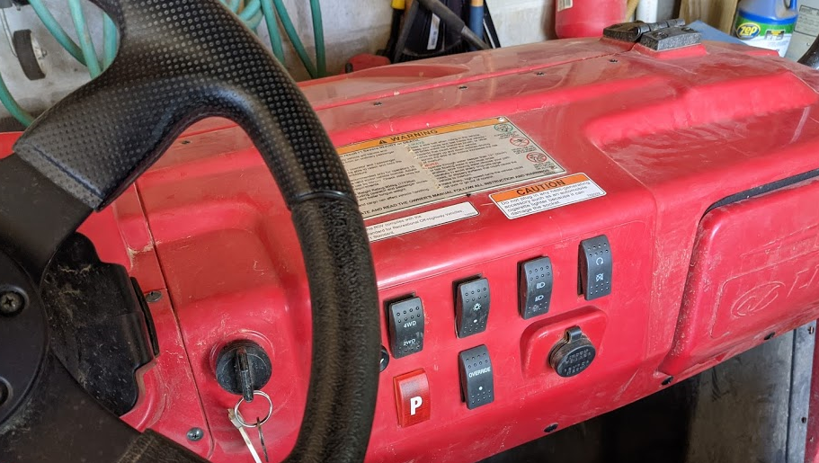

Using the Four-wheel side-by-side machine
Only use 4 WD when dragging the nail drag due to weight. All other uses require just 2 WD.
Starting:
- Pull out choke.
- Step on brake before starting.
- Turn ignition key to start.
- Let idle for 3-5 minutes.
- When ready push choke in and put in gear. Step on brake to shift!

Drive vehicle into the storage area and stay LEFT as much as possible to allow access on right side to the shelving unit.
- When turning machine off always use key to shut off. Do NOT use kill switch!!

